Revision notes: The immune system

Specific defence mechanisms | Notes
- What is a pathogen?
- What is an antigen?
- Where would you find an antigen?
- What kind of cells are lymphocytes?
- Make a sketch of a lymphocyte.
- What are the different kinds of lymphocytes?
- What kind of specific immunity
does each provide us with?
- What different kinds of pathogens
does each protect us against?
- When a B-lymphocyte is activated,
what kind of daughter cells does it produce?
- What is the function of each of the daughter cells?
- What is an antibody
- Where would you find antibodies?
- What do antibodies do?
- When a T-lymphocyte is activated, what kind of daughter cells does it produce?
- What is the function of each of the daughter cells
- What do T-4 helper cells do?
- What is meant by ‘acquired immunity’?
- Which cells are involved in acquired immunity?
Comparison between antibody mediated immunity & cell mediated. immunity.

 | Antibody mediated immunity | Cell mediated immunity
Main cell type
Where 'educated'
Mode of action
Targets
Location
Persistence of immune response

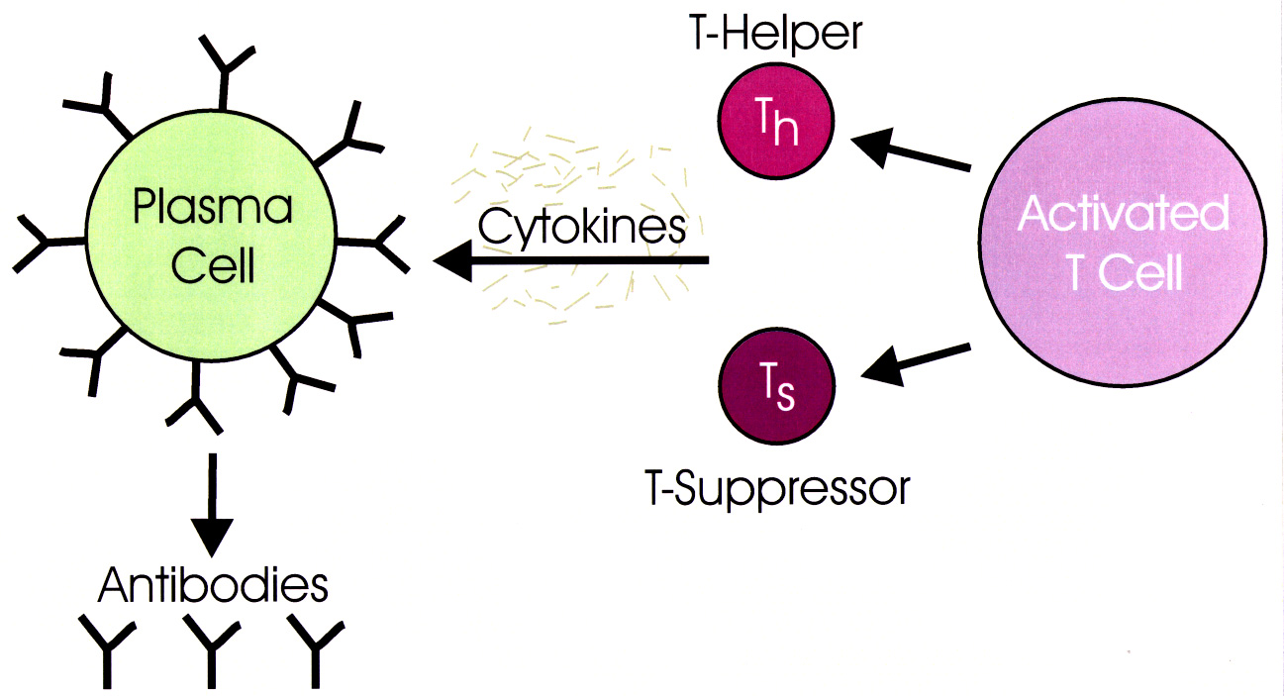

AIDS/HIV
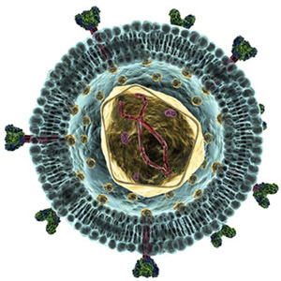
- What kind of organism causes AIDS?
- What does HIV stand for?
- What kind of cells does HIV infect?
- List the 4 most common ways a
person can become infected with AIDS.
- What are the symptoms of a Group 1 HIV infection?
- What are the symptoms of a Group 2 HIV infection?
- What are the symptoms of a Group 3 HIV infection?
- What are the symptoms of a Group 4 HIV infection?
- How long does it take for an HIV
infection to progress from Group 1 to
Group 4 HIV infection?
- What does 'AIDS' stand for?
- Is AIDS always fatal?
- What are the most common
opportunistic diseases that kill
people with AIDS?
