Revision notes: The immune system

Non-specific defence mechanisms | Notes
- What is meant by ‘non-specific’? | Response to any kind of pathogen or cell that is ‘non-self’
- What is the name of the anti-  bacterial enzyme found in tears,  sweat, saliva and nasal secretions? | - Lysozyme act to destroy bacterial cells by hydrolysing the polysaccharide component of the cell wall. It is released from special neutrophils and becomes part of the mucosal secretions of eye/sweat glands etc.  - Lysozyme also makes it easier for macrophages to target bacteria
- Outline 2 ‘non-specific’ defence | - Eyes  - Blinking  - Flushing action of tears  - Lysozyme activity  - Skin  - Impermeable integument  - Lysozyme in sweat  - Lactic acid  - Sebaceous secretions  - Digestive system  - Flushing action of vomiting/diarrhoea  - Stomach acidity  - Stomach protease enzymes  - Respiratory system  - Coughing/sneezing  - Nasal hair and mucous traps  - Ciliated epithelium and mucous secretion  - Lysozyme actiivty  - Urino-genital system  - Flushing action of passing urine  - Flushing action of normal vaginal secretions  - Low ph caused by commensal bacteria in the vagina
mechanisms that protect the:
- Describe two of the body's internal non-specific defence mechanisms. | - Inflammatory response  - Damaged cells release histamine  - Leads to increased permeability of capillary walls  - Loss of blood proteins into the tissues  - Osmotic outflow of water  - Redness, swelling, heat at site  - Proteins assist in repair  - Attraction of neutrophils to site  - Phagocytosis of bacteria & debris – pus forms
- Phagocytosis by professional phagocytes i.e. neutrophils & macrophage
- Enclose and digest cell debis and pathogens
- Fixed macrophages are present in the lymph nodes
- The engulf & digest bacteria & cell debris trapped by the fibrous mesh of the node

Specific defence mechanisms | Notes
- What is a pathogen? | - Any organism that causes disease  - Include bacteria, fungi, ciliates, roundworm, flatworms  - Infective agents (virus)  - Prions (‘mad cow disease’ CJ disease (Creutzfeldt-Jakob)
- What is an antigen? | - substance capable of causing the production of antibodies by plasma cells  - i.e. antibody-generator
- Where would you find an antigen? | - In the bloodstream, in infected tissues, lymphatic system  - Refers to molecules present on the surface of ‘foreign’ cells
- What kind of cells are lymphocytes? | - Kinds of WBCs  - Three main types of lymphocytes:  - killer T-cells which are large, and  - T & B-cells which are small  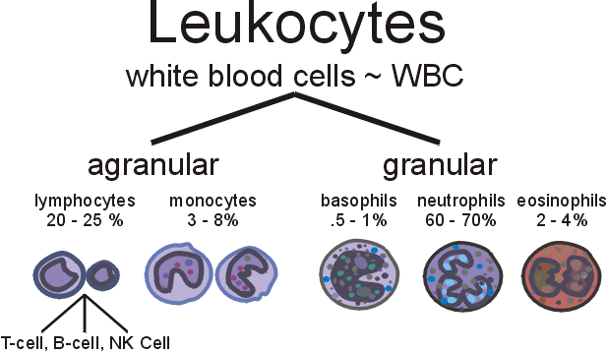
- Make a sketch of a lymphocyte.
- What are the diferent kinds of lymphocytes?
- What kind of specific immunity  does each provide us with? | - B-cells give humoral immunity  - T-cells give cell-mediated immunity
- What different kinds of pathogens  does each protect us against? | - B-cells protect from extracellular bacteria and virus particles  - T-cells from intracellular bacteria & virus, cancer cells, transplanted cells & larger parasites
- When a B-lymphocyte is activated,  what kind of daughter cells does it produce? | - Competent B-cells that clone & specialize to form plasma cells & memory cells
- What is the function of each of the daughter cells? | - Plasma cells form antibodies  - Memory cells to rest & respond to subsequent infection by….
- What is an antibody | - Y-shaped proteins formed by plasma cells  - to identify and neutralize foreign objects
- Where would you find antibodies? | - in the blood and lymph  - attached to B-cell membranes  - in mucous secretions, colostrum, milk
- What do antibodies do? | - Neutralise antigens  - Cause the lysis of bacterial cell membranes  - Identify antigen to macrophage  - Cause agglutination of antigens to facilatate phagocytosis
- When a T-lymphocyte is activated, what kind of daughter cells does it produce? | - Helper, Killer, Suppressor, Memory T-cells
- What is the function of each of the daughter cells | - Helper T-cells  - stimulate plasma cells to form antibody  - stimulate growth of all T-cells (interleukin)  - entice more macrophages & neutrophils to the invaded area  - without Helper T cells there is no immune response  - Killer T-cells  - cells infected with viruses  - cancer cells  - transplanted cells-graft rejection  - activated by cytokines released on infection  - Suppressor cells  - increase slowly after infection.  - limit the immune reaction by inhibiting Helper T-cells  - Memory cells  - Long-lived, retain memory of antigen
- What do T-4 (=CD4) helper cells do? | - T4 cells help coordinate the immune response to infections  - Identify antigens through surface receptors
- What is meant by ‘acquired immunity’? | - Immunity gained from a disease, naturally or otherwise
- Which cells are involved in acquired immunity? | - T-cells and B-cells

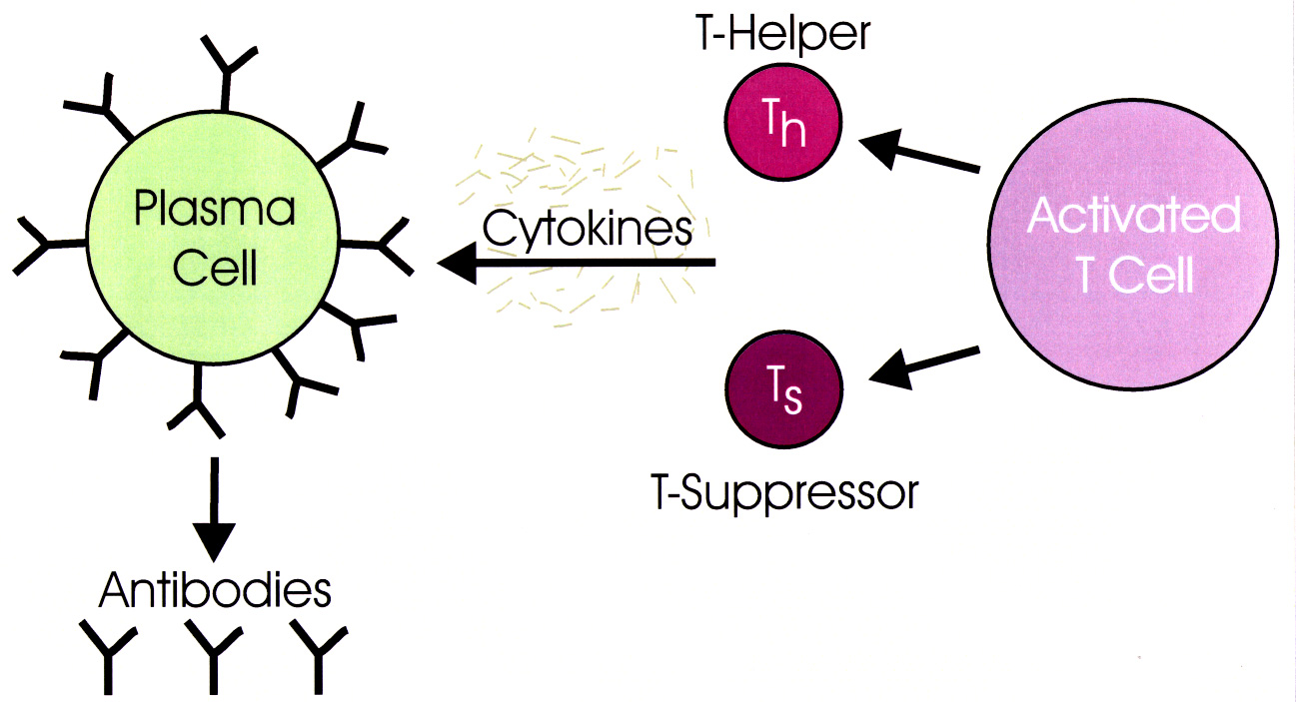
AIDS/HIV
- What kind of organism causes AIDS? | - Virus
- What does HIV stand for? | - Human immunodeficiency virus
- What kind of cells does HIV infect? | - Helper T-cells which have the CD4 protein on their surface which the HIV uses to attach itself to gain entry to these cells
- List the 4 most common ways a  person can become infected with AIDS. | - Unprotected sexual intercourse with infected person  - Needle sharing  - Transplanted tissue from an infected person e.g. blood (largely eliminated through screening)  - Infection at birth or from breast milk
- What are the symptoms of a Group 1 HIV infection? | - primary infection: short flu-like illness
- What are the symptoms of a Group 2 HIV infection? | - clinically asymptomatic stage: lasts for an average of ten years and, is free from major symptoms, although there may be swollen glands. The level of HIV in the peripheral blood drops to very low levels but people remain infectious and HIV antibodies are detectable in the blood, so antibody tests will show a positive result. Virus very active in lymph nodes
- What are the symptoms of a Group 3 HIV infection? | - symptomatic HIV infection: emergence of opportunistic infections and cancers that the immune system would normally prevent. These can occur in almost all the body systems, but common examples are:  - Pneumocystis Carinii Pneumonia (PCP)  - Tuberculosis (TB)  - Kaposi's Sarcoma (KS)  - Candida  - Herpes simplex
- What are the symptoms of a Group 4 HIV infection? | - progression from HIV to AIDS:  - one or more of a specific number of severe opportunistic infections or cancers are diagnosed.  - very low count of T helper cells in their blood. It is possible for someone to be very ill with HIV but not have an AIDS diagnosis.
- How long does it take for an HIV  infection to progress from Group 1 to  Group 4 HIV infection? | - 10 years
- What does 'AIDS' stand for? | - Acquired Immuno-Deficiency syndrome
- Is AIDS always fatal? | - HIV infection cannot be cured. A person with HIV will die with the infection and often of it. Always fatal if no treatment is given
- What are the most common  opportunistic diseases that kill  people with AIDS? | - Pneumocystis Carinii Pneumonia (PCP)  - Tuberculosis (TB)  - Kaposi's Sarcoma (KS)  - Candida  - Herpes simplex  - Cytomegolavirus (CMV)  - Toxoplasmosis

Comparison between antibody mediated immunity & cell mediated. immunity.

 | Antibody mediated immunity | Cell mediated immunity
Main cell type | B lymphocytes | T lymphocytes
Where 'educated' | Bone marrow | Thymus
Mode of action | Antibody | Killer T cells
 |  | Regulatory T cells (Suppressor cells)
Targets | Mainly extracellular bacterial | Chronic intracellular viral
 | infections. | infections.
 | Some acute extracellular viral | Some intracellular bacterial
 | infections | infections.
 |  | Cancer cells, foreign tissue &
 |  | larger parasites.
Location | Mainly in lymph nodes & | Circulate in lymph & blood
 | lymph tissue | plasma; also in lymph nodes &
 |  | lymphoid tissue:
Longevity of immune response | Relatively short | Long lived

