pH and acidity

pH is a measure of the hydrogen ion concentration of a solution.

Solutions with a high concentration of hydrogen ions (H⁺) have a low pH and solutions with a low concentration of hydrogen ions (H⁺) have a high pH.

pH=-log[H+] concentration

The pH is equal to minus the log of hydrogen ion (H⁺) concentration.

Question: what is the pH of an acid of a 0.01M?
Answer: pH = -log (0.01)
= - (-2)
= +2

Hydrogen ion concentration | pH | Solution with a pH of
0.1M | 1
0.01M | 2 | coke and orange juice
0.001 | 3
0.0001 | 4
0.00001 | 5 | black coffee
0.000001 | 6
0.0000001 | 7 | pure water
0.00000001 | 8
0.000000001 | 9 | baking soda
0.0000000001 | 10
0.00000000001 | 11
0.000000000001 | 12 | household bleach
0.0000000000001 | 13 | oven cleaner

Questions:

1. Calculate the pH of a solution with a hydrogen concentration of 0.0005M

2. Calculate the pH of a solution with a hydrogen concentration of 6.5 x 10⁻³.

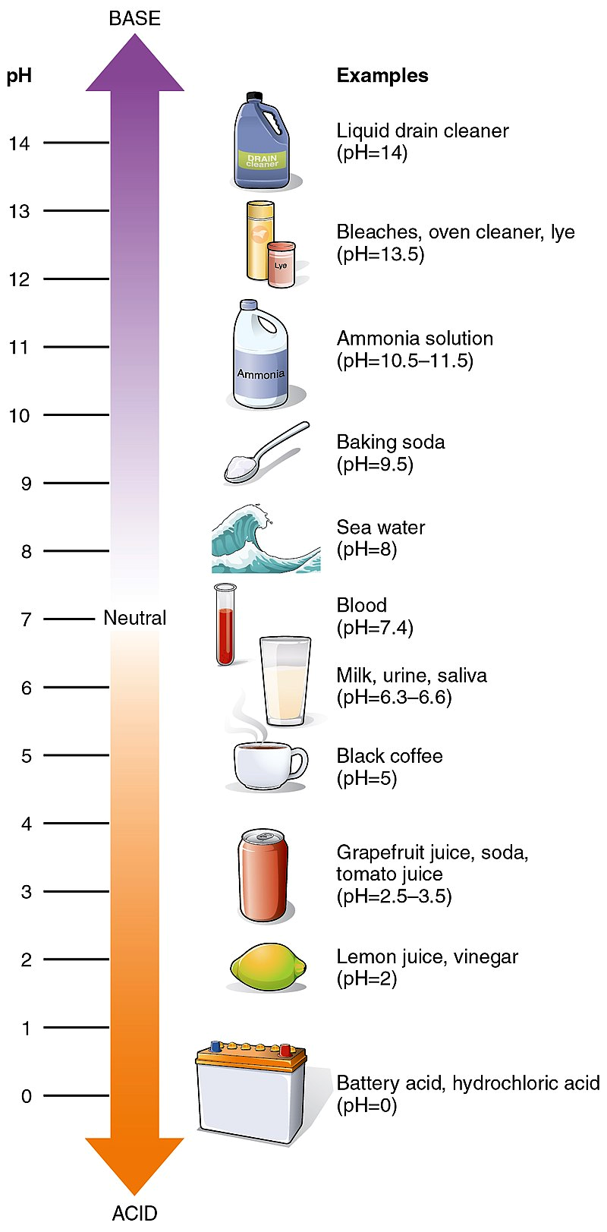
3. In the textbooks pH values range from 0 to 14. What hydrogen concentration should the solution have to get a pH of zero?

4. Calculate the pH of a 4M of hydrochloric acid. What do you note about the pH of this solution of hydrochloric acid?

5. If you were to compare an acid with a pH of 3 and another acid with a pH of 6, how would you describe the acidity of one in relation to the other?

Some Common Acids and Bases
The tables below list a few well-known acids and bases, along with their formulas and a few applications
Common Acids
- Acetic acid (CH₃ COOH): flavouring and preservation.
- Acetylsalicylic acid (HOOCC₆ H₄ OOCCH₃ ): aspirin
- Ascorbic acid (H₂ C₆ H₆ O₆ ): vitamin C
- Carbonic acid (H₂ CO₃ ): soft drinks, seltzer water
- Citric acid (C₆ H₈ O₇ ): citrus fruits, artificial flavourings
- Hydrochloric acid (HCl): stomach acid; tanning and printing.
- Nitric acid (HNO₃ ): fertilizer, explosives and dyes; paint & drugs.
- Sulfuric acid (H₂ SO₄ ): car batteries; remove rust from car body.
- Tartaric acid (C₄H₆O₆): baking powder.
Common Bases
- Aluminum hydroxide (Al[OH] ₃ ): antacids, deodorants; foaming agent in fire extinguishers.
- Ammonium hydroxide (NH₄ OH): glass cleaner; grease remover from clothes.
- Calcium hydroxide (Ca[OH] ₂ ): mortar, plaster; water softener.
- Magnesium hydroxide (Mg[OH]₂ ): laxatives, antacids
- Sodium bicarbonate/sodium hydrogen carbonate (NaHCO₃ ): baking soda
- Sodium carbonate (Na₂ CO₃ ): dish detergent
- Sodium hydroxide (NaOH): lye, oven and drain cleaner; paper and soap.
- Sodium hypochlorite (NaClO): bleach
- Potassium hydroxide (KOH): alkaline batteries.

