Year 10 Science: Biology Revision (First 4 Weeks)

- Label the following cell structures:
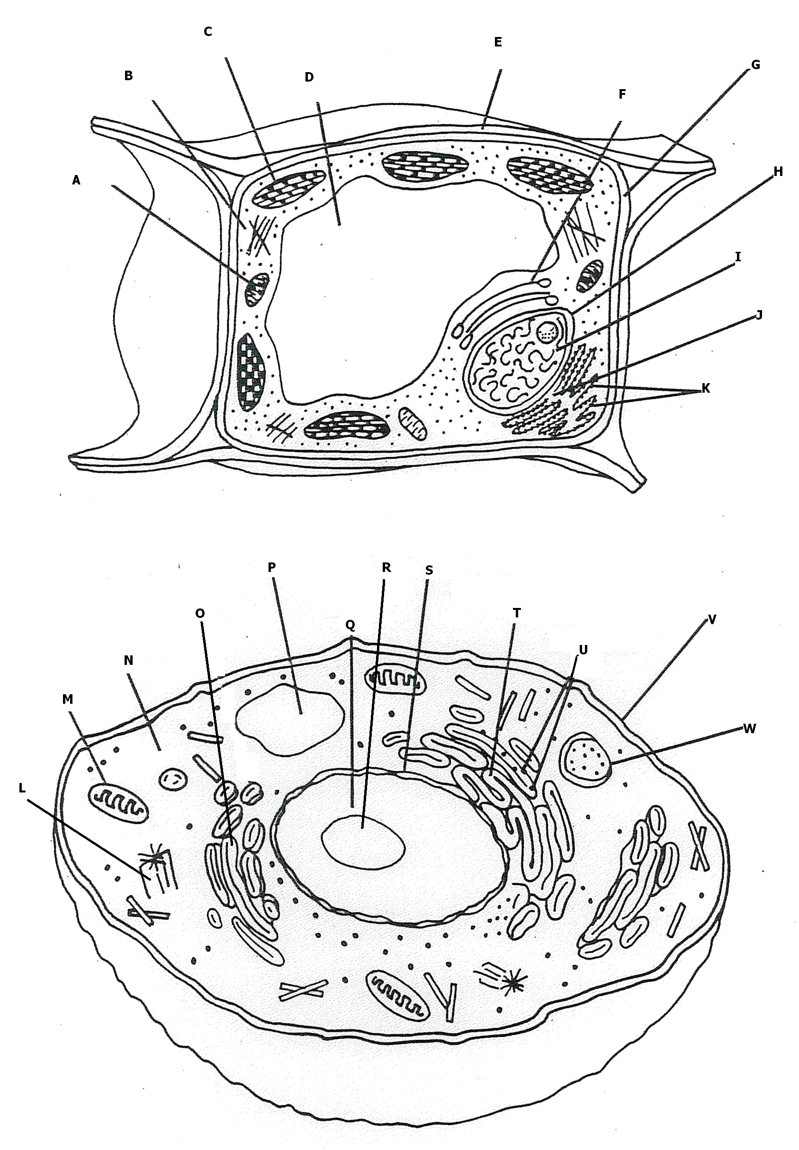

- Match the cell organelle to its function.
Mitochondria |  | The site of photosynthesis
Nucleus |  | An extra protection of the plant cell
Cell Membrane |  | Produces proteins via protein synthesis
Cell Wall |  | Produces Ribosomes
Chloroplast |  | Produces energy for the cell
Nucleolus |  | Produce spindle fibres during cell division
Lysosome |  | Removes substance with its digestive enzymes
Ribosome |  | A protective barrier that controls what enters and exits the cell
Cytoplasm |  | Temporarily stores water and molecules
Vacuole |  | All the organelles are suspended in this jelly-like substance
Centrioles |  | Contains DNA that controls the cell activity
- Define Extinction and list some reasons how it can occur.
- What is the only way a species can continue to exist?
- Outline the differences between sexual and asexual reproduction?
- Explain which type of reproduction leads to variation and why? (In you answer be sure to define variation)
- Outline some different types of Asexual reproduction
- List the advantages and disadvantages for Asexual Reproduction
- Define the terms: Fertilisation, Zygote, Gamete
- Explain the difference between external and internal fertilisation. Give an advantage and disadvantage for each type of fertilisation.
- Explain the difference between external and internal development. Give an advantage and disadvantage for each type of development.
- List the advantages and disadvantages for Sexual Reproduction
- What is DNA and why is it important.
- Draw a DNA structure and label the different components.
- What is DNA replication and why is it important?
- What is RNA? Outline how is RNA different to DNA?
- Briefly describe how RNA is involved in the process of Protein Synthesis.
- What is a mutation? Briefly outline what it means by a gene mutation and a chromosomal mutation.
- Differentiate between the terms: DNA, Chromatin, Histone protein, Chromatid, Chromosome and Centromere.
- Outline how the following people were pivotal to the discovery of genetics/DNA: Gregor Mendel, James Watson, Francis Crick and Rosalind Franklin.
- What is Mitosis and why is it important?
- Describe in detail the events that happen during each stage/phase of Mitosis (Interphase, Prophase, Metaphase, Anaphase, Telophase and Cytokinesis). Be able to recognise the different phases in diagrams.
- What is Meiosis and why is it important?
- What phase/s is unique to Meiosis? (Which phase/s is clearly different to Mitosis phases?)
- Define the term: Homologous chromosomes.
- Complete the table below to differentiate between Mitosis and Meiosis:
 | MITOSIS | MEIOSIS
Purpose/s
Location/s of process
No. of divisions
No. of daughter cells produced
Daughter cells are haploid or diploid?
Variation possible?

- Define the term variation and describe how the following sources lead to variation: Random fertilisation, Independent assortment of chromosomes, crossing over and non-disjunction.
- Describe what a karyotype is and how they may provide useful.
- Describe which chromosomes on a Karyotype are Autosomal and which are sec-chromosomes. How do you tell the difference between a male and a female karyotype?
