ADVANCED CHEMISTRY
REVISION
THE FIRST 5 WEEKS
- Define each of the following words so that you can differentiate between them:-
ELEMENT and COMPOUND, ATOM and MOLECULE
An element is comprised of one type of atom. A compound is combination of more than one type of atom chemically bonded to each other. An atom is the smallest part that an element can be broken down into. A molecule is more than one atom/ion joined chemically (but it can be made of only one element)

- Label each of the following parts on the atom.

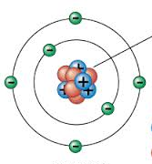
Neutron

Electron

Nucleus

Proton

  - If you pick up an atom off the ground how many electron should there be?
The same as the number of protons
  - What are the relative charges and masses of each of the particles found in an atom?
Particle | Relative Mass | Charge
Proton | 1 | +1
Neutron | 1 | 0
Electron | 1/2000 | -1

  - If the nucleus was blown up to the size of a golf ball, how big is the atom?
If a nucleus was the size of a golf ball and placed in the middle of a football oval, the electrons would be orbiting near the boundary lines.
- What is an ISOTOPE? Draw an example of 3 isotopes of any atom, clearly showing the number of each of the particles.
An isotope is an atom with a different number of neutrons but same everything else. See page 3 of study guide for an example.

- Fill in the following table.
SYMBOL | NAME | ATOMIC NUMBER | MASS NUMBER | NUMBER OF PROTONS | NUMBER OF NEUTRONS | NUMBER OF ELECTRONS
12  C  6 | Carbon | 6 | 12 | 6 | 6 | 6
16  O  8 |  |  | 16 |  |  | 8
 | Nickel |  | 59 | 28
137
Ba
56
 |  | 82 |  |  |  | 82
 | Copper |  |  |  |  | 29
 | Aluminium ion
23 +
Na
11
 | Sulphide ion
14 3-
P
7
(^mistake in paper, should be N, making it the nitride N³⁻ ion. Rest is correct)

- Write down the electron configuration of the following atoms/ions. Lithium, nitrogen, argon, and magnesium ion. Draw each of the atoms including the electrons surrounding each atom.
Li = 2,1 N=2,5 Ar=2,8,8 Mg²⁺=2,8 (2 electrons taken away in the ion)

- Review the Periodic Table. Label each of the following parts:- periods, groups, metals, non-metals.
Periods go across the periodic table in rows. Groups go down the periodic table in columns.
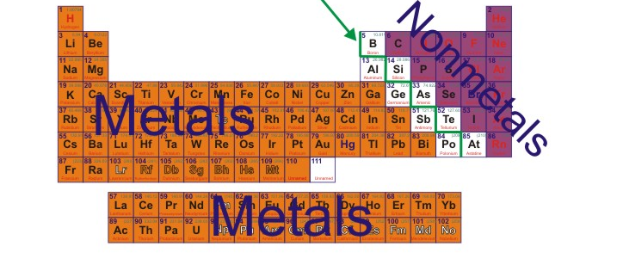

- The valency of the ion is related to the group number. Eg: group 1 elements form +1 ions. Group 17 elements form -1 ions. Group 18 elements don’t form ions.
- Why can it be said that the fluoride ion is, in one way, similar to the noble gas neon? Draw the 2 atoms to illustrate your answer.
A fluoride ion will have the same electron configuration as neon. Two completely filled shells.

- Fill in the following table by writing the correct formulae.
 | FLUORIDE | NITRIDE | SULPHITE | PHOSPHATE
SODIUM
BARIUM
COPPER I
AMMONIUM
IRON IV
CHROMIUM VI
NICKEL III
TIN II

- Fill in the following table by either giving the name or the formula of the missing part.

NAME | FORMULA
Water* | H₂0
Ammonia gas | NH₃
Sulphur trioxide
Silicon dioxide | SiO₂
Dinitrogen tetroxide
Disulphur tetrachloride | S₂Cl₄
Oxygen dichloride
Hydrochloric acid* | HCl
Sulphur hexafluoride
Hydrogen bromide* | HBr
*these names are exceptions to the rules.

- What is the difference between the bonding in the compounds in question 10, and that of the bonding in the compounds of question 11?
Question 10 has ionic bonding which is due to the swapping of electrons. Question 11 has covalent bonding which is due to the sharing of electrons
- What are chemical reactions? Where do you find the products, and where the reactants in an equation. What are subscripts and why are they used in equations?
Chemical reactions are the rearrangement of atoms and ions. Compounds are broken down and reformed into new compounds. The reactants are on the left. The products are on the right. Subscripts (aq, s, l, g) indicate the state of matter of the chemicals.
- What is the meaning of the law in chemistry stated “The law of the Conservation of Mass.”
This means that the type and amount of atoms on the reactant side must be the same as the product side of an equation.

- Write balanced DISSOCIATION equations for the soluble solids potassium sulphate, and magnesium chloride.

- Using a solubility table write down a balanced precipitation equation leaving out the spectator ions. If there are no precipitates produced then write down no reaction.

AQUEOUS SOLUTIONS MIXED | BALANCED PRECIPITATION EQUATION | SPECTATOR IONS
Lead II nitrate and Potassium hydroxide
Copper II sulphate and aluminium chloride
 | 2Fe³⁺_{(aq)} + 3CO₃²⁻_{(aq)} → Fe₂(CO₃)_{3 (s)} | SO₄²⁻ and K⁺
 | + → Fe₃Sn_{2 (s)} | CH₃COO⁻ and SO₄²⁻
Barium hydroxide and magnesium iodide
Strontium II iodide and Barium hydroxide
 | + → Ca₃(PO₄)₂ | OH⁻ and NH₄⁺

- Write fully balanced equations for each of the following reactions
ACID-METAL HYDROXIDE REACTIONS
  - hydrochloric acid is added to calcium hydroxide solution

  - magnesium hydroxide is added to phosphoric acid

  - barium hydroxide mixed with nitric acid

ACID-METAL REACTIONS
  - zinc mixed with hydrochloric acid

  - magnesium added to phosphoric acid

  - aluminium added to acetic acid

  - aluminium and phosphoric acid

  - iron and nitric acid

ACID-CARBONATE REACTIONS
  - hydrochloric acid poured over sodium carbonate
2HCl_{(aq)} + Na₂CO_{3(s)} → H₂O_{(l)} + CO_{2(g)} + 2NaCl_{(aq)}

  - a piece of copper (II) carbonate is added to a beaker of ethanoic acid
CuCO_{3(s)} + 2CH₃COOH_{(aq)} → H₂O_{(l)} + CO_{2(g)} + Cu(CH₃COO)_{2(aq)}

  - a teaspoon of magnesium hydrogen carbonate is added to 500 ml of nitric acid
Mg(HCO₃)_{2(s)} + 2HNO_{3(aq)} → 2H₂O_{(l)} + CO_{2(g)} + Mg(NO₃)_{2(aq)}

  - The marble chips would have bubbled longer as they had less surface area available for reaction, decreasing the rate of reaction.
  - CuCO_{3(s)} + 2CH₃COOH_{(aq)} → H₂O_{(l)} + CO_{2(g)} + Cu(CH₃COO)_{2(aq)}
  - n(CaCO₃)= 0.49955 mol = n(CO₂). m(CO₂)= n × M = 21.99 g

  - M(Br₂) = 159.8 g mol⁻¹
  - M(Fe(OH)₃) = 106.9 g mol⁻¹
  - M(Na₂CO₃) = 105.99 g mol⁻¹
  - M(Mg) = 24.31 g mol⁻¹
19.
a. n(Mg(OH)₂)= 2.57 mol
b. n(OH⁻) = 2 × 2.57 mol = 5.14 mol
c. n(H⁺) = n(OH⁻) = 5.14 mol

