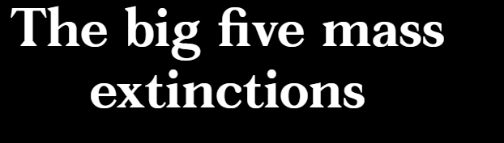

End Ordovician, 444 million years ago, 86% of species lost
— Graptolite 2-3 cm length
Graptolites, like most Ordovician life, were sea creatures. They were filter-feeding animals and colony builders. Their demise over about a million years was probably caused by a short, severe ice age that lowered sea levels, possibly triggered by the uplift of the Appalachians. The newly exposed silicate rock sucked CO2 out of the atmosphere, chilling the planet.
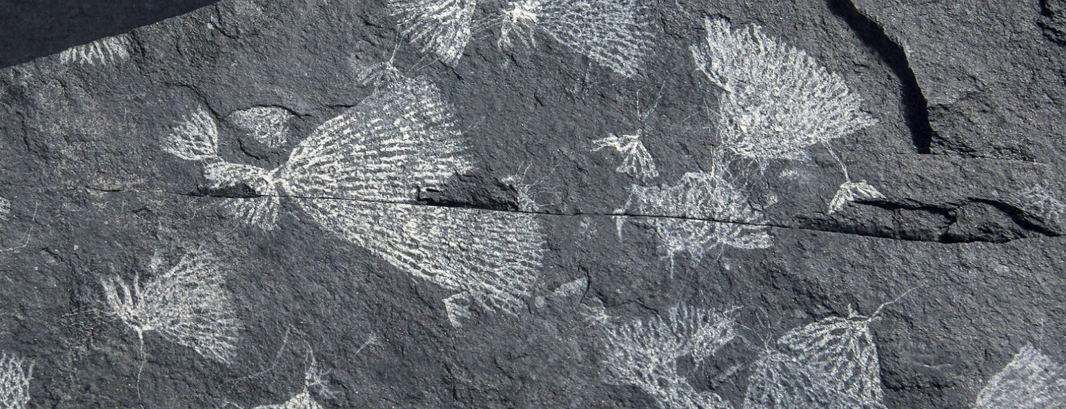

Late Devonian, 375 million years ago, 75% of species lost
— Trilobite, 5 cm length
Trilobites were the most diverse and abundant of the animals that appeared in the Cambrian explosion 550 million years ago. Their great success was helped by their spiky armour and multifaceted eyes. They survived the first great extinction but were nearly wiped out in the second. The likely culprit was the newly evolved land plants that emerged, covering the planet during the Devonian period. Their deep roots stirred up the earth, releasing nutrients into the ocean. This might have triggered algal blooms, which sucked oxygen out of the water, suffocating bottom dwellers like the trilobites.

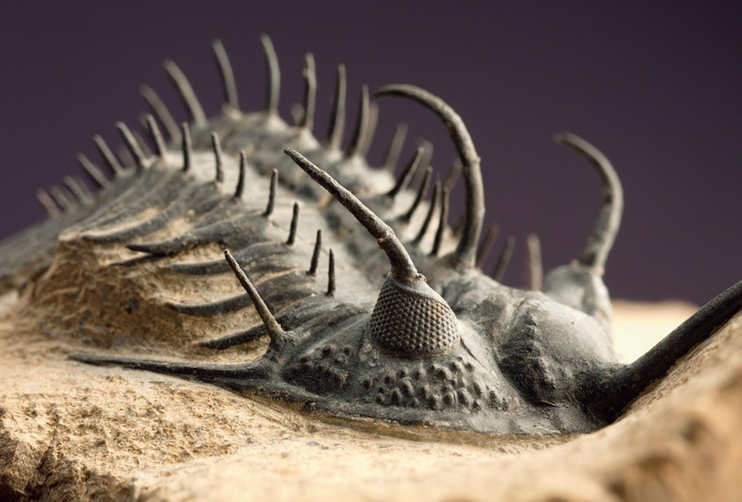

End Permian, 251 million years ago, 96% of species lost
— Tabulate coral, 5 CM
Known as “the great dying”, this was by far the worst extinction event ever seen; it nearly ended life on Earth. The tabulate corals were lost in this period – today’s corals are an entirely different group. What caused it? A perfect storm of natural catastrophes. A cataclysmic eruption near Siberia blasted CO2 into the atmosphere. Methanogenic bacteria responded by belching out methane, a potent greenhouse gas. Global temperatures surged while oceans acidified and stagnated, belching poisonous hydrogen sulfide. “It set life back 300 million years,” says Schmidt. Rocks after this period record no coral reefs or coal deposits.

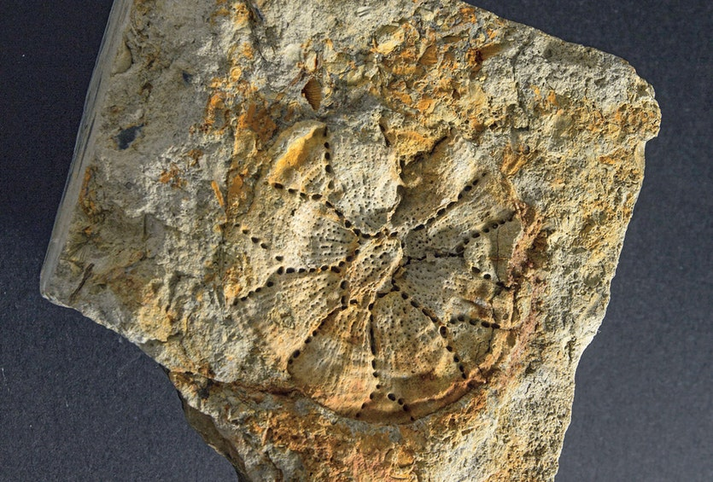

End Triassic, 200 million years ago, 80% of species lost
— Conodont teeth 1 mm
Palaeontologists were baffled about the origin of these toothy fragments, mistaking them for bits of clams or sponges. But the discovery of an intact fossil in Scotland in the 1980s finally revealed their owner – a jawless eel-like vertebrate named the conodont which boasted this remarkable set of teeth lining its mouth and throat. They were one of the first structures built from hydroxyapatite, a calcium-rich mineral that remains a key component of our own bones and teeth today. Of all the great extinctions, the one that ended the Triassic is the most enigmatic. No clear cause has been found.

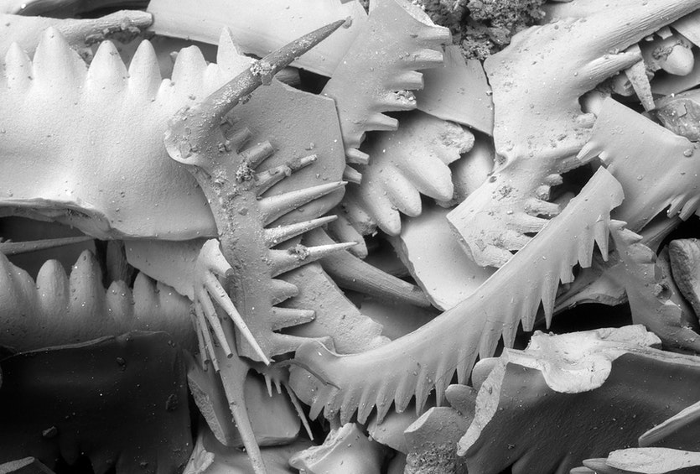

End Cretaceous, 66 million years ago, 76% of all species lost
— Ammonite 15 cm length
The delicate leafy sutures decorating this shell represent some advanced engineering, providing the fortification the squid-like ammonite required to withstand the pressure of deep dives in pursuit of its prey. Dinosaurs may have ruled the land during the Cretaceous period but the oceans belonged to the ammonites. But volcanic activity and climate change already placed the ammonites under stress. The asteroid impact that ended the dinosaurs’ reign provided the final blow. Only a few dwindling species of ammonites survived. Today, the ammonites’ oldest surviving relative is the nautilus. Will it survive the sixth great extinction?

