Year 10 Physical Science Week 2

Acceleration

Objectives:
- Define acceleration as the change in velocity that occurs in a unit of time.
- Perform calculations using the relationship:
- Realise that acceleration is caused by an unbalanced force.
- Draw/interpret a velocity-time graph
- * Extension only: Calculate displacement of an accelerating object using:

Acceleration describes the rate of change of velocity. Acceleration is also a vector quantity, so direction must also be considered.

where: a = acceleration (m s⁻²)
u = initial velocity (m s⁻¹)
v = final velocity (m s⁻¹)
t = seconds (s)
also v = u + at is an alternative formula.

When an object is undergoing positive acceleration it is going faster, when it is undergoing negative acceleration it is slowing down.

Example 1
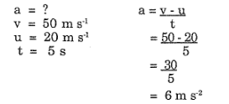
A car travelling at 20 m s⁻¹ uniformly accelerates for 5 seconds. If its final velocity is 50 m s⁻¹, then find its acceleration

Example 2

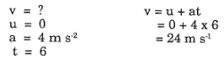
A car is stopped at the traffic lights. When the lights change, the car accelerates at 4 m s⁻² for 6 seconds. What is the final velocity of the car?

Velocity-time graphs can be used in the same ways as displacement-time graphs to summarise the motion of an object. From them we can:
- read directly from the graph
- use the gradient of the graph to find the acceleration of the object
- use the area under the graph to find the displacement of the object or the total distance travelled

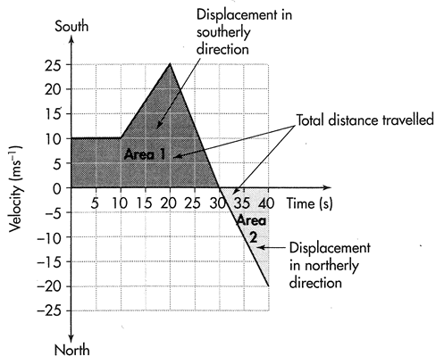
Example 3

The graph tells us that:

- the object travelled at a constant velocity of
10 m s⁻¹ for 10 s, then
- the object accelerated at 1.5 m s⁻² south for the next 10 s (the gradient of the graph), increasing its speed to 25 m s⁻¹, then
- slowed down at 2.5 m s⁻² until it stopped (at time 30 s), then
- accelerated at the same rate in a northerly direction until its velocity was 20 m s⁻¹ north.
- The object travelled 100 m in the first 10 s (the area under the graph)
- The total distance travelled by the object was 500 m (the total area under the graph = area 1 + area 2)
- The maximum displacement of the object was 400 m south (area 1)
- The total displacement of the object was 300 m (area 1 – area 2; remember it changed direction at t = 30 and started to go back towards where it started)
- The average velocity of the object was 7.5 m s⁻¹ south (total displacement divided by total time)
- The average speed of the object was 12.5 m s⁻¹ (total distance travelled divided by total time taken.)

Example 4

A truck uniformly accelerates from zero to 16 ms⁻¹ in 4 seconds.
Calculating acceleration:
gradient = rise
run
= 12 - 4
3 – 1
= 4 m s⁻²

The displacement is the area under the line of the graph.
area = ½ base x height
area = 0.5 x 4 x 16
area = 32 m
So displacement, s = 32 m

a = v – u = 16 – 0
t 4
a = 4 ms⁻²

s = ut + ½ at²
s = (0 x 4) + ½ x 4x 4²
s = 2 x 16
s = 32 m
Therefore:
- acceleration can be calculated by change in velocity over time.
- the displacement is the area under the line of the graph.
- the slope of the graph gives acceleration.

*Extension only - Displacement can also be calculated using the formula:

s = ut + ½ at² where: s = displacement (m)
a = acceleration (m s⁻²)
u = initial velocity (m s⁻¹)
t = seconds (s)

Example 5

A car, starting from rest, reaches a velocity of 63 km h⁻¹ in 3.5 s. If the average acceleration was 5.0 m s⁻², how far did the car travel?

u = 0 s = ut + ½ at²
v = 63 kmh⁻¹ = 0 + ½ x 5 x 3.5²
= 17.5 m s⁻¹ s = 30.6 m
a = 5.0 m s⁻² s = 3.06 x 10¹ m
t = 3.5 s
s = ?

Questions

- A rally driver is driving down a straight road at 90.0 km h⁻¹ when she approached a bend and rapidly slowed to 12.0 ms⁻¹ in 0.905 s. Calculate the acceleration of the car.

- Exercise: Consider the following graph of a remote controlled toy car and then describe the journey.
The toy car starts from rest with a positive uniform acceleration of ________________ for ______ second. It then continues at a positive constant ___________ of _______________ for _______ s. The car then uniformly accelerates at ____________________ for ________s and is now ________ m from where it started. Finally the car accelerates at __________________ for _______ s at which point it has returned to its starting point.

- Exercise: Graph the following journey. A car travelling at 20 m s⁻¹ slows to 15 m s⁻¹ in 5 seconds. It then continues its journey for 10 seconds when it increases it velocity to 25 m s⁻¹ in 7 seconds.
Calculate the displacement.

