Year 9 Change in Ecology
Research – Human impact on ecosystem

A dairy farmer wanted to set up his farm in a rural estate close to a river to obtain fresh water for is cattle. First he cleared the land of all trees so he could grow his corn crop to feed his cows.
He then created a lagoon close to his farm so he could dispose of the cow manure through a pipe.

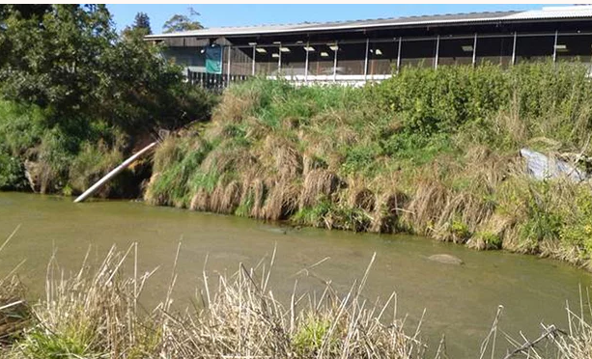
One day the pipe broke and running through the pipe and past it was a steady flow of liquid manure. This seeped into a rivulet running off the land and into the river.

1. Explain the ecological impact of land-clearing to make space for corn crop. In your answer include issues such as:
- Biodiversity,
- Salinity,
- Erosion,
- Nutrient depletion,
- Greenhouse pollution,
- Any other.

2. Explain the impact of this dairy farm practice on the aquatic ecosystem in the river. In your answer include issues such as:
- eutrophication,
- biodiversity,
- food web change,
- Any other.

Upon completing your research you will then be assessed on what you have learnt by sitting an in-class validation assessment that will test your understanding of the above ecological impacts.

