MODES OF INTERACTION IN AN ECOSYSTEM (REEF).

Many of the organisms on the Reef live in special relationships with other organisms. Some types of relationships between organisms are:
Competition, predation and symbiosis, which, includes mutualism, commensalism and parasitism.

1. Competition: is the interaction between organisms of the same population, or species in which the chance of survival of one is affected by the presence of another. Usually organisms compete when there is a limited resource such as food, water shelter or mates.

Competition is one of many interacting biotic and abiotic factors that affect community structure.

Three types of competition
a) Interference competition: when organisms directly and physically prevent others from accessing resources using aggression.
b) Exploitation competition: when organisms indirectly prevent others from accessing resources by utilising or exploiting most of the resources themselves.
c) Apparent competition: when two species are predated upon by same predator and the fact that if one species is greater in number than the other species, it tends to survive and have more resources than its competitor.


Examples of competition
- Trees compete for sunlight. Only tall plants that can obtain sunlight survive. Small plants that have germinated in spring do not receive much light in winter and are shaded by taller plants and therefore die (intra-specific).
- Cactus plants compete for water. They are not found very close together because of their roots that can radiate far from the plant to obtain as much rain during rainfall season (intra-specific).
- Sponges competing with corals for space (inter-specific).

2. Predation: when an animal is predated upon by another larger animal as a source of energy for survival. For example Crown of Thorns feeding on polyps found in corals.
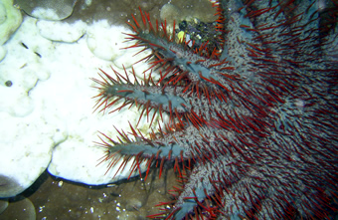

3. Symbiosis: is a term that encompasses three modes of interaction.
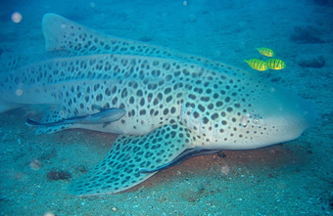
(i) Commensalism: it is the case where one organism benefits and the other is not affected. For example, Remora (sucker fish) and leopard shark. Sucker fish attaches to the sides and belly of Leopard shark to feed on morsels of food that escapes the shark.

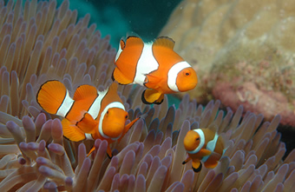
(ii) Mutualism: it is the case where both organisms benefit from each other. For example, Clownfish and sea anemone. The anemone protect the Clownfish from predators and provides it with food scraps from its meal as well as its dead tentacles. In return, the Clownfish defends the anemone from predators and parasites and aerates it by its continual movement.
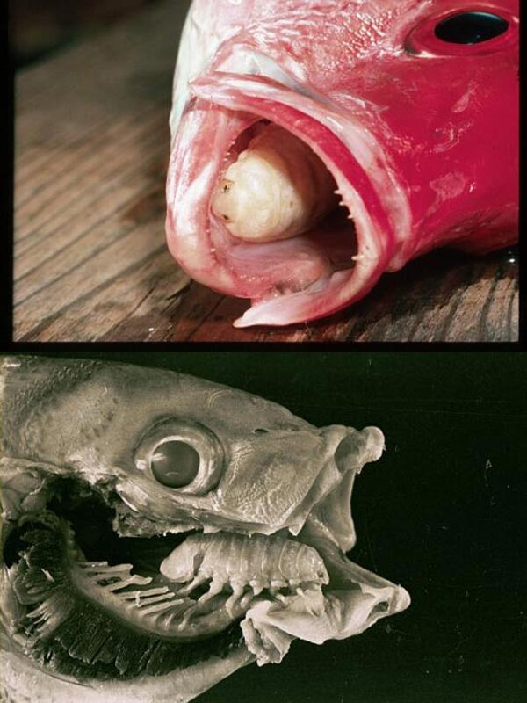
(iii) Parasitism: it is the case where one organism benefits at the expense of the other (the host). The host is harmed in some way. Normally a parasite doesn’t kill its host. For example, an isopod benefits while harming its symbiont (the fish). The isopod eats the fish’s tongue and then getting the first bite of everything the fish consumes.

Q1. Create two more examples of each of commensalism, mutualism and parasitism.

_______________________________________________________________________________________________________________________________________________________________________________________________________________
_______________________________________________________________________________________________________________________________________________________________________________________________________________
_______________________________________________________________________________________________________________________________________________________________________________________________________________
_______________________________________________________________________________________________________________________________________________________________________________________________________________

