Year 10 Physics Investigation – Week 7

Preliminary investigation

Go to S:\CurricShared\Get Work\Science\Resources\year 10 physics and get a copy of the energy skate park. Alternatively, it can be downloaded from the internet
https://phet.colorado.edu/en/simulation/energy-skate-park
(Note: Java software needs to be installed to run this program)

Use this program to investigate the factors that affect how far the skater flies off the end of the track. ie the distance a skater travels from the end of a skate ramp until the point where they hit the ground. It will be necessary to add extra sections of track in some parts and to manipulate the shape of the track carefully to produce good results. It is important that only one variable is changed at any time so if there is an affect we know it is due to that variable.

You only need to complete the table below when reporting your findings on this preliminary investigation.

Variable | Does this variable affect the distance travelled?  yes/no
Mass of the skater
Planet the skater is on
Angle of the end of the ramp
Height of the ramp above ground height
The steepness of the slope the skater rolls down (keep the height constant just change the length of track rolled along)

Some background

In physics scientists are often concerned with finding out how two different things are related. One way that they do this is by constructing a graph of one variable against another. When the graph is a straight line they are able to say that one variable is directly proportional to the other. This doesn’t just mean that as one variable increases the other one will also increase; it means that as we double one variable the other variable will also double.

y
x
As x increases so does y
As x increases so does y
y and x are directly proportional
y
y
x
x

Data sometimes needs to be manipulated to obtain a linear graph. For example if you graphed two variables and obtained a graph that looked like the first graph above the next thing to try would be a graph of y against x² to see if this would give a linear graph. If it did we could then say that y was directly proportional to x².

The Investigation task

Go to S:\CurricShared\Get Work\Science\Resources\year 10 physics and get a copy of the energy skate park. Adjust the track so that the end is horizontal. (You can add sections of track as well as reshape the track) Use this program to investigate the relationship between how far the skater flies off the end of the track and the height above the end of the track that they are released from. See fig 1

Hint having the track a reasonable distance above the ground ensures that variation in the results is significant.

Ensure you control those variables that impact the results that you identified in your preliminary investigation. There is a tape measure in the program as well as a grid that will help you with your measurements. It is a good idea to include the amount of error you have in your measurements of distance and height.

.

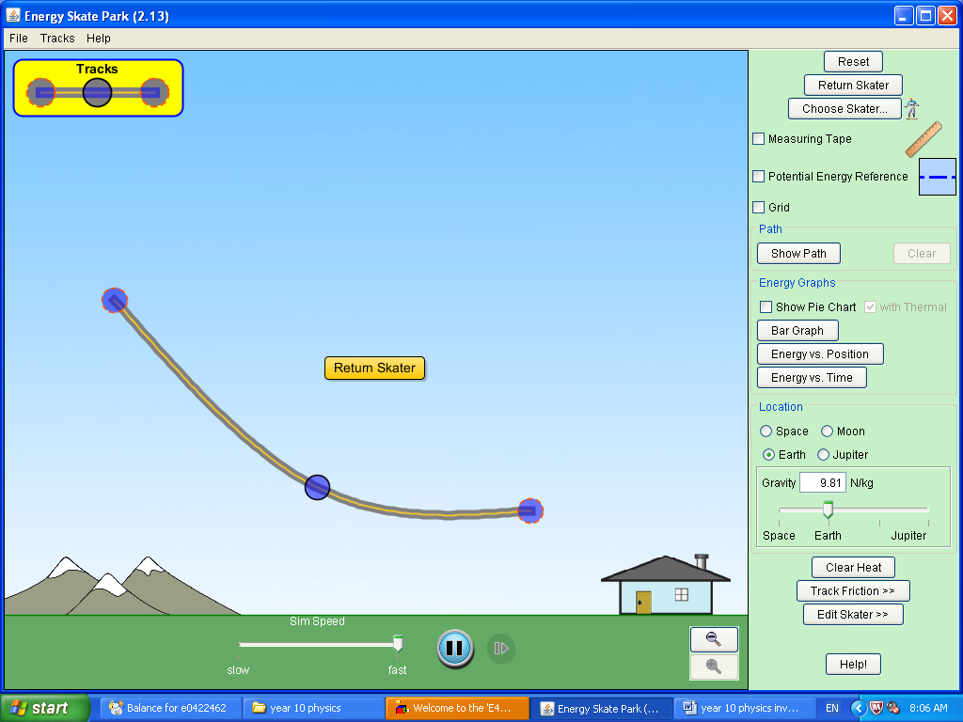
You will be assessed on the concepts/data investigated in an in-class validation test (Friday 31st August).
Fig 1

