BIOLOGY ANSWERS

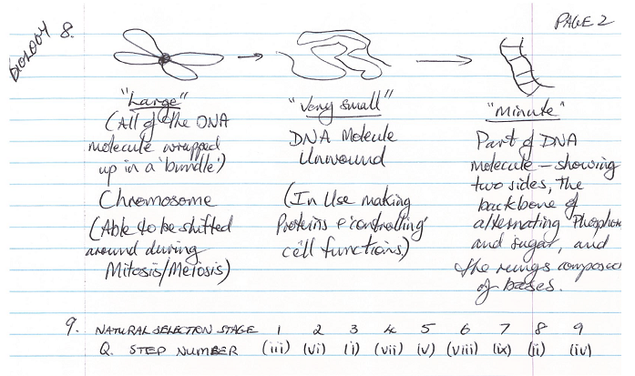
10.
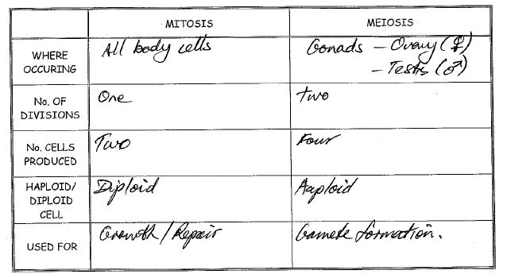

11.
12.
13.

14. Recessive. Individual III3 receives an X chromosome from II6 and a Y chromosome from II5. Since the individual has the disease, the X must contain the disease. Yet it does not show in III6 meaning it is recessive.

15.
X^{h} – diseased chromosome, X^{H} – normal chromosome
I1 - X^{h}X^{h} I2 - X^{h}Y
II1 - X^{H}Y II2 - X^{h}X^{h} II3 - X^{h}X^{h} II4 - X^{h}X^{h} II5 - X^{h}Y II6 - X^{h}X^{H}
III1 - X^{h}X^{H} III2 - X^{h}Y III3 - X^{h}Y III4 - X^{H}Y

 | X^{h} | Y
X^{h} | X^{h}X^{h} | X^{h}Y
X^{H} | X^{h}X^{H} | X^{H}Y

50% offspring suffer from disease. ½ The sons (others are fine). ½ the daughters (others are carriers).

- A sudden permanent change in the DNA of an organism

- Radiation and Chemicals

Beneficial – resistance to antibiotics/toxins, fur colour (camouflage), ability to drink milk and others

Detrimental – seedless grapes, fur colour (not camouflaged), cancer and others

- Recessive as individuals 8 and 9 cannot have a shaded child unless shaded is recessive. (or individuals 3 and 4)

- 5 – Gg, 10 – gg, 13 – Gg or GG

- ¼ GG, 2/4 Gg, ¼ gg

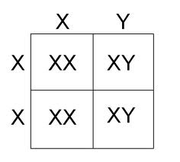2/4 XY = 50% chance of a son

- The pink allele will increase in frequency as pink Babbits will have better survival rates (camouflaged).

- The elongated neck allele will increase in frequency as longer necks allow for better survival rates (can eat taller plants).
- They will die out due to being easy and slow moving prey

- Mutations are random events that may be beneficial, detrimental or be neutral in their effect. Mutations must occur to increase the variation within the population before a change in environment. Natural selection is a guided process that chooses which variations survive. There is no variation in the green Boths so they will die out.

PHYSICS ANSWERS

- Both are a measure of quickness. Velocity is a vector dependent on displacement. Speed is a scalar dependent on distance.

- Average speed = 25ms⁻¹. Average velocity = 0

- 3.21 s

- 72000 m

- a) 22.4 m b) 1.6 ms⁻¹

- 0

- 53.5 km or 53,500 m

- 4.4 ms⁻²

- 21 ms⁻¹

- 90 ms⁻¹

- 6.9 ms⁻¹

- 0.23 ms⁻¹ down

- a) Newton’s First Law of Motion states that: a body will not change its state of rest or motion unless acted on by a net external force. This law is also known as the law of inertia.
Newton’s Second Law of Motion states that the rate of acceleration is proportional to the force supplied and inversely proportional to the mass of the object.
Newton’s Third Law of Motion states that for every force applied (action), an equal and opposite force always appears (reaction), even if no movement results.

b) depends how it makes sense to you!

- 4920 N

- 100 kg

- 363 N

- 588 N

- a) 14.7 ms⁻¹ b) 22.1 m

- 157 J. The same for each W = ∆E = mgh

- 11.8 m

- 14,100 J

- 2,330 J

- 5.10 m

- 110 ms⁻¹

- 20,000 J

- 980 J

- 45.9 m

- The energy will be transferred from the first bob through each of the bobs to the last one. As no energy is lost, the last bob should begin moving with a speed of 0.74 ms⁻¹.

- a) when v= 5 kmh⁻¹, E_{k} = 0.0965 J
when v= 0 kmh⁻¹, E_{k} = 0 J
b) when v= 5 kmh⁻¹, E_{p} = 1.94 J
when v= 0 kmh⁻¹, E_{p} = 2.04 J

- Half way up to maximum height

