RULES FOR USING AN INCLINED HEAD MICROSCOPE

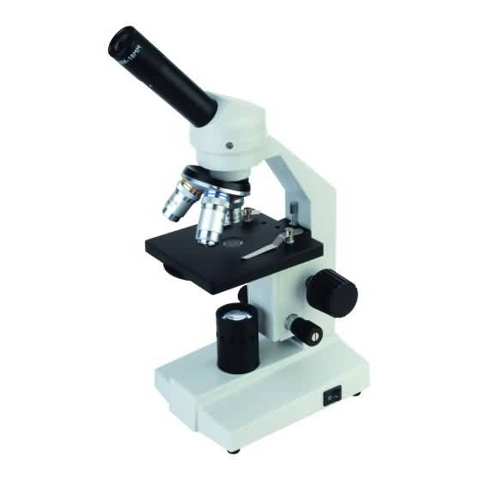
- Always carry a microscope upright, using two hands - one on the arm and one under the base.
base
barrel
arm

- Place the microscope carefully on a flat surface.

- If they are dirty, clean the lenses with lens tissue.
Do not touch them with fingers or allow them to get wet.

- Rotate the revolving nosepiece so that the low power objective is above the condenser lens in the centre of the stage.


- Turn on the power so that a strong beam of light comes up the barrel. (If your microscope has a diaphragm under the stage, this can be used to help regulate the amount of light passing through the object being viewed on the stage.

- Use one eye to look down the microscope’s eyepiece, but try to keep both eyes open.

- Keep the stage of the microscope dry, clean and horizontal.

- Always place an object on a slide in a drop of water and cover it with a cover slip before putting it on the microscope stage.
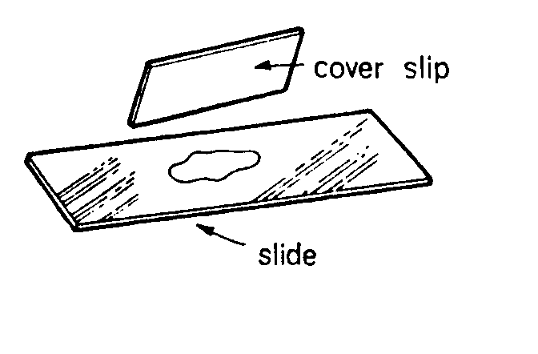

- As you place the slide on the stage, centre the object you want to examine over the centre of the condenser lens.

- To focus, while looking from the side and with the low power objective lens over the condenser lens, raise the stage as far as it will go using the coarse focus adjustment knob. Never use force – it will destroy the focussing mechanism of the microscope. Then look through the eyepiece.

- Focus an image by gently moving the stage downwards away from the objective lens.

- To increase the focussing power of the microscope, first position the object on the slide that you want to see over the middle of the condenser lens. Make sure you have focus on low power, then, without touching the focus knobs, rotate the higher power objective so that it clicks into position over the centre of the condenser lens. Check the focus – the new focus should be obtained by using the fine focus adjustment knob.

Be careful!!


