Yr 9 Science Energy

Waves
1. Label the following transverse waves using the following terms:

Amplitude wavelength crest trough low frequency high frequency

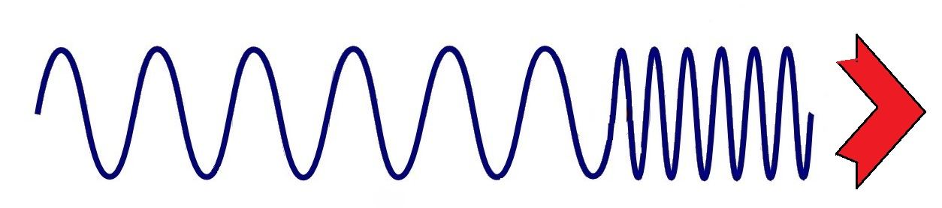
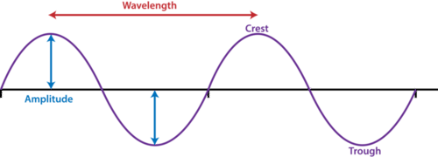
E

F

D

C

A

B

2. Label the following longitudinal wave using the following terms:

Compression rarefaction
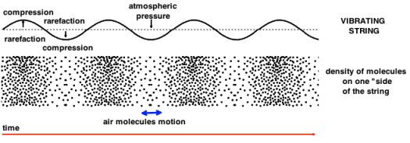

3. Define longitudinal wave.

4. Label which of the two waves depicted in the diagram below is the original and which is the reflected wave.

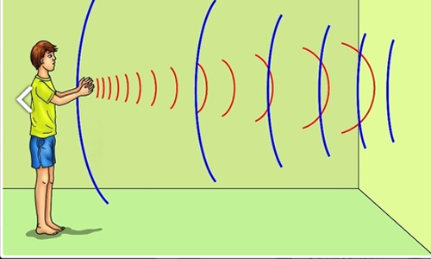

5. Given that sound travels at 343m/s at 20ºC, if you are standing 850m away from a wall, how long will it take before you can hear an echo? Show calculations.

6. What does SONAR stand for? How does it work?

