Physical Sciences - Electricity

Voltage is an electrical potential difference. The greater the difference the greater the voltage. It is the amount of work (J) done on one Coulomb of charge. If you think about a 1.5V electric cell, when you connect the two ends of the cell a Coulomb flows from one end to the other with 1.5J of work. 1.5V = 1.5J/C. the amount of work done on one Coulomb is known as volt.
Like the water level, when there’s a build-up of electric change on one side of the conductor, there’s a tendency for electrons to flow to the other end until there’s no difference.
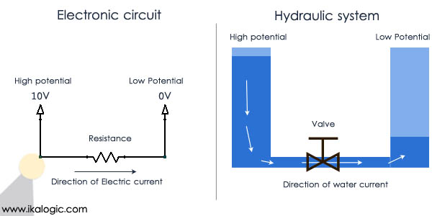

Voltage could be thought of as a force of pushing electrons through a conductor. The greater the voltage, the greater the force pushing electrons along the conductor.

Current is the rate of electron transfer across a conductor. The greater the current the greater the number of charges passing through a wire or conductor. It is the amount of Coulombs that travels through a conductor in one second. I = C/second. 1C/second is equal to 1 Ampere.

Resistance is the ability of a substance to resist flow of electrons.
Resistance of a material depends on:
- Diameter of wire – the thinner the wire the greater the resistance.
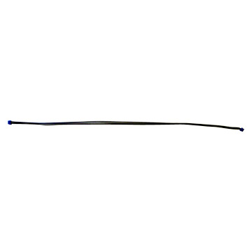
High resistance Low resistance

- Length of wire – the longer the wire, the greater the resistance.

- Nature of material – insulators are great resistors while metals are poor resistors.
When resistors are in a series circuit voltage is shared amongst all resistors, hence it is lowered across each resistor.
In this diagram electrons have to go through both globes, so there is double the resistance for electrons to flow. That means globes have to share the voltage.
Question:
What would be the voltage across each globe if you were to insert three globes in series?
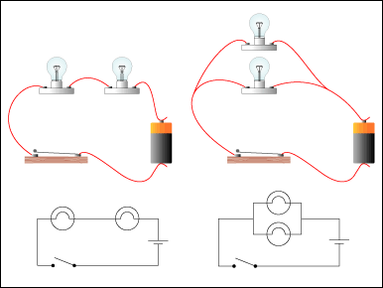

1.5v
1.5v
3v

When resistors are n a parallel circuit voltage is kept the same across all globes. However, current is increased because resistance is lowered.

3v
In this diagram electrons can go through the first loop and the second loop as well. So there is more than one pathway for electrons to flow. That means there is less resistance.
Question:
What would be the voltage across each globe if you inserted 6 globes in parallel?

3v
3v

