Yr 12 Human Biological Sciences

Endocrine system

- Match the following terms to the appropriate statements.

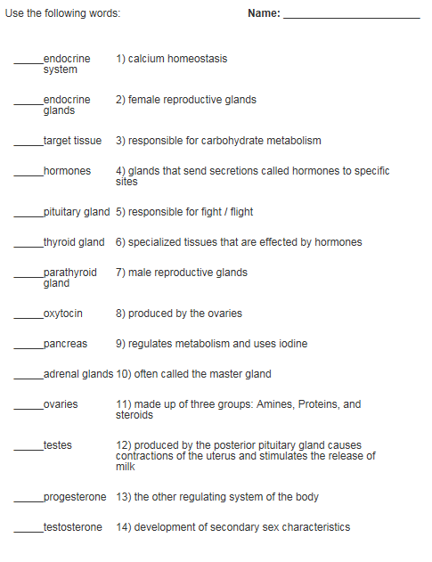
- Label the following diagram and describe the function of each hormone on the target organ.

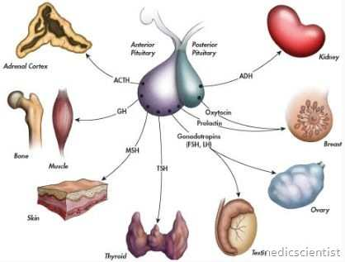
A
B
C
D
E
F
G

 | Name of hormone | Target organ/tissue | Function
A
B
C
D
E
F
G
3. Using labelled diagrams, show how protein hormones differ from steroid hormones in their function.

Protein hormone Steroid hormone

4. Identify four hormones that are not controlled by the pituitary gland and describe their role.

 | Hormone | Function
1
2
3
4

