YEAR 9 WORKSHEET – METABOLISM and ENZYMES

1. Define an enzyme

2. Name the enzyme responsible for digesting:

a) Protein -

b) lipids/fats -

c) carbohydrates -

6. Define a catabolic reaction and give an example.

3. Why only a small number of enzymes is needed to catalyse a chemical reaction?

5. Label parts A-F in the following diagram.

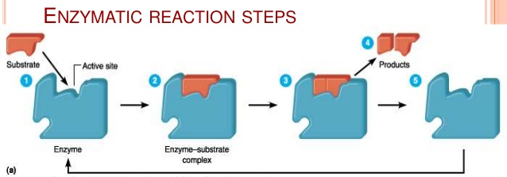
a
d
e
f
b
c

A D

B E

C F

Rate of enzymatic reaction

1. List FOUR factors that affect the rate of enzymatic reactions.

2. By adding more substrates to an enzyme, the rate of chemical reaction increases; however, when more substrate is added the reaction does not increase anymore. Explain why this is so.

3. Explain the message behind this diagram.
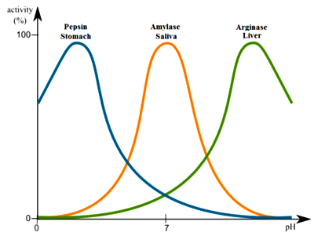

4. Label the parts A to D in the opposite diagram.

A: C:

B: D:

5. How can an enzyme speed up the rate of a chemical reaction?
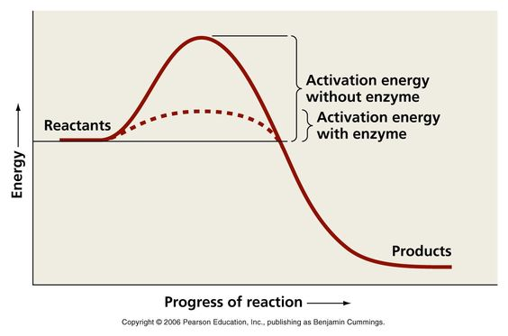

A
C
D

B

5. Amylase was heated to 120ºC and then starch was added to it. Explain why starch did not break up into glucose molecules by amylase.

