Year 10 Physical Science Week 3 and 4

Forces and Newton’s 1st Law of Motion
Objectives:
- Recall that a force is any push or pull that can change or tries to change an objects state of rest or straight line motion.
- Understand the concept of inertia.
- Define Newton’s First Law of Motion.
- Use Newton’s First Law of Motion to describe/predict observable events

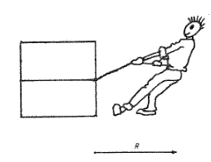
A force is a push or pull on an object that can cause motion of an object at rest. Motion will occur if forces on the object at rest are unbalanced (as shown in the diagram on the right). Unbalanced means that one force is greater than the opposing force. If the forces acting on an object are balanced (equal and opposite; as shown in the diagram below) then the object will either be stationary or moving at a constant speed.

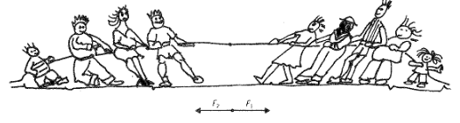
Find the resultant force in the following situations

Example 1

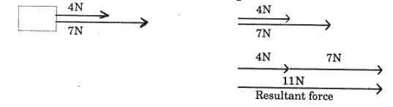
Example 2
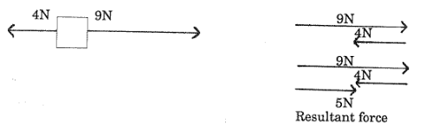
Inertia is a property of an object that resists change in movement. Mass and inertia are closely related. The more mass something has, the harder it is to change its movement so the more inertia it has. In fact, if one object has twice the mass of another object, it also has twice the amount of inertia.

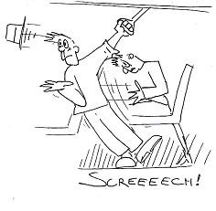
Newton’s First Law of Motion states that: a body will not change its state of rest or motion unless acted on by a net external force. This law is also known as the law of inertia.

Example 3

When a passenger is standing on a moving bus, they are moving at the speed of the bus. When the bus stops, unless a net external force is acting on them (seat or hand hold) they will continue to move forward and can fall over when they lose balance.

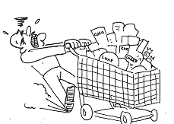
Example 4

A shopping trolley has a large inertia (large mass) so a large resistance to a change of motion. When it is moving it wants to keep moving so it is much harder to stop and you need to apply a large net external force acting in the opposite direction in order to stop it.

Questions

- Explain how the following situations illustrate Newton’s First Law.

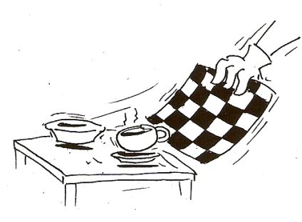
  - Pulling a tablecloth out from under china:

The china wants to stay where it is due to having inertia. When the cloth is pulled quickly horizontally, the frictional force between the china and the cloth is small and does not affect the motion of the china. As a result, minimal external force is acted on the china so it remains on the table.

  - Trying to push a car:
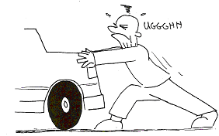
The car has a large mass and therefore a lot of inertia. A large force is required to overcome the static friction in order to move the car. Since the force is not large enough the car remains at rest.

- The law of inertia states that no force is required to maintain motion. So why do you have to keep pedalling your bicycle to maintain motion when riding somewhere?

You have to keep pedalling your bicycle because the force of friction from the ground and air resistance is acting as an unbalanced force on the bicycle. So to enable a constant speed, a driving force needs to be applied that equals these frictional forces.

- In the cabin of a jetliner that cruises at 600 kmh⁻¹, a pillow drops from an overhead rack to your lap below. Since the jetliner is moving so fast, why doesn’t the pillow slam into the rear of the jet?

The pillow is moving with an initial horizontal speed of 600kmh⁻¹ along with the jetliner. Its horizontal speed does not change. The only speed that changes is the vertical speed due to the gravitational force acting on the pillow and therefore the pillow drops into your lap.

- Suppose you place a ball in the middle of the floor of an empty truck, and then accelerated the truck forward. Describe the motion of the ball relative to

  - the ground

The motion of the ball relative to the ground will remain unchanged. The frictional force between the ball and the truck is insignificant and as such the ball will remain where it originally was as per Newton’s first law of motion.

  - the truck

The ball will appear to roll backwards on the tray of the truck. In actual fact it is the truck that is accelerating forwards. Due to the minimal force of friction between the truck and the ball, no additional forces are applied to the ball and so it remains where it originally was. The only additional force being applied is the driving force applied to the truck.

Force and Newton’s 2nd Law of Motion
Objectives:
- State Newton’s Second Law of Motion
- Apply the Second Law to simple situations
- Perform calculations using: and
- Realise that weight is a force
- Calculate weight by using Newton’s Second Law of Motion
- Use equations of motions for analysing falling objects:

Newton’s Second Law of Motion states that the rate of acceleration is proportional to the force supplied and inversely proportional to the mass of the object. Or more simply,

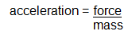
OR which is more often stated as F = ma

As acceleration is proportional to the force, this means:
Large force = large acceleration
Small force = small acceleration

As acceleration is inversely proportion to the mass of an object, this means:
Large mass = small acceleration
Small mass = large acceleration

Example 1

A rocket fired from its launching pad not only picks up speed, but also has a significant increase in its acceleration as firing continues. This is because as fuel is burnt mass is lost. As the amount of mass decreases, the acceleration of the rocket increases.

Example 2

If you use the same force to push a truck and push a car, the car will have more acceleration that the truck because the car has less mass.

Example 3

What force is required to push a 1000 kg car with an acceleration of 1.5 ms⁻²?

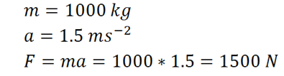

Example 4

What acceleration can be achieved by pulling a 20 kg cart with a force of 45 N?

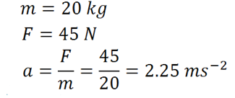

We already know that mass, the amount of matter an object has, can’t be changed unless matter is added or removed. What can be changed is the weight. Weight is the mass of a body acted on by acceleration due to gravity. Weight is therefore a force.

as F = ma where F_{weight} = weight (N)
and g = a F = force in Newtons (N)
then F_{weight} or F_{w} = mg m = mass in kilograms (kg)
g = acceleration due to gravity (m s⁻²)
Example 5

A 10 kg stone is held on the Earth (g = 9.8 m s⁻²) and the moon (g = 1.6 m s⁻²).
What is its weight on each?

F_{w} Earth = mg F_{m} Moon = mg
= 10 x 9.8 = 10 x 1.6
F_{w} Earth = 98 N F_{w} Moon = 16 N

Consider the situation when a ball is thrown into the air and then returns to the same height from which it is thrown.

Using direction to show vector Using positive and negative numbers to show direction, down is negative

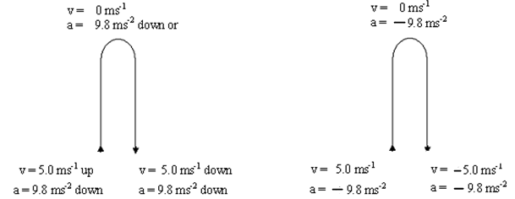

Neglecting air resistance, all objects fall at the same rate, regardless of their mass. This was clearly demonstrated on one of the moon landings when a feather and a rock were dropped and landed on the surface at the same time. The motion of the objects was only affected by gravity – which is constant. On Earth the acceleration due to gravity is approximately 9.8 ms⁻².

As acceleration due to gravity is a uniform acceleration, we can use Newton’s equations of motion in solving problems. Instead of using ‘a’, we can use ‘g’ to represent acceleration due to gravity in equations. In addition, direction now becomes important (for up and down problems) and must be specified. In the examples below up is positive and down is negative.

Example 6

Two children are dropping stones from a bridge to the water below to try and hit the leaves floating by. If one child holds a stone 15.0 m above the water, calculate
- how long before the stone hits the water. b. the final velocity of the stone just as it hits the water.

u = 0 ms⁻¹ s = ut + ½ at² v = u + at
s = -15 m -15 = 0 + (0.5 x -9.8 x t²) = 0 + (-9.8 x 1.7496)
a = -9.8 ms⁻² -15 = -4.9 t² v = -17.1 m s⁻¹
v = 17.1 m s⁻¹ down
t = 1.7496
t = 1.75 s

Example 7

A girl throws a softball vertically upwards and it reaches a height of 20.4 m.
What is the velocity with which the ball leaves the girl’s hand?

u = ? v² = u² + 2as
v = 0 ms⁻¹ 0² = u² + 2 x -9.8 x 20.4
g = - 9.8 ms⁻² 0 = u² -399.84
s = 20.4 m u = $\sqrt{399.84}$
u = 20.0 m s⁻¹ up

Find the time taken to reach the greatest height.

v = 0 m s-1 v = u + at
u = 20.0 m s-1 0 = 20 + -9.8 t
a = -9.8 m s-2 9.8 t = 20
t = ? t = 20
9.8
t = 2.04 s

Questions

- Explain how the following situations illustrate Newton’s Second Law.

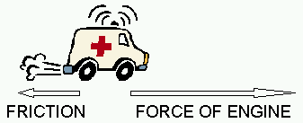

The force of the ambulance’s engine is greater than the force of friction and so an unbalanced force acts in the direction of the force of the engine which accelerates the ambulance. This demonstrates that acceleration is directly proportional to force.

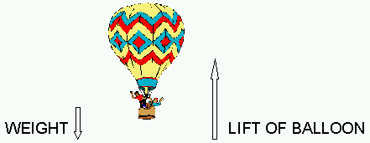

The lift force of the balloon’s is greater than its weight force and so an unbalanced force acts in the direction of the lift force which accelerates the balloon upwards. This demonstrates that acceleration is directly proportional to force.

- A force of 12.0 N is applied to a trolley at rest with a mass of 1.50 kg. After period of time the trolley has a velocity of 34.0 ms⁻¹. Calculate:

  - the acceleration of the trolley.
F = 12N
u = 0 ms⁻¹
m = 1.5 kg
v = 34 ms⁻¹
F = ma
12 = 1.5 a
a = 12/1.5 = 8.00 ms⁻² in the direction of motion

  - the time taken for the trolley to reach the velocity of 34.0 m s⁻¹.
u = 0 ms⁻¹
v = 34 ms⁻¹
a = 8 ms⁻²
v = u + at
34 = 0 + 8t
t = 34/8 = 4.25 s

- Rodney the Rodent applied a force of constant magnitude to push a 0.50 kg block of cheese across a smooth flat table top. The cheese accelerated from rest to a speed of 0.30 m s⁻¹ in a time of 20 seconds. Calculate the magnitude of the force that Rodney applied to the cheese.
m = 0.5 kg
u = 0 ms⁻¹
v = 0.3 ms⁻¹
t = 20 s
a = (v-u)/t
= (0.3-0)/20
= 0.015 ms⁻²
F = ma
= 0.5 x 0.015
= 0.0075 = 7.50 x 10⁻³ N

- Consider a fully outfitted astronaut who has a combined mass of 1.51 x 10² kg. If she were to travel to the moon where the acceleration due to gravity is 1.67 m s⁻², how would her:

  - Mass change?

Mass would remain the same on both the Earth and the moon

  - Weight change? (Include a calculation)

Her weight would decrease
On Earth F = mg On the Moon F = mg
F = 151 x 9.8 = 151 x 1.67
= 1.48 x 10³ N down = 252 N down

- Oren is helping his Dad clean the gutters for winter. He is holding a 155 g ball that was thrown up onto the roof earlier and drops it to the ground 4.20 m below.
  - What was the final velocity of the ball as it hit the ground?
Down is negative
m = 0.155 kg
u = 0 ms⁻¹
s = - 4.20 m
a = -9.8 ms⁻²
v² = u² + 2as
= 0 + (2 x -9.8 x -4.20)
= 82.32
v = ±9.07 ms⁻¹
= 9.07 ms⁻¹ down

  - How long did it take for the ball to reach the ground?
m = 0.155 kg
u = 0 ms⁻¹
s = - 4.20 m
a = -9.8 ms⁻²
v = -9.07 ms⁻¹
v = u + at
-9.07 = 0 + -9.8t
t = -9.07/-9.8
= 0.926 s

- A scientific research hot air balloon launched from Northam moved vertically upwards with an average velocity of 4.00 m s⁻¹. Unfortunately after only 5.00 mins an important piece of equipment fell out of a gap in the basket and fell towards the ground. (Assume no air resistance.)

  - How high above the ground was the balloon when the equipment fell out?

v_{av} = s/t
v_{av} = 4 ms⁻¹
t = 5 mins
= 300 s
4 = s/300
s = 4 x 300
= 1.20 x 10³ m above the ground

  - At what speed will the equipment impact the ground?

Down is negative
v² = u² + 2as
u = 4 ms⁻¹
s = -1200 m
a = -9.8 ms⁻²
= 4² + (2 x -9.8 x -1200)
= 16 + 23520
= 23536
v = ± 153.41 ms⁻¹
= 153 ms⁻¹ down

  - How long does it take for the equipment to reach the ground?
u = 4 ms⁻¹
s = -1200 m
a = -9.8 ms⁻²
v = u + at
-153 = 4 + -9.8t
-157 = -9.8t
t = -157/-9.8
= 16.1 s
Force and Newton’s 3rd Law of Motion
Objectives:
- State Newton’s Third Law of Motion
- Apply the Third Law to simple situations
- Appreciate that forces never occur in isolation
- Appreciate that the pair of forces acts on different objects
- Apply the Third Law to car collisions and the secondary collisions of the passengers.

Newton’s Third Law of Motion states that for every force applied (action), an equal and opposite force always appears (reaction), even if no movement results.

The most important aspect of Newton’s Third Law is to be aware of the fact that there are TWO different forces acting. While the value is identical, the directions are reverse so they are different forces. The forces act on different objects, NEVER on the same one, so the forces can’t cancel each other out.

e.g. body A exerts a force on B – ACTION
body B exerts a force on A – REACTION

Example: Kicking a ball: A common misunderstanding of Newton’s Third Law – if I kick a ball, the ball can’t move as action/reaction forces are the same. But if the ball is kicked it accelerates. Does this contradict Newton’s Third Law? No!

The only force on the ball is the kick, so it can accelerate, the reaction force acts on your foot and slows it down – that is the force from the ball on your foot.
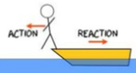
Example 1

When you jump off a small rowing boat into water you will push yourself forward towards the water. The same force you used to push forwards will make the boat move backwards.
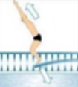
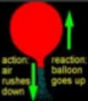
Example 2

When air rushes out of a balloon, the opposite reaction is that the balloon flies up.

Example 3

When you dive off a diving board you push down on the springboard. The board springs back and forces you into the air.

Questions

- Toby has taken up rifle shooting. Before firing the rifle, Toby places the butt plate of the rifle against his shoulder for support. He fires the rifle and it jerks back into his shoulder causing a bruise. By naming and using physics principles, explain why this happens.

Newton’s 3rd law states that for every action there is an equal and opposite reaction. The action force that cause the bullet to be fired from the gun equals the reaction force of the gun pushing backwards into Toby’s shoulder. Whilst the magnitude of the forces are equal and they are opposite in direction, the forces themselves act on different objects which creates motion.

- If a large Mack truck and a small Volkswagen car have a head-on collision, which vehicle will experience the greater impact force? Explain your answer.

Newton’s 3rd law states that for every action there is an equal and opposite reaction. The magnitude of the force of the Mack truck on the Volkswagen will be the same as the magnitude of the force of the Volkswagen on the Mack truck. However, due to the Mack truck having a much greater mass than the Volkswagen, its inertia will be greater and therefore its momentum will also be greater. Therefore, the impact force will be the same on both but the Volkswagen is likely to experience greater damage and an acceleration in the opposite direction to its initial motion.

- Draw the Action and Reaction arrows in the diagram showing the moment when the fire hose is first turned on.
Action – water pushing forwards out of the hose


Reaction – hose recoiling backwards in fireman’s hands

