Year 10 Earth and Space Science Week 2 and 3

Questions:

  - In your own words, briefly explain how our solar system was formed.

- solar system began formation approx. 4.6 billion years ago as a nebula
- nebula compressed in on itself
- Intense pressure caused nuclear fusion
- 99% of gas and dust made Sun
- Left over bits clumped together due to gravity.
- Collision of clumps led to planets and dwarf planets being formed.

  - Explain why our Sun will not become a black hole. Use a flow diagram to assist your explanation.

Our sun does not have enough mass to become a black hole – black holes require 3 Solar Masses and the stars that produce them need to start with greater than 8 solar masses

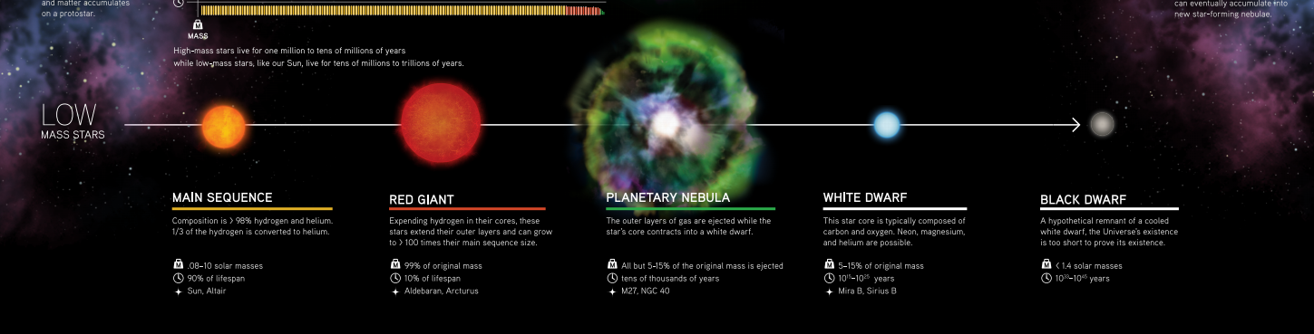

  - What is nuclear fusion and why is it important to human life?

Nuclear Fusion is the process where the collision of two small nuclei produce a larger nuclei and energy.
The process is vital to all food chains on earth as it provides energy to producers (plants) which start all food chains and food webs (including)

  - What is the ozone layer and how does it protect us?

The ozone layer is comprised of 3 oxygen atoms (O3) that is chemically bonded. The ozone layer in our atmosphere absorbs harmful UV radiation which prevents it from reaching Earth.

  - Despite our atmosphere, some UV radiation makes it to Earth. What are some of the negative consequences of too much UV exposure?

- Eye damage
- Sunburn
- Aging skin
- Skin Cancer

  - How can we protect ourselves from too much UV exposure?
- Slip – On a shirt
- Slop – On some sunscreen
- Slap – On a hat
- Seek – Adequate Shade
- Slide – Slide on some Sunglasses

