Year 9 Science Maintaining Balance Worksheet - Disease and Immune system
Q1. Define disease: An abnormal condition whereby the body is not functioning normally.

Q2. Define a pathogen: A disease causing organism

Q3. List FOUR different types of pathogens: bacteria, fungus, virus, protists.

Q4. Write a brief description under each heading relating to disease.

DISEASE

Infectious –

Diseases that can transmitted from one person to another.

Non-infectious –
Disease that cannot be transmitted to another person.

Contagious
A disease that can be transmitted by direct contact with an infected person or with an item touched by the infected person; e.g. measles, gonorrhea

Non-contagious

A disease that can be transmitted indirectly by sharing needles, using vectors such as mosquitoes, and sexual intercourse; e.g. AIDS; malaria.

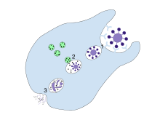

Q5. Classify the following diseases as contagious, non-contagious or non-infectious.
Gonorrhoea (STI) measles arthritis malaria Cancer AIDS diabetes stroke chicken pox flu

Contagious | Non-contagious | Non-infectious
Gonorrhoea  Measles  Flu  Chickenpox | AIDS  Malaria | Cancer  Stroke  Diabetes  Arthritis

Q6. Outline the different types of modes of transmission and include an example of each.
Method of disease transmission | Example
V__ector __ __ __ __ | Malaria
D __ roplets__ __ __ __ __ __ | Influenza
F __ood __ __ __ | Salmonella
W __ ater__ __ __ | Cholera
P __erson to person __ __ __ __ __ __ __ __ | Measles

Q7. Classify the following diseases whether they are caused by virus, a bacteria or fungus.
Measles whooping cough ringworm flu mumps tetanus cholera thrush
Bacteria | Virus | Fungus
Tetanus  Cholera  Whooping cough | Flu  Mumps  Measles | Ringworm  Thrush
Q8. Describe the role of the immune system.

Q9. Identify each part of the human body responsible for providing external immunity against pathogens and describe how it protects against germs.
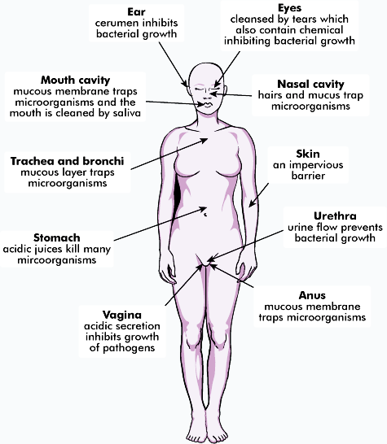
Eye – lysozyme destroys pathogens.
Ear – cerumen or wax; traps foreign particles.
Nasal cavity – mucous membranes; traps pathogens
Mucous membrane – traps pathogens.
__ Skin__ __ __ – an impervious barrier
Trachea & bronchi – cilia and mucous membranes trap pathogens.
Stomach – acid kills pathogens.
Urethra – action of flushing removes pathogens.
Vagina – acidic medium inhibits pathogens from growing.
Anus – mucous membranes taps pathogens
Q10. When pathogens enter through our skin, the second line of defence is activated. Name the cell responsible for attacking the pathogen and describe how it reaches the pathogen and how it destroys it.
Name of cell - macrophage
How it reaches the pathogen - it leaves the blood capillary and navigates through the tissue until it reaches the site where the pathogen is.
How it destroys the pathogen - the macrophage engulfs the pathogen in a process called
phagocytosis.

Q11. How does the lymphatic system clean our extracellular fluid from pathogens?
lymph nodes along the lymphatic vessels traps and destroys pathogens found in the lymph (fluid circulating in the lymph vessels). Macrophages and lymphocytes destroy the pathogen.

Q12. Pathogens that are not destroyed by the non-specific immune system, i.e. first and second line of defence are destroyed by the specific immune response.
a) Name two cells that are part of the specific immune response. B-cell and T-cell
b) What does a B-cell produce when it encounters a pathogen? antibodies
c) Describe two ways an antibody can destroy a pathogen. One way is by causing the pathogens to clump together making easier to be destroyed by macrophages. Another way is antibodies coat the pathogen and preventing it from entering the cell.

Q13. How does a T cell destroy a pathogen?
a T-cell secretes chemical called perforin which perforates (punches holes) the cell membranes of a
pathogen resulting in the death of the pathogen.

Q14. Memory cells are produced from B-cells and T-cells.
a) What role do they serve in the specific immune response?
memory cells recognise the same pathogen when it reinfects a person and they cause a quick
immune response resulting in a high and quick production of antibodies, which kills the pathogen
before the individual feels sick.
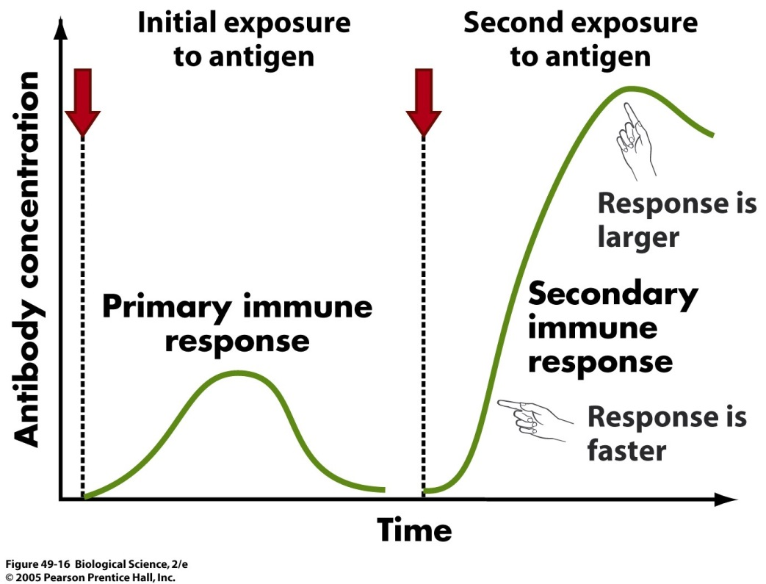
b) This diagram shows how the body’s immune system responds to a pathogen initially and how it responds to the same pathogen in a subsequent exposure. Explain the difference in the level of antibody concentration in the blood between the two exposures.
during a second immune response due to a second
exposure to the same pathogen, there is a higher
spike in antibodies over a short period of time. A higher concentration of antibodies in the blood
results in rapid destruction of pathogen.

c) Why does the level of antibodies in blood decline after it reaches a peak?
due to the elimination of the pathogen by the immune system.
Q15. Identify two ways an individual can gain natural immunity.
by breast feeding (antibodies in mother’s milk) or through the bloodstream (before birth).
or by naturally contracting the pathogen.
Q16. List two methods to provide an individual with artificial immunity.
by injecting someone with a pathogen (vaccine) so their bodies produce antibodies.
or by passively injecting them with antibodies to fight infection.
Q17. What is vaccination and how it works?
vaccination is the introduction of a weakened pathogen into the tissue of the individual so the
immune system detects it and starts producing antibodies against it. Since it has been weakened it
will not harm the individual; it will only allows the body to mount a specific response so if the
idividual gets the real pathogen later, they will have a defense system in place to fight it quickly.

Q18. What is an antibiotic? When is it prescribed?
an antibiotic is a chemical designed to fight infections and in particular bacterial infections.

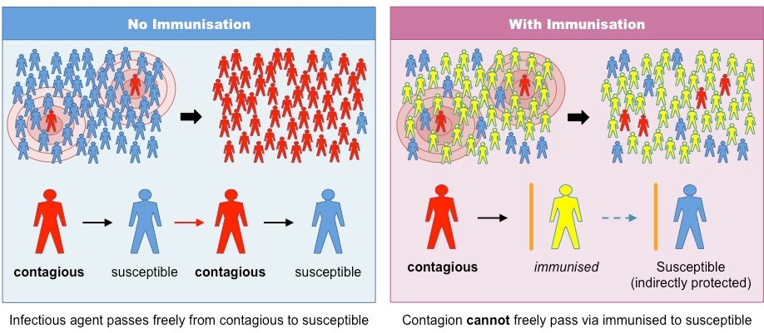
Q19. Explain what this diagram is trying to inform you.

In the left diagram a susceptible person will get infected because they don’t have immunity against
the disease. In the diagram at the right susceptible individuals are protected against infection
because of ‘herd immunity’. Since most people around them are vaccinated, they are not likely
to contract the disease because its ability to spread is reduced thanks to those immunised people
who will not pass it on to others.

Q20. A tourist wanted to go to a destination known to be a place where meningitis is common. She took a vaccine for meningococcal disease. When she went overseas she came in contact with a person with the disease but never contracted it. Explain how this is possible.
by taking the vaccine, her body developed antibodies against the bacteria. When she came in
contact with the bacteria, her body was able to launch a rapid and large response by releasing a
great amount of antibodies against that bacterium before it has a chance to infect the tourist and
cause signs and symptoms.

Q21. Describe the benefit of ‘herd immunity’.
when more than 90% of the population are vaccinated to reduce the spread of infection.

Q22. When people get injured, usually pus forms. What is pus made up of?
bacteria, macrophage (white blood cell) and cell debris.

