Year 10 Biological Sciences

Week 8 to 10 – Natural Selection and Evolution

Objectives:
Natural Selection and Evolution:
- Definition of a species.
- Understand that variation within a species gene pool is brought about by:
  - Mutations (mutations cause unexpected variations in offspring)
  - the independent assortment of chromosomes
  - crossing over during meiosis
  - Random mating
- Describe the different types of adaptations and understand that some variations bring about adaptations.
- Explain that adaptations occur over generations due to mutations in the germ line (gametes) and that only a small percentage of mutations cause advantageous adaptations.
- Describe how selection pressures select adaptations that help an organism survive in its environment and that variations in populations increase biodiversity that allow them to survive ecological changes e.g. drought, rising sea levels, salinity, climate change.
- Natural selection leads to change in characteristics of a population e.g. pesticide resistance, bird beaks, flowers and pollinators
- Be able to provide examples of evolution. e.g. antibiotic resistance, rabbits, etc.
- Speciation
- Geographical and reproductive isolation acts as barriers to gene flow.
- Artificial selection has practical application e.g. the selective breeding of animals and crops.
- Investigate changes caused by natural selection in a particular population as a result of a specified selection pressure such as artificial selection in breeding for desired characteristics.

Evidence for Evolution:
- Describe the different the following forms of evidence for evolution:
  - fossil record
  - comparative anatomy: homologous structures
  - comparative anatomy: vestigial structures
  - embryology of vertebrates
  - comparative biochemistry (DNA and proteins/amino acid sequencing)
  - geographical distribution

Natural Selection and Evolution

A species is defined as a population of organisms that normally interbreed, and produce fertile offspring.

The theory of natural selection was postulated by Charles Darwin and is described as 'survival of the fittest'. The theory postulates that organisms living today have changed over time and evolved from common ancestral organisms

Natural selection is a mechanism by which evolution is thought to occur and is based on five key factors:

- Variation between individuals exists in a population
Natural selection cannot occur without genetic variation within a population allowing for a variety of inheritable traits.

Genetic variation can occur through:
- Gene mutations: A permanent change in the DNA sequence of a gene which may alter the expression of the associated trait. These can only be inherited if occurring within the cells responsible for gamete production. Gene mutations can also be caused by heat, chemicals and radiation. Such factors are called mutagenic.
    - Gene flow: Organisms immigrating into a population bringing new alleles to the gene pool or organisms leaving a population removing alleles from the gene pool.
    - Sexual reproduction: The combining of alleles through the random fusion of gametes provides variation. Variation can also be created due to random assortment of chromosomes and crossing over in meiosis.

- Competition for survival
Not all individuals that are produced in a population survive to produce offspring. There is competition for resources between organisms in the same species and between organisms of different species

- Selection Pressures
External agents which affect the ability of an organism to survive are referred to as selection pressures. Selection pressures can be negative and decrease the occurrence of a trait, or beneficial and increase its proportion within a population

Types of selection pressures include:
- Availability of resources: sufficient food, water, habitat and mates for reproductive purposes.
- Environmental conditions: Temperature, weather conditions
- Biological factors: Predation and disease

- Survival of the Fittest
Adaptations are special features that an organism develops to help it to survive in its environment.

These adaptations may be categorised in a number of different ways:
- Structural: Physical differences in biological structure (e.g. tail and muzzle length in cats and dogs)
- Physiological: Variations in detection and responses by vital functions (e.g. colour blindness)
- Behavioural: Differences in patterns of behaviour (e.g. certain possum species feigning death when threatened)

Those individuals with more beneficial adaptations that are best suited their environment survive longer and are able to reproduce, passing on their genes. Individuals that are without these beneficial adaptations are less likely to survive and pass on their genes. This is termed “survival of the fittest”.

- Change in allele frequency
Over time, the beneficial adaptations are more likely to be passed on to subsequent generations. This will increase the proportion of the alleles responsible for the adaptation in the gene pool. This will be evident in the population as more of the individuals are likely to present with the adaptation. This is evolution.

Mechanism of Natural Selection
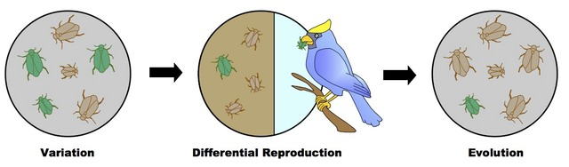

Artificial Selection/Selective Breeding

Artificial selection occurs when humans choose breeding partners for animals and other organisms to select certain traits for their offspring. An example may be breeding two varieties of budgerigar to produce offspring with desired qualities. For instance, breeding a standard grey budgerigar with excellent markings and a good head structure with an albino budgerigar is more likely to produce further albino budgerigars with the same markings and head structure as the grey budgerigar.

Evolution

Evolution is the permanent change in the frequency of alleles in a population due to natural selection. An example of this is antibiotic resistant bacteria. Some bacteria have evolved via natural selection, through random mutation, to obtain resistance to antibiotics. Those bacteria which have a mutation allowing them to survive will live on to reproduce. They will then pass this trait to their offspring, which will be a fully resistant generation.

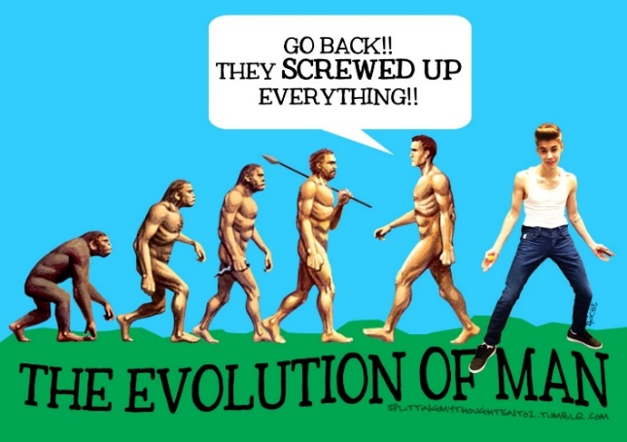
If a bacterium carries several resistance genes, it is multi-resistant and known as a ‘superbug’. This has caused a lot of issues as the ‘superbug’ is then unable to be treated with antibiotics.

As a species evolves over many generations through genetic inheritance, a new species may eventually be formed. This is known as speciation.

Speciation

A new species is considered to have been produced a new species when the changed population can no longer breed with the original population. This occurs through the following process:

- Isolation of population
A small population moves away from its parent population. Genes can no longer flow between these two populations. This can occur due to:
- Geographical isolation - This can happen when a species is physically separated into two. For example: a mainland population may be separated from a population on an island, a mountain range may rise between a population. These prevent gene flow within the population.
- Ecological isolation: Occurs when two species inhabit similar regions, but occupy different habitats.
- Temporal isolation: occurs when two species mate or flower at different times of the year. For example: different frog species live in the same pond but breed at different times.

- Mutations occur
In each population gene mutations occur at a constant and low rate. Some are beneficial and result in increasing the organism’s reproductive success. This mutation will therefore be passed on.ion will develop mutations

- Natural Selection occurs
The process of natural selection occurs to each population. Selective pressures may act on individuals in the populations. The individuals with the most beneficial adaptations will survive as they are better suited to their environment and will pass on their alleles to their offspring. Those with unfavourable adaptations with die out and their alleles will no longer be in the gene pool.

- Speciation occurs
Over time, the genetic differences between the two populations will be so great that reproductive isolation will result. The two populations will no longer be able to produce fertile offspring from reproduction. Thus a new species has formed.

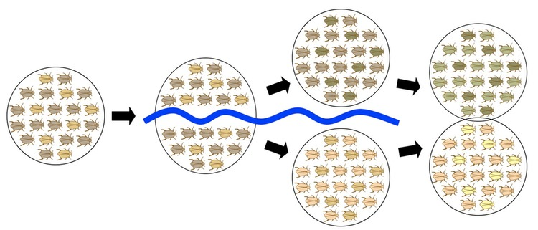

Evidence for Evolution

The theory of evolution is supported by the following forms of evidence.
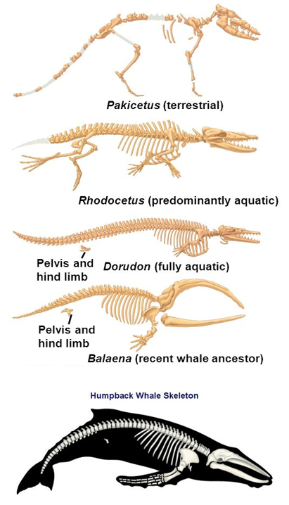
Fossil Record
- A fossil is the preserved remains or traces of an organism from the distant past
- The fossil record is a list of all of the organisms that fossil evidence has been found for.
- Fossil evidence may be either direct, such as bones and teeth, or indirect such as footprints and tooth marks.
- The fossil record reveals that, over time, changes have occurred in features of organisms living on the planet.

Comparative anatomy
- homologous structures
  - Features in the anatomy of a species that are similar to other species but perform different functions
  - These similarities are evidence that life on Earth has a common ancient ancestor that the diverse species have evolved from over time.
  - For example, the pentadactyl limb structure in vertebrates shows that many animals have a similar bone structure despite the limb being used for different forms of movement (e.g. bat - wing for flying, human - hand for manipulating tools)

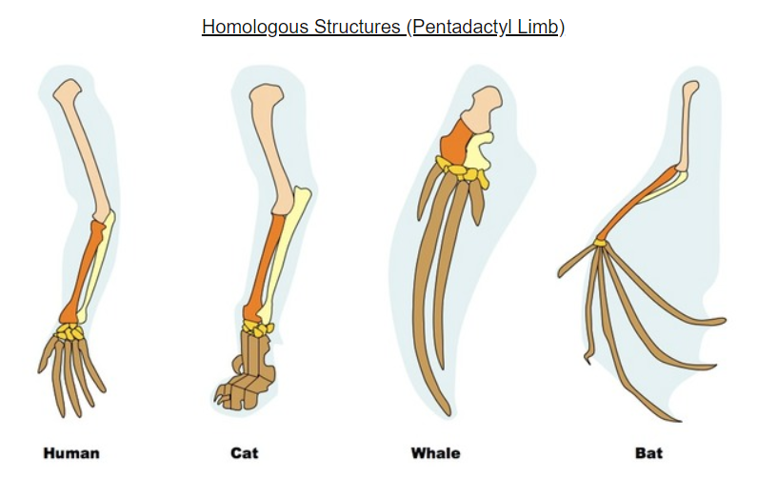

- vestigial structures
  - A structure found in a species which is not being used as it is in other species.
  - For example, Humans still have an appendix and a small tail because they evolved from species who had working versions of these organs

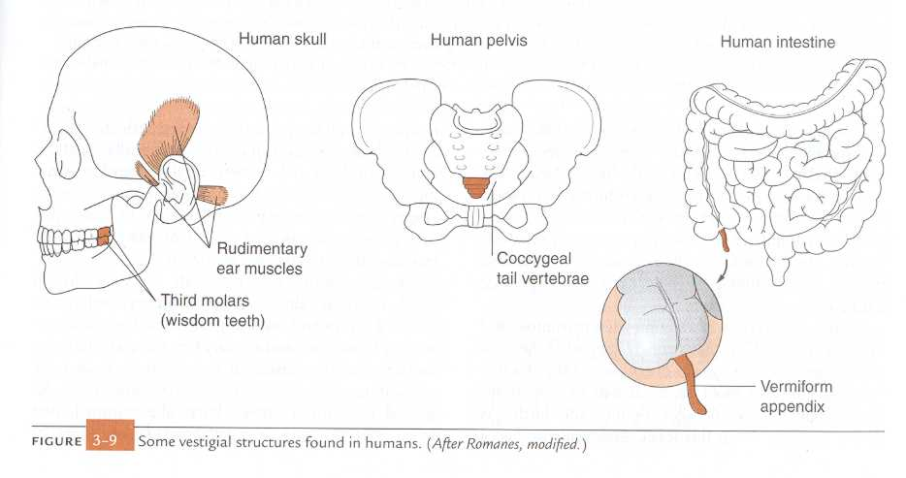

Embryology of vertebrates
- When comparing embryos in different species it was found that closely related organisms go through similar stages of development
- For example, all land animals have non-functional gill slits as early embryos which indicates they may have originated from an aquatic organism.
- Humans and many other vertebrates also have a primitive tail at certain stages of embryonic development
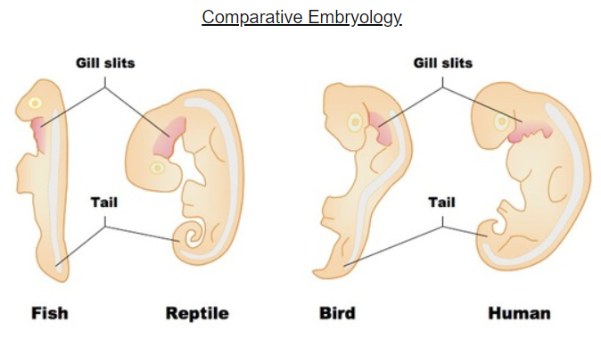

Comparative biochemistry
- DNA sequencing
  - Similar DNA sequences show that species are linked by a common ancestor.
  - Humans have 98% of the same DNA sequences as chimpanzees
- proteins/amino acid sequencing
  - All living things use the same 20 amino acids to make proteins
  - The same type of proteins in different species can be very similar.

Geographical distribution
- Closely related species are usually found in close physical proximity to one another and the fossils from these regions resemble modern organisms. This suggests that these species share a common ancestor

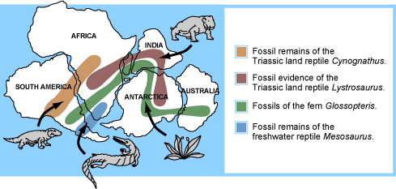

Bibliography
Mechanism of natural selection
http://www.vce.bioninja.com.au/aos-4-change-over-time/evolution/natural-selection.html
Evolution of man
https://elc.polyu.edu.hk/ecNews/1310/FromOurStudents.htm
Speciation
http://www.vce.bioninja.com.au/aos-4-change-over-time/evolution/speciation.html
Fossil Record
https://images.app.goo.gl/hZPoKqkmPCBVySsS6
Homologous structures and Comparative Embryology
http://www.vce.bioninja.com.au/aos-4-change-over-time/evolution/evidence-for-evolution.html
Vestigial organs
https://edu.glogster.com/glog/evidence-in-evolution/1wx137h41sg
Geographical distribution
http://www.geologyin.com/2017/06/geology-biology-agree-on-pangaea.html

Questions

- In the future you have two children. Your children have similar characteristics but are not identical to each other. Explain two ways that this variation between siblings may have occurred.

- What is meant by natural selection?

- For the following sequence of diagrams, explain in the boxes (b), (c) and (d) what is happening at each stage where one species has over time resulted in two species forming. The first description in box (a) has been done for you.
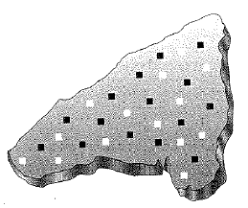 | (a)  On this island there is one species of mouse with alternative alleles for body colour. The black shaded boxes represent black fur and the white shaded boxes represent white fur.
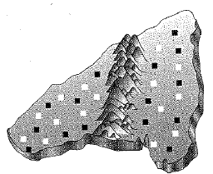 | (b)
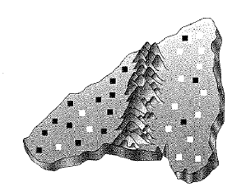 | (c)
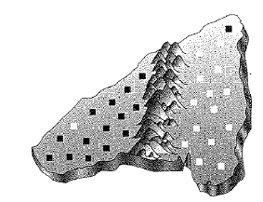 | (d)

