Elements and Compounds

- Complete the following paragraphs using the words below.

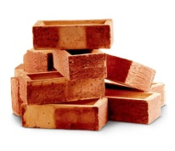
Solids stay in one place. They do not _________. Solids are often __________. The ____________ of an object is the amount of space it takes up. Solids cannot be ____________ – their volume can’t be ______________.
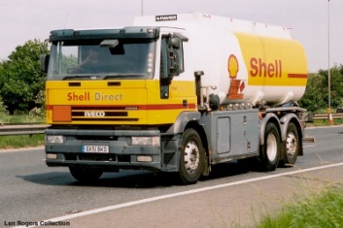
Liquids cannot be moved in a truck like solids can because they flow. Liquids are carried in ___________ and can be pumped. The _____________ of a liquid cannot be changed – liquids can’t be squashed.

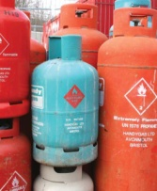
Gases are normally transported in cylinders. Gases flow very _____________ and ____________ out to ________ the container they are in. Gases __________ have a fixed volume. A gas can be squashed to fit in a smaller container. Gases are less dense than ___________ and ____________.

Word to use: changed dense don’t easily fill flow liquids solids spread squashed tankers volume

- Tick the box if the stated property applies to a solid, liquid and/or gas

Property | Solid | Liquid | Gas
It will mould its shape to its container
It will spread out on a surface
It will hold its shape unless broken
It does not flow
It can be compressed
Its particles are free to move past each other
There is lots of space between each particle
Its particles are in contact with one another
It can flow
Its particles are not in contact with one another
Its particles cannot move past each other
There is little space in-between each particle

- In diagram 1 box, draw how the particles appear in a solid. In the Explanation box, describe how the particles are behaving. Repeat this for a liquid in diagram 2 and a gas in diagram 3.

Explanation...
................................................................................................................................................................................................................................................................................................

Diagram 1

Diagram 2
Diagram 3
Explanation...
................................................................................................................................................................................................................................................................................................

Explanation...
................................................................................................................................................................................................................................................................................................

- The melting point is the temperature at which a substance changes from a

_________________ to a _______________

- The boiling point is the temperature at which a substance changes from a

_________________ to

a ________________

- Water melts at ___________°C and boils at _______________°C

- What is the physical state of water at these temperatures?

45 °C = ____________________

125 °C = ____________________

-24 °C = ____________________

75 °C = ____________________

- Label each of the 3 pictures with the correct state of matter
Label each of the arrows with the name of the change in state

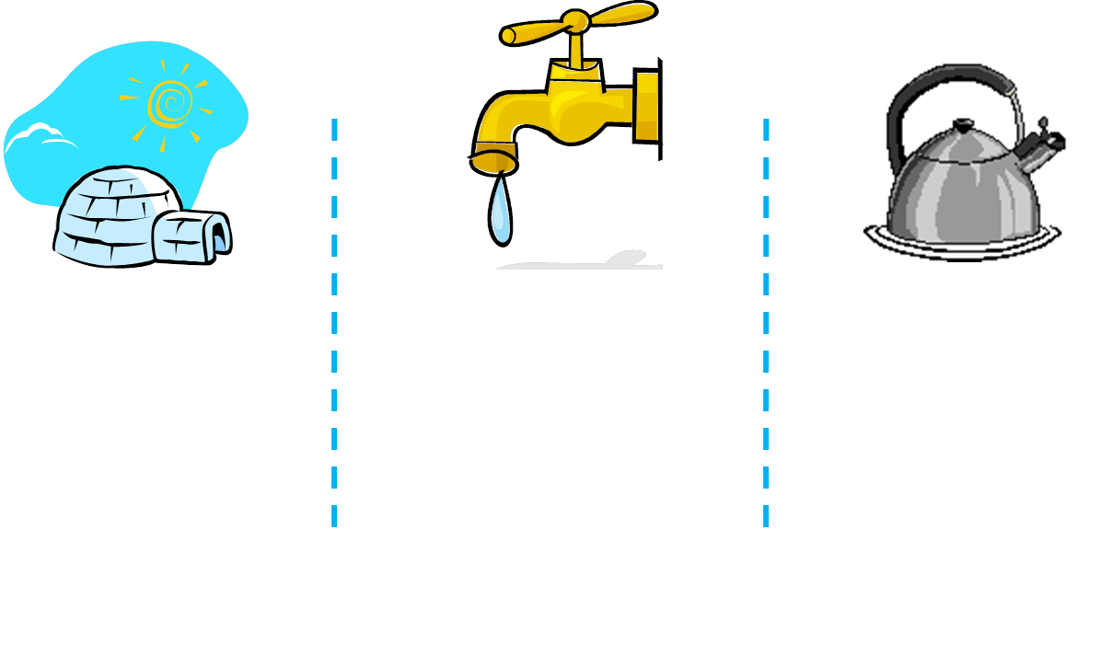
Temperature at which the change of state occurs ______°C
Temperature at which the change of state occurs ______°C
Increase in temperature

- Describe what happens to the kinetic and potential energy of the particles in a block of ice as it melts.

- Describe what happens to the kinetic and potential energy of cold water particles as the water warms up.

- Elements are found in the Periodic Table. All elements can be shown as a symbol. Complete the following table.
Name of Element | Symbol
Hydrogen
Sodium
 | Ca
 | S
 | He
Iron
Chlorine
 | Mg
Zinc
 | Au
Potassium

- Colour in or highlight the elements that are metals in the table above.

- In a different colour, colour in or highlight the elements that are nonmetals in the table above.

- Complete the following tables of properties of metals and non-metals

Property | Metal | Non-Metal
Lustre
Ductility
Malleability
Conductivity

- Complete the following paragraph about groups and periods of the Periodic Table

Elements are arranged in rows and columns in the periodic table in order of increasing atomic mass. The vertical columns are called __________ and the horizontal rows are called ___________. Li, ____ and K are in the same group while N, ____ , F are in the same period. Elements in the same groups have similar ___________ and physical properties

- Fill in the missing words in the definitions below.

Missing words: elements, different, one, joined, atom, type, two

- An element consists of ______ ______ of _______.

- A compound contains _____ or more __________ ______ joined together.

- A mixture contains two or more _________, but they are not chemically ________.

- According to our definition above, H₂O (water) is a compound. However, it is sometimes called a molecule. O₂ (oxygen gas) is also a molecule. Can you think of a way to define a molecule?

A __________ consists of _____ or more _______ chemically

________ together. These _____ can be of the same _________ or different elements.

- Using the definitions, decide whether the following diagrams represent an element, a compound, or a mixture. Explain your choice.

a) This diagram shows a(n)
C
H
H
H
H
C
H
H
H
H
C
H
H
H
H

__________________________________.

I think this because:

_______________________________________

_______________________________________

_______________________________________

b) This diagram shows a(n)
Ne
Kr
Kr
Kr
Kr
Kr
Ne
Ne
Ne
Ne
Ne
Ne
Ne
Ne
Ne
Ne

__________________________________.

I think this because:

_______________________________________

_______________________________________

_______________________________________
Xe
Xe
Xe
Xe
Xe
Xe
Xe
Xe
Xe
Xe
Xe
Xe
c) This diagram shows a(n)

__________________________________.

I think this because:
________________________________________

________________________________________

_______________________________________
S
S
S
S
S
S
S
S
S
S
S
S
S
S
S
S
S
S
S
S
S
S
S
S
S
d) This diagram shows a(n)

___________________________________.

I think this because:
_______________________________________

_______________________________________

_______________________________________

- Identify the following substances as either a mixture or a compound.

  - Carbon dioxide
  - Air
  - Water
  - Salty water
  - Soil
  - Bronze
  - Copper oxide
  - Table salt

