Energy Revision Answers
Gravitational Potential Energy:

This is the energy an object has because of its mass, height above the ground and the force of gravity.

E_{p} = m x g x h
m = mass of object (kg)
g = acceleration due to gravity( g=10 m/s² on earth)
h = height above the ground(m)

Q1. 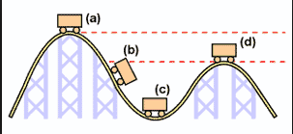

In which position will the potential energy of the rollercoaster

- be the greatest_______A______________

- be the least__________C__________

Q2. In which position will the kinetic energy of the rollercoaster

- be the greatest__________C___________

- be the least___________A_________

Q3. Explain why the rollercoaster track has to be the highest at the start of the ride.
As energy will be lost during the ride, due to friction and wind resistance creating heat, the coaster will not have enough kinetic energy at the bottom of the track to climb back to the height it started from, therefore other peaks in the track need to smaller than the first peak height.
Q4. Write down the energy transfers that occur from {a d}
{a c } _____Ep___________ ___Ek__+ heat__________
{c d } _____Ek___________ ___Ep + heat.____________
What forms of energy will the object possess at b?_____Ek + Ep______________
Q5. List two ways of increasing the potential energy of the rollercoaster.
a) higher hill
b) more mass for coaster(ie more passengers or more carriages)

Q6. Calculate the potential energy of a passenger in the rollercoaster at the
start of the ride, if the passenger has a mass of 50 kg and he is 10 m above the ground.(Extension question#)
Ep = m x g x h
= 50 x 10 x 10
= 5000 J

Kinetic Energy
Kinetic energy is the energy an object has because of it’s mass and velocity(speed).
E_{k}= ½ mv²
E_{k} = kinetic energy(J)
m= mass (kg)
v= velocity (m/s)

Q7. Calculate the kinetic energy of a 2 kg rock that has fallen off a ledge and is travelling
at 20 m/s.

Ek = ½ mv²
= 0.5 x 2 x (20)²
= 400 J
Q8.
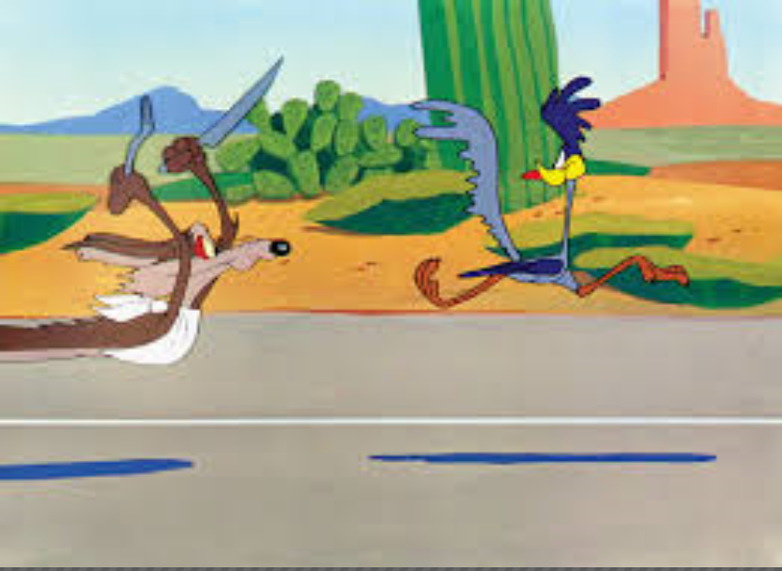
Which has more kinetic energy, the Road Runner or the Coyote?
Explain why.
The Coyote, he’s going at the same speed as the Road Runner but has a larger mass.
Energy Revision

- What is Energy?
Energy is the ability to do work
- What is another name for stored energy? Potential Energy

- There are 3 main types of stored energy:
(a) Elastic Potential Energy eg. a stretched rubber band, windup toy.
(b) Chemical Potential Energy eg. candle (wax) is burning to give out light and heat
(c) Gravitational Potential energy. Eg a bicycle on top of a hill.

- What is the unit for energy? Joule

- How many joules in a kilojoule? 1000

- Convert:
  - 6 kJ to J_____6000 J
  - 40 kJ to J__40,000 J
  - 0.04 kJ to J__400 J
Convert
  - 30,000 J to kJ____30 kJ
  - 400 J to kJ___0.4 kJ

- How many joules in a mega joule?

1000,000 J
- Convert:
  - 3 MJ to J__3000,000 J
  - 16 MJ to J 16,000,000 J

- How many kilojoules in a mega joule?
1000 kJ
- Convert:
  - 12 MJ to kJ___12,000 kJ
  - 20 MJ to kJ 20,000 kJ
  - 14 000 kJ to MJ____14 MJ
  - 7000 kJ to MJ___7 MJ
Efficiency

Efficiency = Useful Energy Output x 100
Energy Input

11 (a) Calculate the efficiency of a torch that uses 600 J of chemical potential energy to produce 40 J of light energy.

Efficiency = Useful Energy Output x 100
Energy Input

= (40/600) x 100
= 6.67 %

(b) How much wasted energy is produced? Wasted energy = 600-40
= 560 J

(c) What is the main form of wasted energy produced? Heat

12. If a petrol engine of a car is 25 %, how much kinetic energy will it produce when it uses
a litre of fuel that contains 20 MJ of energy.

Useful Energy = (25/100) x 20 MJ
= 5 MJ

Energy Transformations

13. State the changing energy:
a) flashlight’s batteries
C __ __ __ __ __ __ __ energy
L __ __ __ __ energy
H __ __ __ energy

) b) talking on the phone
H __ __ __ __ energy
S __ __ __ __ energy
E __ __ __ __ __ __ __ __ __ energy

c) green plants undergo photosynthesis

S __ __ __ __ energy
C __ __ __ __ __ __ __ energy

d) Eating high energy food and drink, so that you can run faster.

