Yr 9 Science Light – Eye structure and function
1a Label the following structures of the eye.

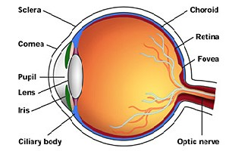
^{j}
ª
^{i}
^{b}

^{h}
^{c}

^{d}

^{e}

^{g}
^{f}

1b State the function of the following structures.

2. Match the following terms with their appropriate function by placing the appropriate letter next to each statement.

A | Lens | Transmit nerve message from the retina to the brain.
B | Sclera | Crystalline structure that converges light on the retina.
C | Optic nerve | Transparent membrane that bends light as it enters the pupil.
D | Vitreous humour | Tough protective membrane of the eye.
E | Iris | A thin membrane that houses photoreceptors where the image is focused on.
F | Ciliary body | Jelly-like fluid that gives the eyeball its shape.
G | Cornea | A muscle that changes the shape of the lens to help in focusing an image on the retina.
H | Retina | Pigmented layer that regulates the amount of light entering the eye.

