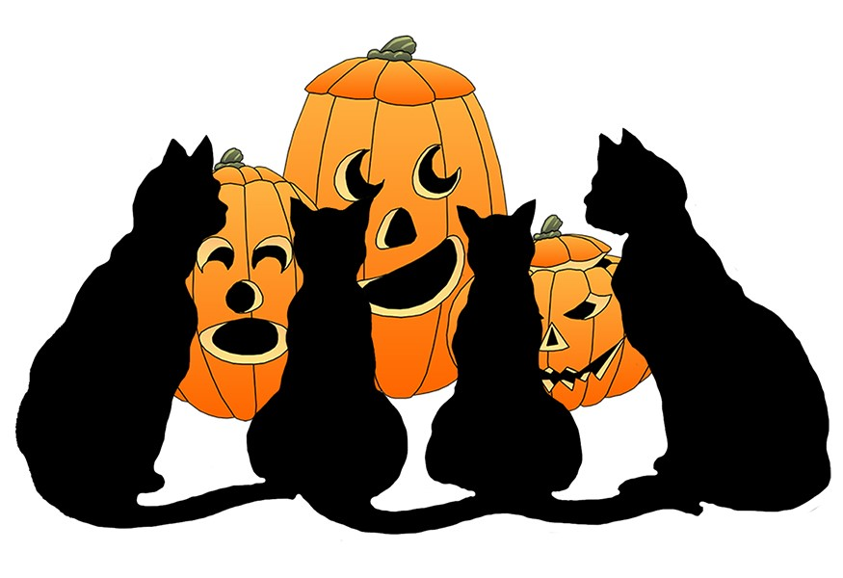
Competition Rules for the Halloween Flash Fiction House Competition
1. An entrant must be a current student in any year group at Rossmoyne SHS. One entry per student only.
2. The flash fiction must be the student’s own, original work. (There are consequences for plagiarism).
3. The student’s story must be no more than two correctly punctuated, grammatical sentences long. Entries that do not conform to this requirement may not be considered.
4. Flash fiction stories must incorporate ideas related to Halloween and address the iCARE theme of “Integrity” in an appropriate way.
5. The submitted story document must contain the student’s first and last name, year group and home room. Preferred names are acceptable.
6. Entries must be received on Moodle by Wednesday, 31st October 2018 at 4pm. Late entries will not be accepted. Students must enrol in the Rossmoyne English Competitions course page to be eligible for entry.
7. Entries must be submitted as a Word document or PDF. Other document formats cannot be accepted.
8. Students will receive house points for their valid competition entries. The winning house will be the house that earns the most points. The winning house will be revealed in the Daily Notices.
9. Judges will select year group winners and/or house winners dependent upon quality of entries.
10. Winning students will be announced in the Daily Notices and on the Moodle Competitions page, and will receive house points and a certificate acknowledging their achievement.

