Biological Science Mid Topic Test Revision Sheet

Name: ________________________________
Introduction to Microscopes

- Label the microscope below
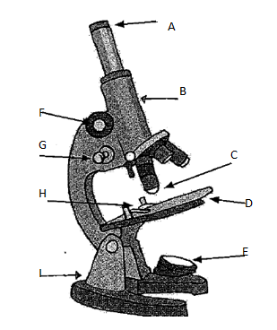
- State the function of the parts of the microscope indicated in the table below.

 | Function |  | Function
a |  | e
c |  | f
d |  | g

- Calculate the total magnification of the following lens pairings

Ocular(eye piece) (X) | Objective lens  (X) | Total magnification (X)  Ocular x objective lens
10 | 4
10 | 10
10 | 40

Viewing Cells
- Define field of view and explain how field of view varies with magnification.

- Explain the difference between unicellular and multicellular organisms.

Identifying cell organelles and describe their functions

- Complete the following table.

- Draw a plant cell include - Cell membrane, cell wall, vacuole, cytoplasm, mitochondria, chloroplast, nucleus (including chromosomes), ribosomes |  | - Draw an animal cell include - Cell membrane, small vacuoles, cytoplasm, mitochondria, nucleus (including chromosomes), ribosomes
Organelle | Function
Cytoplasm

Ribosome

Chloroplast

Mitochondria

Cell membrane
Nucleus

Vacuole

Comparing Animal, Plant and Fungal Cells

- Complete the following table of characteristics.

Characteristic ( tick present X absent) | Plant | Animal | Fungi
Cell wall (if so what is it made of)
Cell membrane
Vacuole
Cytoplasm
Mitochondria
DNA in a nucleus
Chloroplasts
Ribosomes
Usually unicellular or multicellular

Specialised Cells

- Draw the following specialised cells. Explain how each is specialised.
Nerve cell | Muscle cell | Sperm | Root hair cell | Guard cell

Mitosis

- Use two different coloured pens to draw a cell undergoing mitosis.

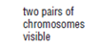 | 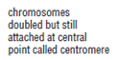 | 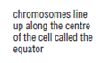 | 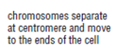 | 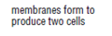

- Complete the following passage by using the words below.

repair | body | division | 2 | chromosome | DNA | growth | exact | 46

Mitosis is a type of cell _____________. It is cell division for ____________ and __________. Mitosis takes place all over the __________. In mitosis the cell replicates the ________. The cell then divides into two and a copy of each _____________moves into each cell. _________ identical daughter cells are produced. The daughter cells are _______ copies of the parent cell that divided.
Human body cells have ___________ chromosomes in their nucleus. Each daughter cell produced from a human body cell undergoing mitosis would have __________________ chromosomes in its nucleus.

Levels of Organisation
- List the following in order from simplest to most complex tissue, system, cell, organ

- Explain the difference between cells and tissues.

Body Systems
- Complete the following table by outlining the main function of each of the body systems.
Body system | Main Function
Digestive
Respiratory
Excretory
Circulatory
Reproductive
Endocrine
Musculoskeletal
Immune
Nervous

Digestive System
- Label the following structures on the digestive system diagram.
mouth | oesophagus | stomach | pancreas | Small mintestine | Large intestine

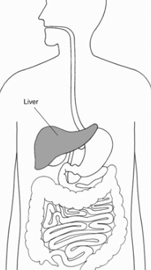
Provide the function/s of each of the followin structures of the digestive system.
mouth | 1.  2.
oesophagus
stomach | 1.  2.
panctreas
Small intestine | 1.  2.
Large intestine

