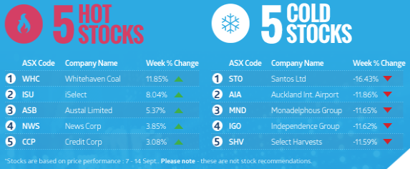
ASX SHAREMARKET GAME

4 Weeks in – What are the Leaders doing:
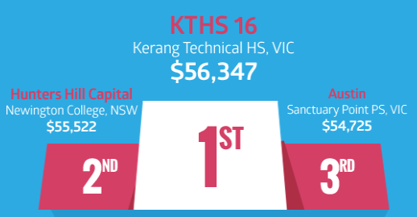

Syndicate 1: This syndicate has traded quite a bit, buying 17 times and selling 11 times. They are holding 5 stocks at present including APO, PRG, SHL and two others. The majority of the time they have sold stocks to lock in profits, only selling at a loss twice. They have invested in most sectors.

Syndicate 2: This syndicate has not been quite as active, buying 12 times and selling 6. At present they are holding 6 stocks including ALU, AQG, EVN, BSL and two others. They have tended to sell stocks that are not performing and have kept their winners. They have sold once to take a profit. The sectors they are invested in include consumer discretionary, consumer staples, industrials, IT, materials, financials and health care.

Syndicate 3: This syndicate has bought 13 times and sold 9 times. At present they are holding 4 stocks including ABC, NST and two others. They have sold to lock in profits, only selling two stocks at a loss. The sectors they are invested in include financials, health care, consumer discretionary, materials and utilities.

