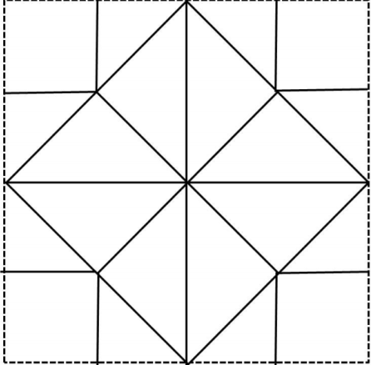
8
8a
7
7a
6a
6
5a
5
4
4a
2
2a
3a
1
3
1

Each number, X is a question with the answer found in Xa. E.g.:
1 – “What is the brightest thing in the night sky?”
1a – “The Moon”
Write the question and answer to match the orientation of the labels on the template.
Video on how to make it - https://www.teacherspayteachers.com/Product/Continental-Drift-Plate-Tectonics-Activity-Earthquakes-Faults-Hot-Spots-etc-1775909

