Yr 9 Science Sound – Ear structure and function
1a Label the following structure of the ear.
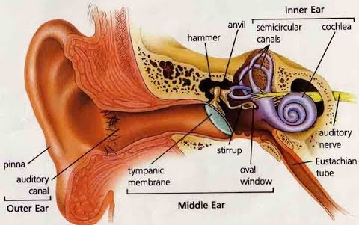
^{f}
^{d}

^{c}

^{e}
^{h}
^{g}
^{b}

ª
1b State the function of the following structures.

2. Match the following terms with their appropriate function by placing the appropriate letter next to each statement.

A | Organ or Corti | Directs sound waves into the auditory canal.
B | Malleus, incus & stapes | It equalises the pressure in the middle ear and allows tympanic membrane to function properly.
C | Pinna | Filled with fluid and contains the Organ of Corti.
D | Auditory nerve | A thin flexible membrane that separates the outer and inner ear and serves to transform sound energy into mechanical energy.
E | Cochlea | This structure contains many specialised sensory hair cells called cilia.
F | Tympanic membrane (eardrum) | Transfers auditory information from the cochlea to the brain.
G | Semi-circular canals | Filled with fluid and contains sensory hairs that detect the position of the head and allows maintenance of balance.
H | Eustachian tube | They transmit sound from the outer ear to inner ear.

