YEAR 8 REVISION – BIOLOGY 2018

CELLS AND MICROSCOPES:

Q1. On each of the cells below, label the different organelles.

Terms to use: Nucleus, Mitochondria, Cell Membrane, Cell Wall, Ribosomes, Cytoplasm, Endoplasmic reticulum, Golgi body, Vacuole, Chloroplast

(a)
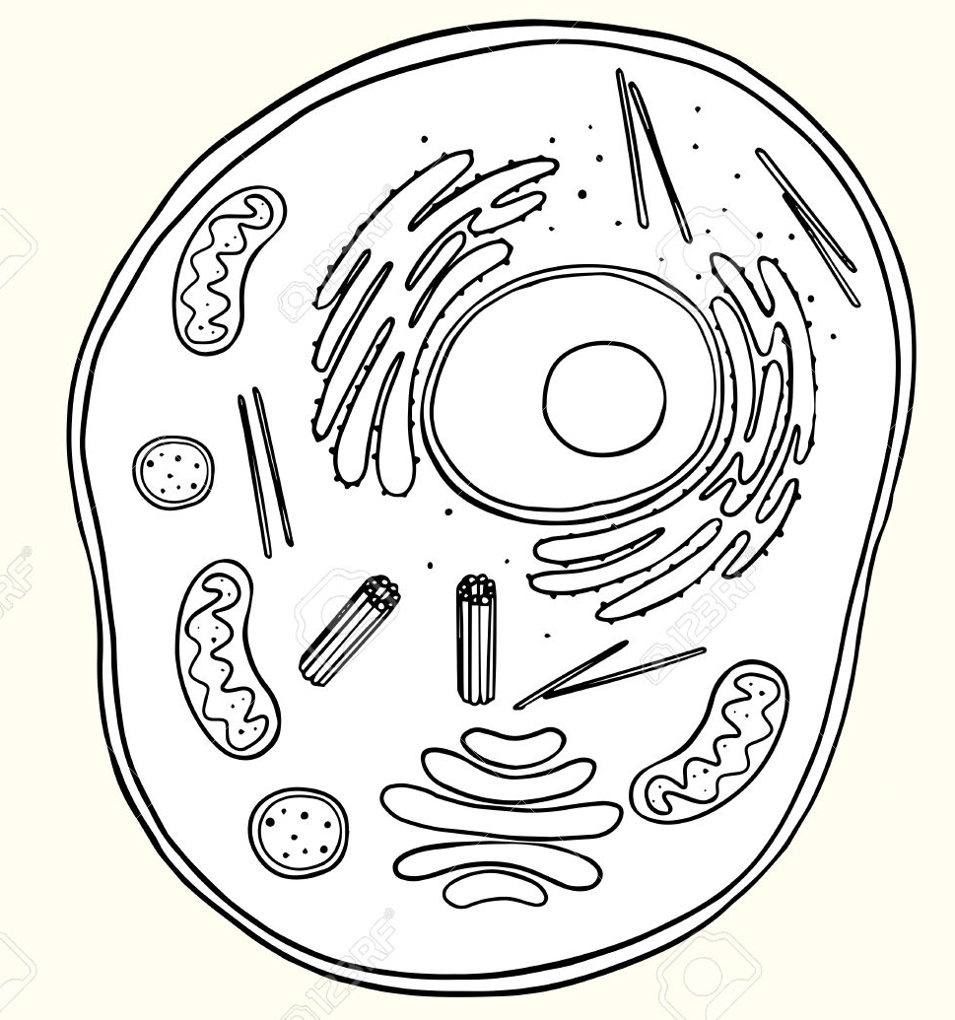

(b)

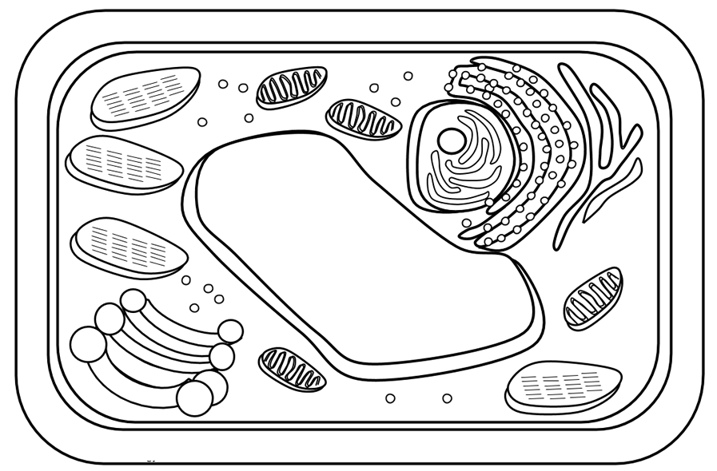

Q2. Outline the function of the following organelles.

Nucleus |  | Cytoplasm
Cell Membrane |  | Cell Wall
Chloroplast |  | Ribosome
Vacuole |  | Mitochondria

Q3 (a) In the Venn diagram (and using the diagrams above), compare the organelles between animal and plant cells.
Animal Cell
Plant Cell
Both

(b) Which organelles are different? Describe the function of these organelles (i.e. why is it important for that cell?

Q4. Living organisms can be described as either unicellular or multicellular. Describe what this means.

Q5. Define the following:

(a) Cell

(b) Tissue

(c) Organ

(d) System

Q6. Give the word equations for the following processes:

(a) Cellular Respiration:

(b) Photosynthesis:

Q7. Mitosis is the division of cells which results in two daughter cells which are identical to the parent cell. Outline the purpose of Mitosis below.

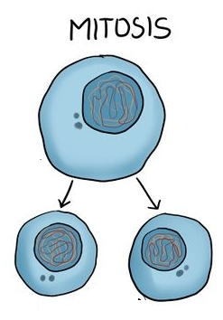

Q8.Label the microscope parts below:

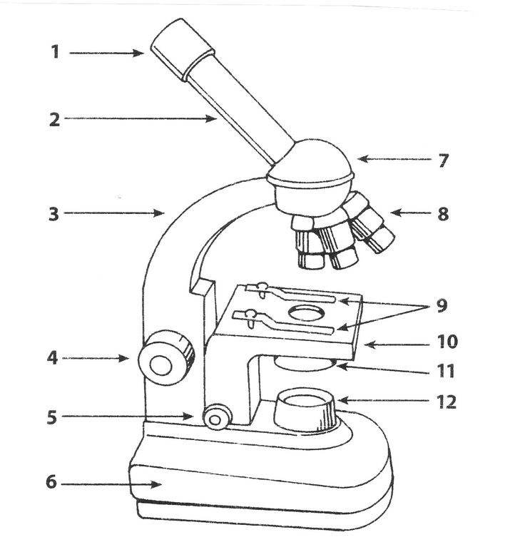
Q9. Calculate the following (and show all working):

(a) The total magnification of the microscope, if the objective lens is 50X and the ocular lens is 10X

(b) The total magnification of the microscope, if the objective lens is 15X and the ocular lens is 10X

(c) The objective lens magnification, if the ocular lens is 10X and the total magnification is 450X

DIGESTIVE SYSTEM:

Q10. What is the purpose of the digestive system?

Q11. Contrast between mechanical and chemical digestion.

Q12. Label the different structures/organs on the image below.

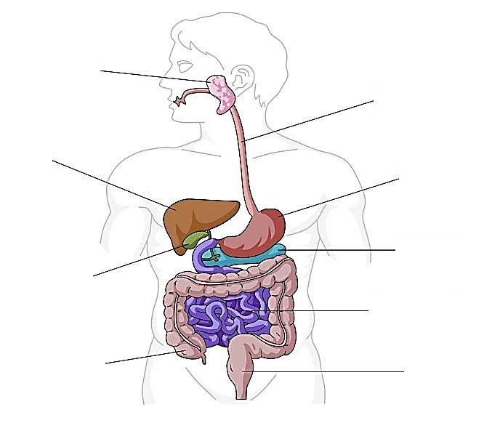
Q13. What is an enzyme and how does it work?

Q14. Food that is broken down is given different names as it moves along the digestive tract. Where in the body is it when it is called:

(a) Chyme:

(b) Bolus:

(c) Faeces:

Q15. Complete the table below:

Organ | Role in the digestive system  How will it perform this important task? Is there a special term used to describe a process that occurs here? Is there anything special about this organ that helps it to perform this task?
Mouth
Oesophagus
Stomach
Pancreas
Liver
Small Intestines
Large Intestines
Rectum

Q16. Complete the table below to compare the digestive systems between the three different organisms: (you can use Pg. 84 of Pearson textbook to help)

Animal | Type of foods eaten (type of consumer) | Types of teeth | Digestive structures which assist in digestion
Human
Dog
Cow

RESPIRATORY SYSTEM:

Q17. What is the purpose of the Respiratory System?

Q18. Label the structure of the Respiratory system below.
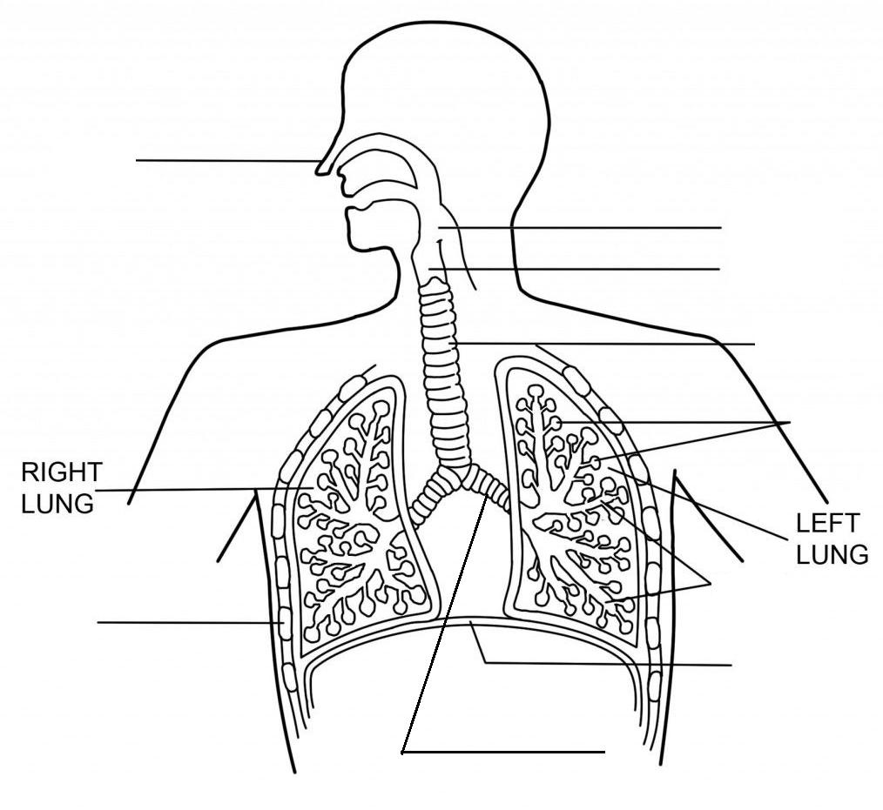
Q19. What is the function of the Diaphragm?

Q20. (a) What is gas exchange and where does it occur in this system?

(b) Define diffusion.

(c) Describe what happens during gas exchange. Use a labelled diagram to assist.

Q21. As per your research assignment, you should also be able to compare and contrast respiratory systems of different organisms.
GOOD LUCK

