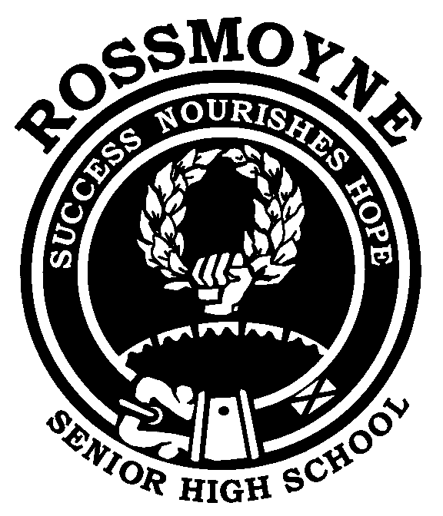
Humanities and
Social Sciences
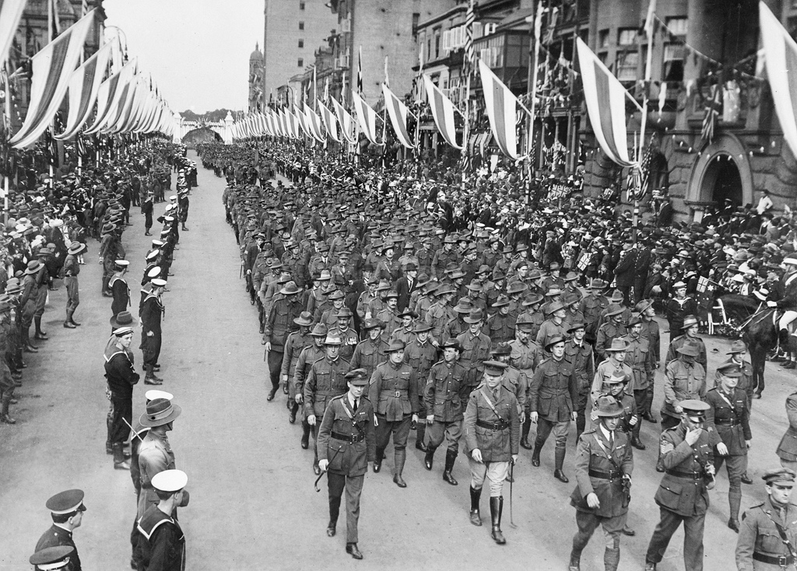

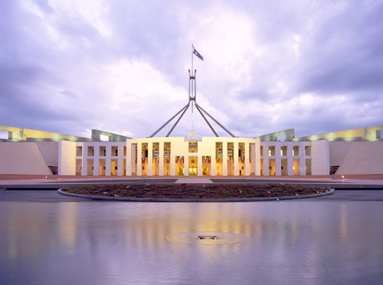

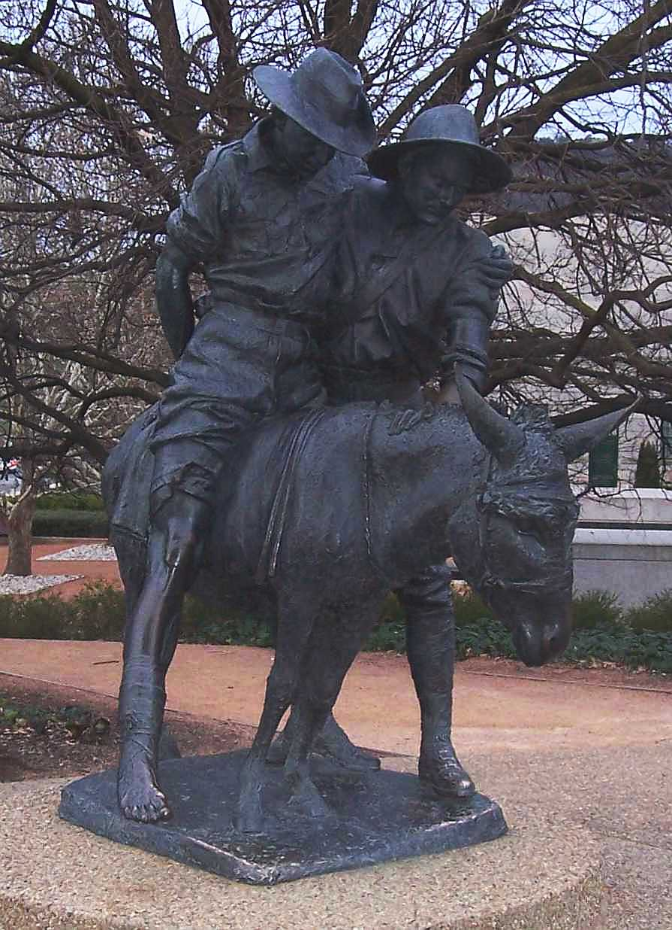

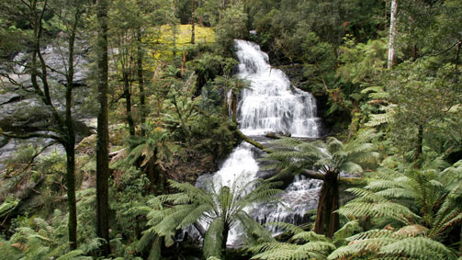
Year 9 Parent and Student Information Booklet 2015
Also available at http://www.rossmoyne.wa.edu.au/Programs/LearningAreas/HumanitiesandSocialSciences.aspx

Student’s Name __________________________________

Teacher’s Name __________________________________

Developing Active Citizens for the Future

Dear Parent/Guardian and Student

The Humanities and Social Sciences Learning Area provides opportunities for students to acquire the knowledge, skills and values to become active citizens in a rapidly changing world. During the course of the Lower School Humanities and Social Sciences Program, students will develop an understanding of how and why individuals and groups live together and interact with their environment. This will involve developing a respect for our cultural heritage, a commitment to social justice, the democratic process and ecological sustainability.

Monitoring Progress
Students are encouraged to record their Humanities and Social Sciences results in the Student Record of Achievement on page 7 of this document. This provides parents with the opportunity to monitor their child’s progress and contact the classroom teacher if there are any issues of concern that need addressing. Teachers will likewise contact parents when necessary.

Upper School Courses of Study
The knowledge, skills and values acquired during the Lower School Program will equip students to successfully complete studies in the following Upper School Courses of Study:
- History ● Geography
- Politics & Law ● Economics
- Accounting and Finance ● Certificate II Business

Please read the remainder of the booklet to familiarise yourself with the whole program being offered by the Humanities and Social Sciences Learning Area.

Please sign below to indicate you have read through the Parent and Student Booklet and please feel free to contact us for any further information that you may require.

Student’s Name: _______________________ Signature: ____________________________

Parent’s Name: ________________________ Signature: ____________________________

Following our Sustainability Priority – the whole booklet is available on
http://www.rossmoyne.wa.edu.au/Programs/LearningAreas/HumanitiesandSocialSciences.aspx

Acknowledgements Cover Page Images
A march past of Australian ANZAC soldiers during peace celebrations in Sydney. Date: 1919 Photographer: Sydney Morning Herald and Sydney Mail; Id number: H16146 ights Info: No known copyright restrictions. This photograph is from the Australian War Memorial's collection www.awm.gov.au Persistent URL: cas.awm.gov.au/item/H16146 accessed 29/11/2013
Simpson and his Donkey Photo released into the public domain by Mark Gallagher at en.wikipedia http://upload.wikimedia.org/wikipedia/commons/d/db/CanberraSimpsonMemorial.jpg accessed 29/11/2013
Parliament House Canberra Parliamentary Education Office Catalogue no. 0193 http://www.peo.gov.au/multimedia/library/pages/0193.html
Source/Credit line: Auspic (Auspic Reference No. 054) accessed 29/11/2013
Country Alpine Mountain Stream, Kathie Nichols, Stock Photo Graphical Resources Free Photographs and Graphs for Education
https://www.dreamtime.commountain-stream-victoria-australia-country-alpine-country-42284219.jpg accessed 17/12/2014

COURSE OUTLINE SCHEDULE FOR YEARS 9 AND 10

The structure of the Humanities and Social Sciences’ courses are currently undergoing considerable changes with the implementation of the Australian Curriculum. The each semester grade will be based on the courses below.

Research skills will be included in all courses and not be reported separately.

 | Year 9 2015 | Year 10 2016
Semester  1 | - History  The making of the modern world from 1750 to 1918.  The Industrial Revolution.  The movement of people – convict, slaves and settlers.  Indigenous culture and the effects of colonisation.  World War I and impact on Australia | - Geography  Environmental Change and Management  Geographies of Human Well Being
Semester  2 | - Geography  Biomes and Food Security  Geographies of Interconnections  - Government and Law  Structure of Australia’s government  Role of parliament  Election process and voting systems  Types of law | - Economics  Standard of Living  Economic Performance  - History  The Modern World and Australia  Keys for Life  Students who successfully complete this course will receive a Driver Education Course Certificate but the course does not appear on the student’s report.
HUMANITIES AND SOCIAL SCIENCES YEAR 9 COURSE OUTLINE CONTENT
Semester 1  HISTORY  Australia and the Modern World  Making a Better World  The Industrial Revolution 1750-1914  - Technological innovations and new ideas (in agriculture and industry) contributing to change across the world and within Australia  - Changed living and working conditions of men, women and children across the world and in Britain and Australia  - World movement of peoples - slave trade, convict transportation and expanding empires  World War 1 1914-1918  - Overview of causes (with reference to political ideas such as nationalism and imperialism)  - Why Australian men enlisted and places where they fought  - Nature of warfare including the Gallipoli campaign  - Impact of World War I – emphasis on Australia (propaganda, changing role of women and conscription debate)  - Nature and significance of World War I in world and Australian history (Anzac Day and Anzac Legend)  GEOGRAPHY  Environmental Systems & Biomes  - Distribution and characteristics of biomes  - Interconnections of climate, soil, vegetation and productivity in a biome  - Environmental effects of land use  Food Security / Global Food Crisis  - Environmental, economic and technological factors that influence crop yields  - Challenges and issues to food production and future sustainability | Semester 2  Geographies of Interconnections  - People’s perceptions and uses of places  - The way information and communication technologies are used to connect people to services, information and people  - The ways places are interconnected through trade, services and tourism  GOVERNMENT & LAW  Government  - Representative democracy in Australia  - Three levels of government  - Constitution – its function and the role of referendums  - Three arms of govt. - legislative, executive and judicial  Westminster system of parliament  - House of Representatives and Senate  - Roles of Prime Minister, Governor General, cabinet and opposition  - Passing a bill through parliament  - Political parties – their policies, membership and leaders  - Electing representatives – voting systems (preferential and proportional), processes on election day  - Influencing govt. – lobby groups - unions, businesses, environmentalists  - Different political systems  Australia’s Legal System  - Statute and common law  - Civil and criminal law  - Customary law  - Types of courts, their functions and court officials  - Principles of justice – equality before the law, presumption of innocence, right of appeal
HUMANITIES AND SOCIAL SCIENCES: - YEAR 9 COURSE OUTLINE

SKILLS TO BE DEVELOPED DURING THE YEAR
Research  More information regarding research assignments may be found on the next page. | Planning research assignments - devising useful focus questions  Identifying suitable sources of information  Forming hypotheses; developing mechanisms to test hypotheses  Using a range of techniques to find and observe data e.g. interviews, questionnaires  Using a variety of types of information - primary and secondary sources  Evaluate sources for their reliability, bias, perspective and usefulness  Collect, select, record, organise, process and combine information using ethical protocols  Drawing conclusion based on evidence, presenting the evidence  Presenting data in a range of different formats - reports, tables, sketches  Self-reflection and analysis of performance
Information Technology | Use Word, Excel, tables, graphic organisers – mind & concept maps  Construct diagrams, add notes, electronic presentations e.g. podcasts, iMovie  Access network drive and files, Moodle  Using search engines/strategies, information gathering/evaluation/referencing
Communication  Literacy | Develop a range of communication skills (oral, graphic, written and digital)  Paragraph, essay and report writing  Topic Sentences  Developing & Supporting Sentences – Use evidence to support statements & strengthen arguments  Linking Sentences  Concluding Sentence  Editing text  Explaining a process or narrative  Comprehension: inferential, literal & evaluative
Map Interpretation and Construction | Atlas Skills - using legends, scale, locating features  Map & table interpretation and construction of climatic, vegetation, economic & trade data  Photograph interpretation
Graphing | Construction and interpretation of line, pie and bar graphs
Pictures, Diagrams and Table Interpretation | Develop observation skills and tactics: examine and evaluate information from a variety of sources such as trade figures and food production  Identify causes and consequences of actions and interconnections
Historical & Geographical Skills  Timeline Construction and Interpretation | Use of historical and geographical terms e.g. prehistoric, decade, and concepts e.g. time periods according to themes like medieval history  Chronology, sequencing historical events and periods  Biomes, interconnectedness, food security  Analysis and use of primary and secondary sources  Identifying the origin, purpose, views, attitudes and values of sources
Test skills | Time management, working under pressure, study skills

The main process/methodology of learning in Humanities and Social Sciences is through research.
There are four stages involved in research tasks:

1. PLANNING RESEARCH
Students plan ways to organise and gather information:
- Identify factors to be considered
- Devise questions
- Identify possible sources of information
- Make simple predictions
- Negotiate how to use the information
- Formulate hypotheses

2. CONDUCTING RESEARCH
Students, conduct the investigation by determining where sources of information are located then organising and evaluating the information:
- Use a range of social science techniques to make observations
- Refer to more than one source and type of sources e.g. interviews, DVDs, internet
- Use a variety of techniques to record information e.g. tables
- Identify a range of perspectives
- Identify the most appropriate sources of information

3. PROCESSING & TRANSLATING INFORMATION
Students process and translate information to make findings/judgements:
- Select, categorise and compare information gathered
- Transform the information into structured forms of display
- Identify, select and combine information
- Connect similar ideas
- Make generalisations and draw conclusions
- Present a particular point of view

4. APPLYING & COMMUNICATING FINDINGS
Students evaluate data, apply and communicate findings according to purpose and audience:
- Present findings
- Present evidence for findings
- Communicate findings effectively
- Demonstrate consideration of facts, opinions and motives of a particular point of view

Students will have numerous opportunities to work on developing their proficiency in the above skills.
PLAGIARISM
Plagiarism is presenting work that is not your own. To avoid this situation, students need to ensure that they:
- Take key points from sources rather than ‘cut and paste’
- Label notes with the references used
- Maintain a detailed bibliography
- Develop their own findings regarding the topic based on research

Students who plagiarise may have marks deducted or not receive any credit for the task.

ASSESSMENT TASKS

Throughout each semester, students will have the opportunity to demonstrate their understanding of the course knowledge and skills through different types of assessments such as;
- research tasks
- in-class essays or extended answer questions
- common assessment tasks
- class participation in discussions and other activities

Students are encouraged to record their results on the Student Record of Achievement below,

ASSESSMENT STRUCTURE AND WEIGHTING

SEMESTER 1 |  | SEMESTER 2
History  Common Assessment Task  Source analysis on World War I | 30% | Geography  Common Assessment Task  (Testing skills knowledge and understanding through multiple choice, short answer, data analysis questions and an extended response) | 30%
Historical Research Skills | 30% | Other Geography Tasks | 20%
History Essay | 25% | Government and Law  Common Assessment Task (Testing skills knowledge and understanding through multiple choice, short answer and data analysis questions) | 30%
Other History Tasks | 15%
Total | 100% | Government and Law Essay | 20%
 |  | Total | 100%

STUDENT RECORD OF ACHIEVEMENT

Date | Description of Assessment | Result |  | Date | Description of Assessment | Result

COMPLETING ASSESSMENT TASKS

All assessment tasks need to be completed. Failure to complete an assessment task will jeopardise your chances of being awarded a higher grade.

ABSENT FOR AN ASSESSMENT

If a student misses an in-class assessment OR a due date for handing in a piece of work as a result of being away on the day, a parent note will need to be presented to the teacher on the day they return to school. Alternatively, a telephone call (or email) can be made to the teacher.

If a satisfactory explanation for the absence is not provided, a mark of zero may be awarded for that section of the course.
Please refer to the Assessment Policy in the School Handbook or Rossmoyne Senior High School’s website for more information. http://www.rossmoyne.wa.edu.au/AboutUS/Policies/Assessment.aspx

HOMEWORK AND STUDY

Students will need to spend time working on their Humanities and Social Sciences learning out of school hours.
This may take one of the following forms:
- A set task to be completed by a certain date
- General review of material covered in class
- Revision for an in class assessment
- Conducting research
- Completing tasks which cannot be completed in class e.g. local area study

The amount of time students should be spending on their Humanities and Social Sciences learning should fit within the parameters set by the school for each year group for all subjects.

MONITORING AND REPORTING PROGESS

Teachers will monitor student progress and report in the following ways:
- Marking of assessment tasks
- Parent Evening
- Semester 1 and 2 reports
- Letters of Commendation and Concern
- Telephone calls and/or e-mails

ACHIEVEMENT TARGETS

Students aiming to successfully proceed into Politics & Law, History, Geography, Economics and Accounting & Finance courses should be achieving B grades or better.

The Humanities and Social Sciences Learning Area has a strong focus in providing students with opportunities to participate in a wide range of competitions and activities. Some examples are:

Premier's Anzac Tour
Students prepare a five minute oral presentation on an ANZAC related topic to a panel of RSHS Humanities and Social Sciences teachers. One student from each age category continues to a district level and a possibility of being selected for a remarkable trip to a World War I or a World War II location with the other state winners.

Camp Gallipoli
A once in a lifetime opportunity for all students to join in a special night of remembrance and entertainment to sleep out under the same stars as the original Anzacs did 100 years ago, in celebrating the birth of that special Aussie & Kiwi ANZAC spirit on the 100th anniversary of Gallipoli.

This event is fully endorsed by the Anzac centenary committee, Department of Veterans Affairs, Federal Education Department, RSL and Legacy.

National History Challenge
The National History Challenge encourages inquiry-based learning, the use of primary and secondary sources and offers a variety of presentation styles that can cater to individual learning preferences. Students are the historians, they can investigate their community, explore their family’s past, major events, new ideas or historical theories.

Australian Geography Competition
Students complete a multiple-choice test which can lead all the way to an interstate or international competition. All entrants will receive a certificate informing them of the level they have achieved.

Sir Charles Court Young Leaders Program Year 10
Students are nominated for a four day camp where leadership skills are sharpened and students participate in collaborative activities that enhance their learning.

ASX School Share-Market Game
Students participate in an online virtual share market game. Students develop a range of skills including decision making in an ever-changing environment.

Asia Activity Day Year 8
Students will be given the opportunity to experience the different arts and traditions of an Asian culture from Tai Chi to calligraphy, mah-jong to origami.

Each semester, student achievement in the Humanities and Social Sciences Learning Area will be acknowledged in the following ways:
- The most outstanding Humanities and Social Sciences students will receive Outstanding Student Awards in each year group
- The top student in each class will receive a Certificate of Acknowledgement
- Up to 5 students in each class will be awarded Certificates of Endeavour

End of Year Awards
The most outstanding student in Year 7, 8, 9 and 10 will receive one of the following Humanities and Social Sciences medals:
- Year 7 - C.Y. O’Connor Medal
- Year 8 - Yagan Medal
- Year 9 - Dorothy Tangney Medal
- Year 10 - John Curtin Medal

The Selection Process for Outstanding Student and Medal Awardees:
Teachers will invite students who have performed at the highest level in their Humanities and Social Sciences studies to submit a portfolio reflecting their progress.

The portfolio should contain:
- A short summary of how they have performed in their Humanities and Social Sciences studies
- ONE extended answer (essay)
- ONE investigation (research assignment)
- Documentation that reflects active citizenship in the school environment and beyond in accordance with the principles and values associated with the democratic process, social justice and ecological sustainability

Students can use the following guidelines to ensure they maximise their achievement.

ARRIVING TO CLASS ON TIME
It is your responsibility to be in class on time.

ABSENT FROM CLASS
If you know you are going to miss class ensure you inform your teacher at the earliest opportunity so the necessary arrangements can be made. If you have an unscheduled absence check with your classmates and teacher to ensure you catch up on all work missed.

BEING ORGANISED
Students need to use their diary to ensure they are fully aware of their Humanities and Social Sciences responsibilities. This will include using their diary effectively, always having the appropriate equipment, completing homework, meeting deadlines and being involved in class activities.

EQUIPMENT NEEDED
Students will need a file with their Humanities and Social Sciences section clearly labelled, pens, pencils, ruler, eraser, sheet protectors, plenty of paper, a USB and earphones. Students should have their school diary with them every day. The bringing of a laptop computer every day is highly recommended.

ORGANISING YOUR INFORMATION
All work needs to be correctly titled, dated and completed neatly. It is important to be able to keep sections of work together – particularly when working on a research assignment . All Humanities and Social Sciences work completed on computers should be kept in an Humanities and Social Sciences folder with sub-folders for separate topics such as Research Assignments, History, Politics etc.

COMPLETING TASKS IN CLASS
It is important for students to participate in all aspects of their Humanities and Social Sciences learning. This involves being able to discuss ideas, ask questions and complete a variety of tasks which will include researching, writing, using a variety of information sources such as texts, atlases and the internet.

WORKING IN THE LIBRARY AND ON COMPUTERS
Students need to ensure they gain maximum benefit from being in the library or using computers.
This will involve identifying a clear task for you to complete, identifying the source of information you wish to use quickly and using appropriate note taking skills to record the information needed. Use Moodle to access information to upload your work, download tasks and for collaborative learning activities.

Year 9
- Financial Management

Year 10
- Accounting | - Law and Commerce
- Criminal Investigation | - Philosophy
- International Tourism | - Psychology

Successful completion of the Year 8 – 10 Program will provide an excellent platform for selecting the following upper school courses.

Politics & Law
Democracy requires involvement. An essential part of life in the 21st century is an understanding of the framework of politics and law in this society so that students will be able to participate in the processes which will, in turn, empower them to make informed choices.

The knowledge, skills and values examined by the course allow students to become informed, active participants in the political and legal decisions that affect their lives and the future of their communities.

Geography
Some of the areas studied in upper school include natural hazards, resources, urban planning and climate change. By exploring their impact and proposed solutions for sustainable development whilst meeting environmental, economic and community needs, students should develop knowledge, skills and understandings that enables them to live and work in a rapidly changing world.

History
The Modern History course fosters students’ skills through analysing information and using evidence to develop a strong coherent argument. Students are encouraged to question and evaluate historical sources, representations, interpretations and versions of history. Historical studies help students to use critical thinking skills as they compare and contrast information, detect inconsistencies in details, recognise manipulation of evidence, note one-sided presentation of material and evaluate degrees of accuracy in sources.

These skills are taught in context through topics such as Capitalism – The American Experience 1907-1941, Nazism in Germany, Australia 1920’s-1959 and Ideas – Russian Revolution.

Economics
The Economics course provides the knowledge and develops the skills of reasoning, logical thinking and interpretation that are demanded by business and government. Topics are taught within the real world context of the retail market, stock market, labour market and international markets. Macroeconomics and the government’s role in the economy are explored. Issues such as economic growth, inflation, unemployment, income distribution, business strategy, and international relations, global markets and economic policy are considered and financial literacy skills are developed.

Accounting and Finance
Accounting provides students with an understanding of concepts and procedures needed to process the financial records of a small business. The course includes some computerised accounting. The knowledge and skills gained in this course are useful for careers in accounting, marketing, management and finance.

Certificate II in Business
The Business course covers a range of business subjects including word processing, spread sheets, designing organisational documents, mail procedures, preparing and processing accounts and processing and maintaining workplace information.

Students develop relevant technical skills, vocational and interpersonal competencies suitable to employment and further training in business as well as skills, knowledge and experiences that are transferable to other industry areas.

Answering essay questions is a skill that can be acquired with a combination of practice and applied technique.

The technique of essay writing:

- PLANNING THE ANSWER
- Planning is the key to success
- All good essays are well constructed, follow a sound ‘line of argument’ and answer the question clearly
- To plan successfully, you must have a clear understanding what the question is asking. Underline key words and know what these key words are asking you to do e.g. evaluate.

- WRITING THE ESSAY ANSWER
Essays should have an introduction, a body of several paragraphs and a conclusion

INTRODUCTION:
- State the central argument/theme/thesis that you are presenting
- Outline the structure of your essay, what major points you are going to make?
- Identify the limits/parameters of your essay
- Where appropriate define any terms
- Relate the topic to the keywords of the question e.g. describe, compare.

BODY:
- ‘Say it’
- Use paragraphs
- Put one main point in each paragraph
- For each paragraph provide a topic sentence, explain the point, give evidence and examples to support your explanation, conclude the paragraph by connecting it to your thesis/question
- Try, if possible, to link each paragraph to the one before or to the question.

CONCLUSION:
- ‘Say that you’ve said it’
- Keep the conclusion crisp, strong and clear
- Make a direct reference to the question, re-iterate key words of the question if you can and show that you have answered the question.

The purpose of your conclusion is to draw all the major points of your answer into one or two strong, powerful statements.

3. CHECKLIST FOR ESSAYS

Ask yourself the following questions when editing your essay:

1. Does the essay answer the question?
2. Have I followed the instruction words i.e. discuss, analyse, compare?
3. Does the essay have an introduction that outlines the main points?
4. Does the essay present relevant information and details appropriate to the question?
5. Is there a logical sequencing of ideas and facts?
6. Is the essay coherent with correct use of grammar, spelling, sentence and paragraph structure?

Account for | To give reasons for something.
Analyse | To separate or break up a whole into its parts so that you may study how each part relates to the whole question/event/topic, etc. It is important to make some comment about the main idea or concept of the question/event/topic.
Assess | To estimate the importance, quality, significance of something. Look carefully at the situation/aspect you are being asked to assess. In general, you should point to strengths and weaknesses and/or similarities and differences.
Compare | To look for similar and different qualities or characteristics of events/ ideas, etc.
Contrast | To stress dissimilarities/differences of qualities, events or problems.
Criticise | To judge the merit or truth of factors or views mentioned. Give the results of your analysis of these factors, discussing their limitations and good points.
Debate | To present an argument. To argue a particular point of view, using evidence to support the argument. You must present a proposition.
Define | To give short, clear and authoritative meanings. Do not give details but keep to the limits of the definition by staying on the point.
Describe | To narrate or write a detailed account of the particular event or factor.
Develop | Put forward your ideas in a logical and detailed manner.
Discuss | To critically examine and give reasons for and against. Present your views in detail using examples or illustrations. This may require the student to combine definition, description, explanation, drawing conclusions etc. The answer should be comprehensive and detailed.
Evaluate | To present a judgement of an issue by stressing both strengths/advantages and weaknesses/limitations. Conclude with your own opinion (not using first person) or evaluation supported by available evidence.
Examine | To carefully inspect the known facts about a particular situation/aspect and present the findings in a balanced way.
Explain | To make clear with detailed information. To provide reasons for -
Identify | To recognise or establish something e.g. reasons for a particular event/aspect or concept through an examination of the known facts.
Illustrate | To use example/s to explain a particular topic or proposition.
Interpret | To make sense of something, often a table of data or a graph.
Justify | Give an explanation why a particular course of action has been or should be followed. Justify means make a reasoned choice.
List | To write an itemised series of concise/accurate statements using prose (complete sentences). Do not use note-making format in Humanities and Social Sciences subjects.
Outline | Summarise by mentioning important points only. Provide a short discussion to demonstrate a good overall knowledge of the topic or concept.
Relate | (a) Show how events are related to one another or  (b) to explain the link between cause and effect – understand a relationship.
State | To narrate or write main points in a brief, clear and logical sequence.
Suggest | Identify possible reasons why an event has occurred. The question might also be asking for a prediction – suggest what might happen if…?
Summarise | To give the main points or facts in a condensed/shortened form omitting details and illustrations. Do not use note-making format.
Trace | To describe in narrative form the progress, development or sequence of historical events from the point of origin.

