Decision Making Tools
- Outline why decision making tools are useful in deciding on your career path.

Cost/Benefit Analysis
- Describe how cost/benefit analysis works.
- Identify the advantages of using cost/benefit analysis when deciding on your career path.
- Identify the disadvantages of using cost/benefit analysis when deciding on your career path.
- Apply a cost/benefit analysis to your career development. Add in your own criteria.
Choice #1:
Criteria | Cost | Value |  |  | Benefit | Value
 |  | 1 | 2 | 3 |  | 1 | 2 | 3
Length of training
Working conditions
Pay rates
Holidays
Work/life balance
Work requirements, eg. Shift work, travel

Choice #2:
Criteria | Cost | Value |  |  | Benefit | Value
 |  | 1 | 2 | 3 |  | 1 | 2 | 3
Length of training
Working conditions
Pay rates
Holidays
Work/life balance
Work requirements, eg. Shift work, travel

Decided course of action based on the above cost/benefit analysis of two possible career development options.

Paired Comparison
- Describe how paired comparison works.
- Identify the advantages of using paired comparison when deciding on your career path.
- Identify the disadvantages of using paired comparison when deciding on your career path.
- Apply paired comparison to your career development.

 | A | B | C | D
A
B
C
D

Decided course of action based on the above paired analysis of two possible career development options.
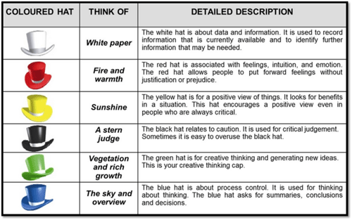
Six Thinking Hats
- Describe how six thinking hats work.
- Identify the advantages of using six thinking hats when deciding on your career path.
- Identify the disadvantages of using six thinking hats when deciding on your career path.
- Apply six thinking hats to your career development.

Question: Create your own question related to your career development. Eg. Should I become a dance choreographer.
White | Red
Yellow | Black
Green | Blue

Decided course of action based on 6 thinking hats.

