Human Perspectives ATAR Units 3 & 4

Worksheet 6.1 Homeostasis of body fluids

Using Chapter 6 of Human Perspectives ATAR Units 3 & 4, complete the following activities.

1 Explain why the regulation of body fluids is important for the maintenance of homeostasis.
2 Draw a diagram to describe the relationship between the intracellular fluids and extracellular fluids in the body.

3 Define the term ‘excretion’.

4 Complete the following table.
Organ involved in excretion Substance/s excreted by the organ

5 Label the following diagram of the kidney and associated organs.

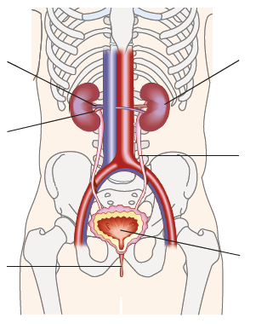

6 The kidneys are the principal excretory organs. The structural and functional unit of the kidney is the nephron.
a Label the following diagram of the nephron using the boxes provided.
b In red, trace the pathway of nutrients that are filtered and reabsorbed into the capillaries surrounding the tubule; in blue, trace the pathway of cells and molecules such as proteins that are too big to be filtered; and in yellow, trace the pathway of the wastes destined to become urine.

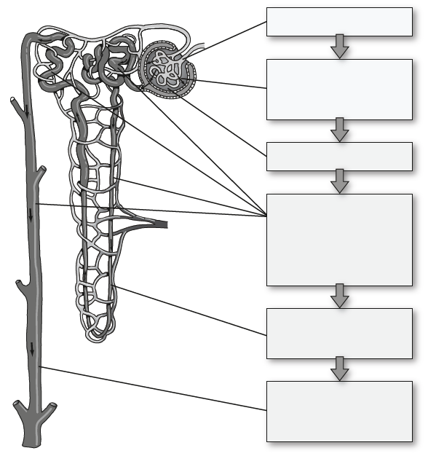

7 Write a story, and include illustrations, describing the journey and fate of Wally the Water Molecule from the time he enters the renal artery from the aorta until he becomes part of the urine in the bladder.

8 What is antidiuretic hormone (ADH), where is it produced and what effect does it have on the body?
9 If alcohol inhibits ADH production, what effect would drinking several small glasses of a spirit such as whisky have on a person’s urine concentration and urine output?
10 In an experiment conducted at school during a day when the outside temperature was 32 °C, some students had to exercise for 20 minutes without drinking any water. This led to a decrease in the volume of tissue fluid.
a Explain why there was a decrease in the volume of tissue fluid and, using a steady state control model, explain how a decreased volume of tissue fluid would stimulate water retention by the kidney.
b After the experiment, the students complained of feeling very thirsty and asked the teacher if they could get a drink. Explain the mechanisms that bring about this ‘water seeking’ behaviour.

