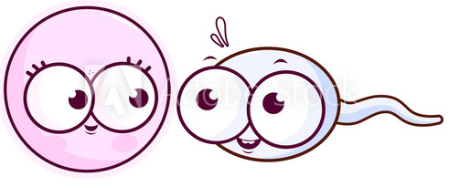
Sex-Linked Inheritance
Complete the following problems.
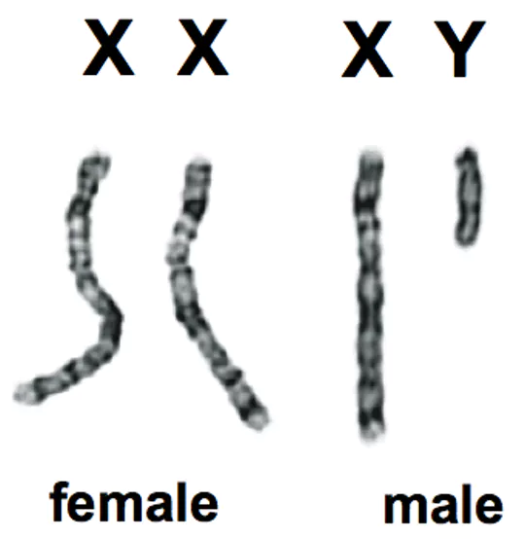
Q1. Complete a punnett square for the cross between a human female (XX) and a human male (XY). What is the chance the child will be a girl? What is the chance the child will be a boy?

Q2. If the same parents have four boys, what is the probability their 5th child will be a girl?

Q3. Give the genotypes for the following:
a) A male with a sex-linked recessive trait.
b) A female with a sex-linked recessive trait.
c) A male with a sex-linked dominant trait.
d) A female who is normal but carries the sex-linked recessive trait.
e) A female who is homozygous dominant for a sex-linked trait.

Q4. Which sex is more likely to have a recessive, sex-linked trait? Males or Females? Explain why this is the case and use a punnett square to further support your answer.

Q5. Which parent do sons inherit recessive, sex-linked traits from?
The mother or father

Q6. Which type of sex chromosome do you find most sex-linked traits on?
The X or the Y

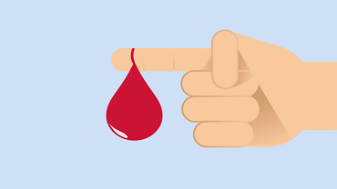
Q7. Haemophilia is a sex-linked (X-linked) recessive trait that prevents proper blood clotting and results in excessive bleeding when a person is injured.
A woman who is a carrier (heterozygous) for haemophilia has children with a man who does not have haemophilia (hemizygous normal).
a) What are the parent genotypes?

b) What are the genotype and phenotype probabilities of the offspring? (Show a punnett square to prove your answers)

c) What is the chance it will be a daughter affected with haemophilia?
d) What is the chance it will be a son affected with haemophilia?

Q8. Red-green colour-blindness is a recessive, sex-linked disorder in humans. A colour-blind man has a child with a woman who is a carrier of the disorder. Use the letters N= normal vision and n = colour-blindness.
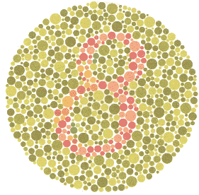
a) What is the genotype of the man?
b) What is the genotype of the woman?
c) Draw a punnett square to show the cross between the man and the woman.

d) What is the chance a child will be colour-blind?
e) What is the chance it is a daughter who is colour-blind?
f) What is the chance it is a son who is colour-blind?
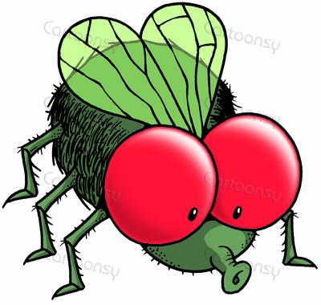
Q9. In fruit flies, red eyes are dominant over white eyes. Eye colour in fruit flies is a sex-linked trait. A red-eye male fruit fly mates with a white-eyed female. Use the letters E= Red and e = white.
a) What is the genotype of the male?
b) What is the genotype of the female?
c) Draw a punnett square to show the cross between the male and female fruit fly.

d) What is the chance the offspring will be red eyed? And white eyed?

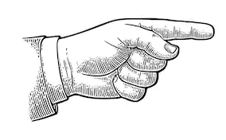
Q10. Webbed fingers are inherited as an X-linked recessive disease. An unaffected male marries an affected female.
a) Draw a Punnett square of the possible offspring.

b) List the phenotypes of the possible children.

GENE SPY
Genetic counsellors help prospective parents determine the probability of their children being born with a genetic disorder. In this activity, you will act as a genetic counsellor for a couple with a family history of haemophilia who wish to start a family. Haemophilia, like other sex-linked traits, is determined by a gene on the sex chromosome and shows a different pattern of inheritance in males than in females.
The possible sex-linked genotypes are as followed:
Unaffected male = X^{R} Y | Unaffected female = X^{R} X^{R} or X^{R} X^{r}
Affected male = X^{r} Y | Affected female = X^{r} X^{r}

Q11. A genetic counsellor begins with what is known about his or her current clients. In this case, your male client has haemophilia. What is the man’s genotype?

Q12. The female client does not display the symptoms of haemophilia. However, because she was adopted, you know nothing of her genetic history and cannot be sure of her genotype. What are the possible genotypes of the female?

Q13. Using the space below, your next task is to use Punnett Squares to determine all possible genotype outcomes for this couple’s future children (the F1 generation). Since you don’t know exactly what the mother’s genotype is, you will need to complete two Punnett Squares, one for each possibility.

Q14. Use the results from question 3 to complete the table.
 | What percentage of the offspring are female and affected? | What percentage of the offspring are male and affected?
If the mother is homozygous dominant
If the mother is heterozygous
/ a carrier of the disease
Q15. After talking with this couple, they decide that the risk of their children having haemophilia is not great enough to cause them to reconsider starting a family. Four years later you find out that their first child (a girl) does not display any signs of haemophilia. However, their second child (a boy) is born with the disorder. What does this information now tell you about the mother’s genotype? Explain your answer.

Q16. Now that you know the mother’s genotype, what are the chances that the couple’s daughter (first child) is a carrier of this disease? How do you know?

Q17. The daughter (first child) then marries a man who does not have haemophilia. Could any of her daughters have haemophilia? Could any of her sons? Construct a Punnett square to support your prediction.

Q18. In a population, 1 in 10,000 males will have haemophilia compared to only 1 in 1,000,000 females. Explain why this is so.

