Year 10 Physical Science
Mid-Topic Test Revision Questions

- Classify the following units of measurement as scalars or vectors.
mass, force, velocity, distance, weight, displacement, time, acceleration, speed

Scalar | Vector
mass  distance  time  speed | force  velocity  weight  displacement  acceleration

- Ella walked 105m west in 75 seconds to her nearest pokéstop where she stopped for 35 s to spin the stop and catch a squirtle. She then walked 650m east in 8.10 minutes to meet her friends for a 5-star raid battle at a pokégym.

  - Draw a distance time graph for this scenario on some graph paper.

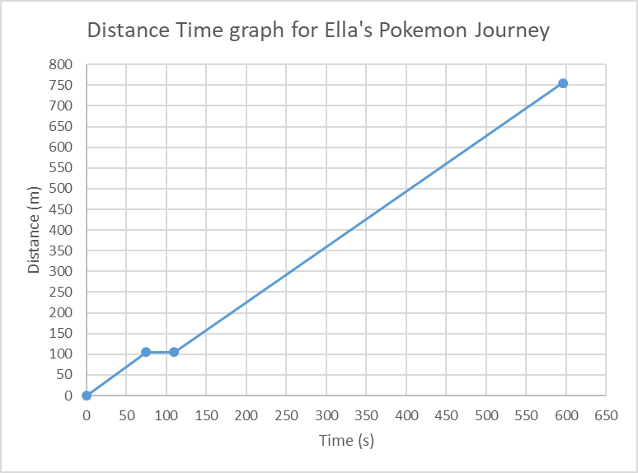

  - What total distance did Ella walk?

Total distance = 105 + 650
= 755 m

  - What was Ella’s average speed?

distance = 755m
time = 75 + 35 + (8.1 x 60)
= 596 s

speed = $\frac{distance}{time}$ = $\frac{755}{596}$ = 1.27 ms⁻¹

  - Draw a vector diagram of this scenario

650m East

Resultant = 545m East
105m West

  - What was Ella’s final displacement?

Displacement = 105m west + 650m east
= 650m east – 105m east
= 545m east (see vector diagram above)

  - Draw a displacement time graph for this scenario on some graph paper.

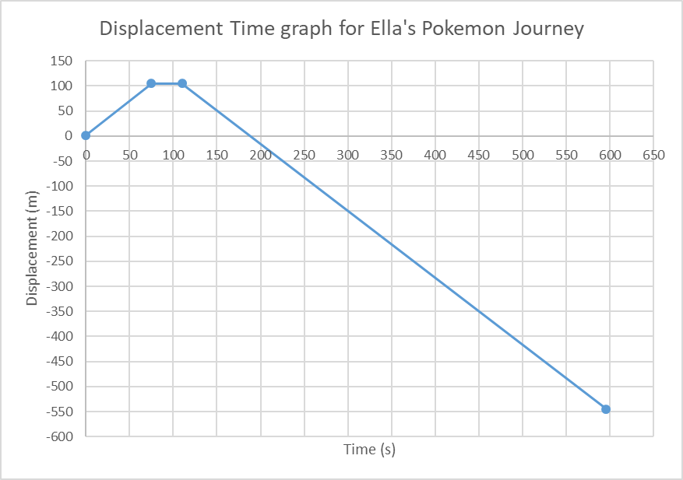

  - What was Ella’s average velocity when walking to the pokéstop?

s = 105m west
t = 75 s
v_{av} = $\frac{s}{t}$ = $\frac{105}{75}$ = 1.40 ms⁻¹ West

  - What was Ella’s average velocity when walking to the pokégym?

s = 650m east
t = 486 s
Vav = $\frac{s}{t}$ = $\frac{650}{486}$ = 1.34 ms⁻¹ East

  - Draw a velocity time graph for the scenario on some graph paper.

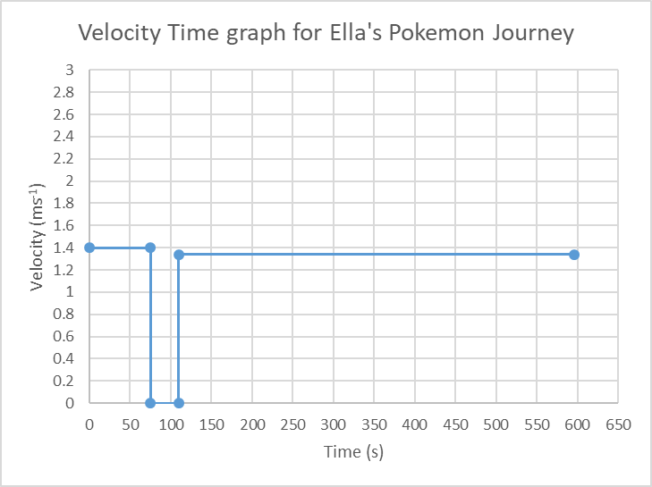

  - What was the Ella’s average velocity for the entire journey?

s = 545m east
t = 596 s
Vav = $\frac{s}{t}$ = $\frac{545}{596}$ = 0.914 ms⁻¹ East

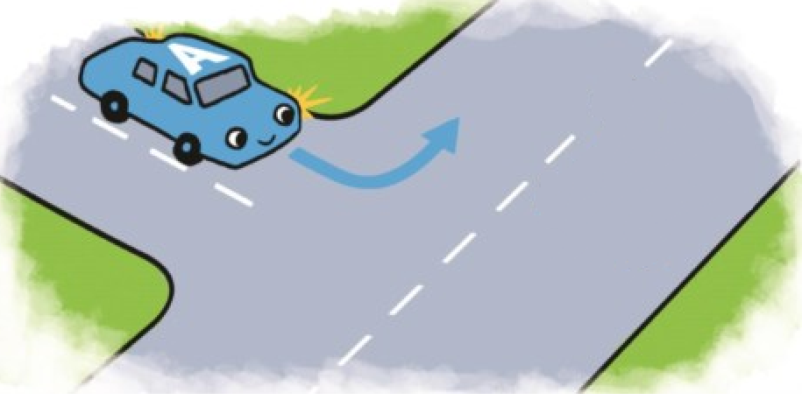
- A car driving at 25 kmh⁻¹ south rounds a corner and accelerates to 60 kmh⁻¹ east in 4.50 seconds.

  - Draw a vector diagram showing the change in velocity of the car.

Δv = v + (- u)
-u
(25kmh⁻¹ north)
Ɵ
v
(60kmh⁻¹ East)

  - Calculate the acceleration of the vehicle.

v = 60 kmh⁻¹ east $a = \frac{v-u}{t}$
= 16.7 ms⁻¹ east
u = 25 kmh⁻¹ south $a = \frac{16.7 - 6.94}{4.50}$
= 6.94 ms⁻¹ east
t = 4.50 seconds a = 2.16 ms⁻² forwards

Technically the direction of the acceleration will be in the same direction as the change in velocity vector. At year 10 level you are not expected to be able to do this, however this is how it is done.

$$\tan{θ=}\frac{25}{60}$$
$${θ=tan}^{-1}{\frac{25}{60}}$$
$$θ=22.6°$$

Therefore the acceleration is 2.16 ms⁻² East 22.6° North

  - If the car had a mass of 1100 kg, what net force was required to achieve the acceleration?

m = 1100kg F = ma
a = 2.16 ms⁻² F = 1100 x 2.16
F = ? F = 2.38 x 10³ N forwards

  - What is the weight of the vehicle?

m = 1100kg W = mg
g = 9.8ms⁻² W = 1100 x 9.8
W = ? W = 1.08 x 10⁴ N down

  - Explain, using physics principles, why the car would take longer to accelerate to the same velocity if it was fully loaded.

Newton’s second law states that mass is directly proportional to force and inversely proportional to acceleration. Therefore, if the mass of the vehicle is increased the acceleration will decrease. A lower acceleration value means that it will take longer to reach the same velocity.

  - The car travelling at 60kmh⁻¹ now brakes suddenly. Explain, using physics principles, what happens to a box sitting on the back seat of the car.

Newton’s first law of motion states that objects at rest will stay at rest and objects in motion will continue in motion unless acted on by an external force. The box was travelling in the car at 60kmh⁻¹. When the car braked, the box continued moving at 60kmh⁻¹, moving forwards until it collides with the front seat. The friction between the seat and the box would be minimal and not enough to reduce the velocity of the box at the same rate as the vehicle.

  - If the car, travelling at 60kmh⁻¹, has a retardation of 9.68 ms⁻², how long does it take to come to rest?

u = 60kmh⁻¹ $a = \frac{v-u}{t}$
= 16.7 ms⁻¹
v = 0 ms⁻¹ $t = \frac{v-u}{a}$
a = -9.68 ms⁻²
$t = \frac{0 - 16.7}{- 9.68}$

t = 1.72 seconds

- Sebastian is standing on the balcony of the maths building. James, standing directly below, threw a ball up to Sebastian with a velocity of 8.50 ms⁻¹. Sebastian catches the ball 0.75 seconds later. What is the velocity of the ball as Sebastian catches it?

u = 8.50 ms⁻¹ v = u + at
t = 0.75 s v = 8.5 + (-9.8 x 0.75)
a = -9.8 ms⁻² v = 8.5 – 7.35
v = ? v = 1.15 ms⁻¹ up

- A 20 g bullet is shot out of a rifle barrel in 2.50 milliseconds. The force on the bullet is 3500 N.

  - What is the speed of the bullet as it leaves the gun barrel?

m = 0.02 kg For this question we first need to find a.
t = 2.50 x 10⁻³ s
F = 3500 N F = ma
u = 0 ms⁻¹ $a = \frac{F}{m}$
v = ? $a = \frac{3500}{0.02}$
a = 175000 ms⁻²

Now that we know a, we can solve for v.

v = u + at
v = 0 + 175000 x 0.0025
v = 438 ms⁻¹ forwards

  - Explain, using Physics principles, why the gun pushes back into the shoulder of the person firing it when the bullet is fired.

Newton’s third law of motion states that every action has an equal and opposite reaction. The action of the bullet being fired causes the equal and opposite reaction of the gun moving backwards into the shoulder of the shooter.

