Year 9 Biology Part B Revision
Excretory System
- Name the organs involved in excretion?

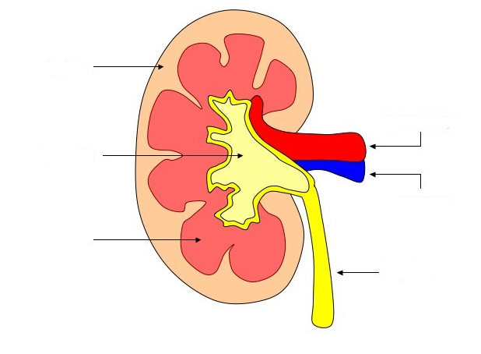
- Label the following diagram of a Kidney using the terms: Renal Artery, Renal Vein, Cortex , Renal Pelvis, Medulla, Ureter

- Explain the role of the following in the excretory system
Part | Role
Bladder
Renal Artery
Ureter
Skin
Lungs

- Label the following diagram of the urinary system
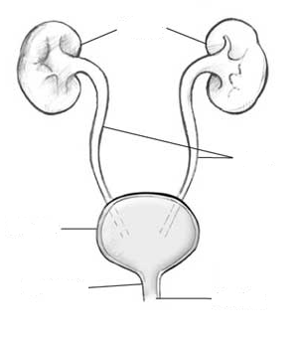

- Explain why a person’s urine is darker when they are dehydrated

Immune System
- What is non-specific immunity and what organs have a role in it?

- Define the following terms
Term | Definition
Antigens
Antibodies
Immunity
Pathogen
Disease

- Explain how vaccines work

- What is the role of B-Cells (B Lymphocytes)?

- What is the role of T-Cells (T-Lymphocytes)?

- How is pus formed?

Nervous System
- Fill in the missing labels on the diagram of a reflex arc below
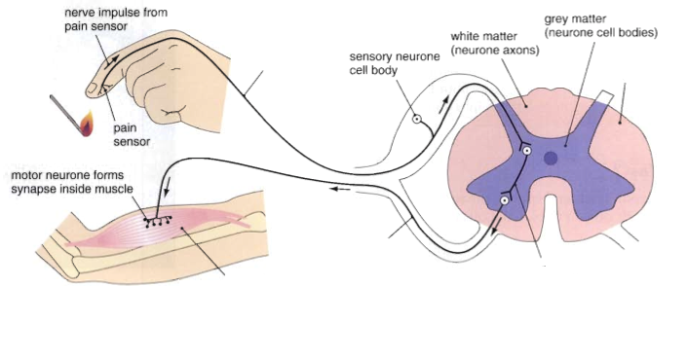

- Define the following terms
Term | Definition
Receptor
Reflex Arc
Dendrite
Cell Body
Axon

- Label the following diagram of a neuron
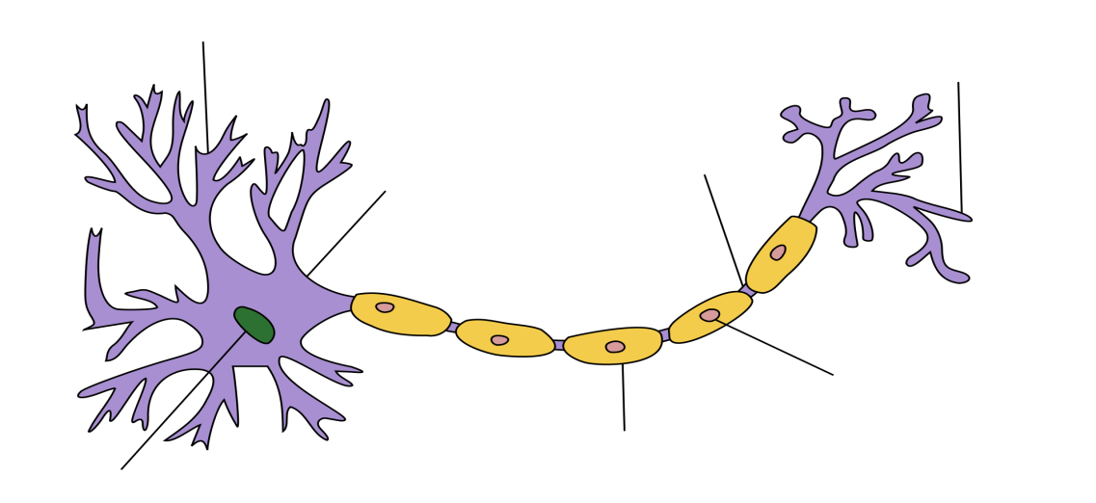

Endocrine System
- Compare how the endocrine and nervous systems work
Characteristic | NERVOUS SYSTEM | ENDOCRINE SYSTEM
Type of message:
Message transported by:
Cells affected
Type of response:
Time taken to respond:
Duration of response:

- What is a hormone?

- Name the endocrine glands and where they are located in the body
Gland | Location

- Define the term homeostasis

