Neurons & Nerve Transmission
Q1. Define the term ‘action potential’.

Q2. Complete the table below:
State | Membrane Potential (mV) | Event/s  (describe membrane proteins involved, movement of ions etc.)
Rest / Polarised

Depolarisation

Repolarisation

Hyperpolarisation

Q3. All neurons have a threshold potential. Describe the events that occur to bring the membrane to the threshold potential.

Q4. Explain what the refractory period is and how long it lasts for.

Q5. a) Give the structural and functional classification of the neuron pictured below.
Structural: ___________________________________
Functional: _____________________________________
b) Label structures (A-G).

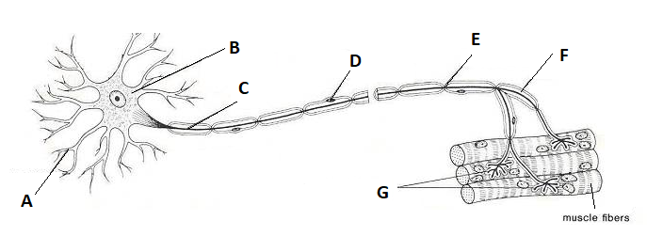

Q6. Contrast between nerve transmission along a myelinated and an unmyelinated fibre.

Q7. The following diagrams show different phases of nerve transmission (not in any particular order). Identify the state/phase for each.
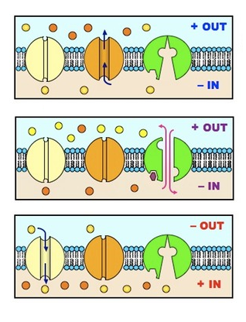

- ________________________________

- ________________________________

- ________________________________
Q8. Complete the table below:
Structural Classification of Neurons
Type of Neuron | Number of dendrites connecting with the cell body | Number of axons | Examples
Bipolar
Multipolar
Pseudounipolar
Unipolar

Q9. State the function/s of
- Motor neurons: __________________________________________________________________________________
- Sensory neurons: __________________________________________________________________________________
- Interneurons: ___________________________________________________________________________________
Q10. The next two multiple choice questions refer to the diagram shown below, which represents a nerve impulse moving along the axon of a neuron. The flow of ions across the axon membrane is represented by arrows.
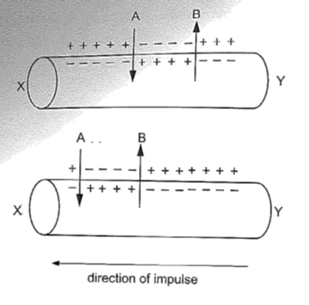
- Which of the following is correct?

- Arrow A represents potassium ions
- Arrow B represents chloride ions
- Arrow A represents sodium ions
- Arrow B represents calcium ions

- What is occurring between arrows A and B?

- Action potential
- Resting state
- Repolarisation
- myelination

Q11. Multiple sclerosis causes demyelination of nerve cells in the brain and spinal cord. Using your knowledge of nerve transmission, explain why the nerve cells in a person with this condition would unable to communicate effectively with one another.

Q12. Describe what is meant by the ‘all or none response’ and explain why it is that we are able to distinguish between stimuli of different intensities.

Nerve Transmission – Fill in the blanks
- The potential for a neuron at rest is _____________. The resting membrane potential is generated by differences in the ion concentrations of _____________________ fluids and ____________________ fluids, and the differential permeability of the membrane to those ions.
- The resting membrane potential is ‘maintained’ by passive _______________ channels and the ______________-_______________ pump (which ejects three __________ out of the cell, to every two __________ back into the cell).
- During rest _____________-________ channels are closed.
- A ____________________ will cause some _________________ channels to open and ____________ ions enter the cell.
- If there is enough sodium ions entering this will cause the membrane potential to rise to ____________. This is known as the ______________ potential. Once the threshold is exceeded more sodium _______________-___________ channels open, causing a great influx of ___________________ ions.
- During _________________________, the inside becomes more _______________ in relation to outside and the voltage rises quickly to ________________.
- As soon as the voltage reaches +30mV, _______________ channels close and _______________ voltage-gated channels open causing _______________ ions to diffuse out of the neuron. This is known as ____________________________. During this phase the inside becomes ______________ once again and the outside ________________.
- During repolarisation the _________________ channels close ______________, allowing more _____________ ions to diffuse out of the membrane. This brings the potential below resting membrane potential. This dip in voltage is known as ___________________________. The neuron then returns to resting potential.
- The depolarisation-repolarisation is known as an ____________ ___________________.
- Once a section has undergone an action potential, it cannot be _______________ again. This is known as a _____________________ period.
- A refractory period ensures that an action potential does not _____________ ________________, but instead keep going in ____________ direction, from ___________________ to ________ terminals.
- If the axon is __________________, then the action potential takes place between Schwann cells at the _________ ____ ___________ at a much _____________ rate. The name for this type of transmission is called ____________________ ________________.
- If the axon is ________________________, then the action potential occurs down the ______________ length of the axon, as ___________________ in one section triggers ___________________ in the adjacent section. This type of nerve transmission is called ___________________ _____________________.

