Investment: Does Money Grow?
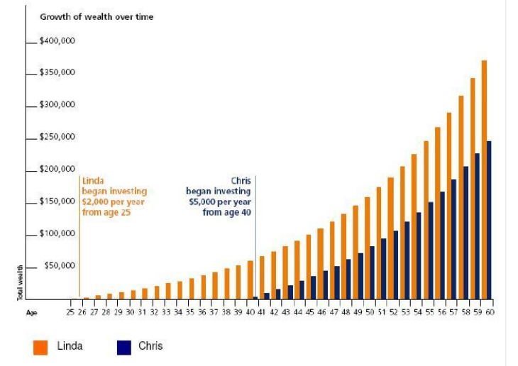

- Complete the following table from the above graph:

Total Invested | Investment Amount | Number of Years Invested | Total Invested | Value at Age 60
Linda
Chris
- Using the table over the page answer the following questions:

- Which class has had the highest return overall?
- Which class has had the lowest return overall?
- The asset class with the least amount of risk is _______________?
- Discuss the returns across all asset classes in Dec 2008? Consider why this could be the case.
- How does diversification spread risk?
*Volatility is the pace at which prices move higher or lower, and how wildly they swing.
