Draw a sketch of a ‘good graph’ and indicate where marks are usually allocated on a test/exam:

What is the difference between validity and reliability in scientific investigations….. give examples of how we might ensure experiments are valid and reliable:

Label the cell diagram. Give the function of each organelle:
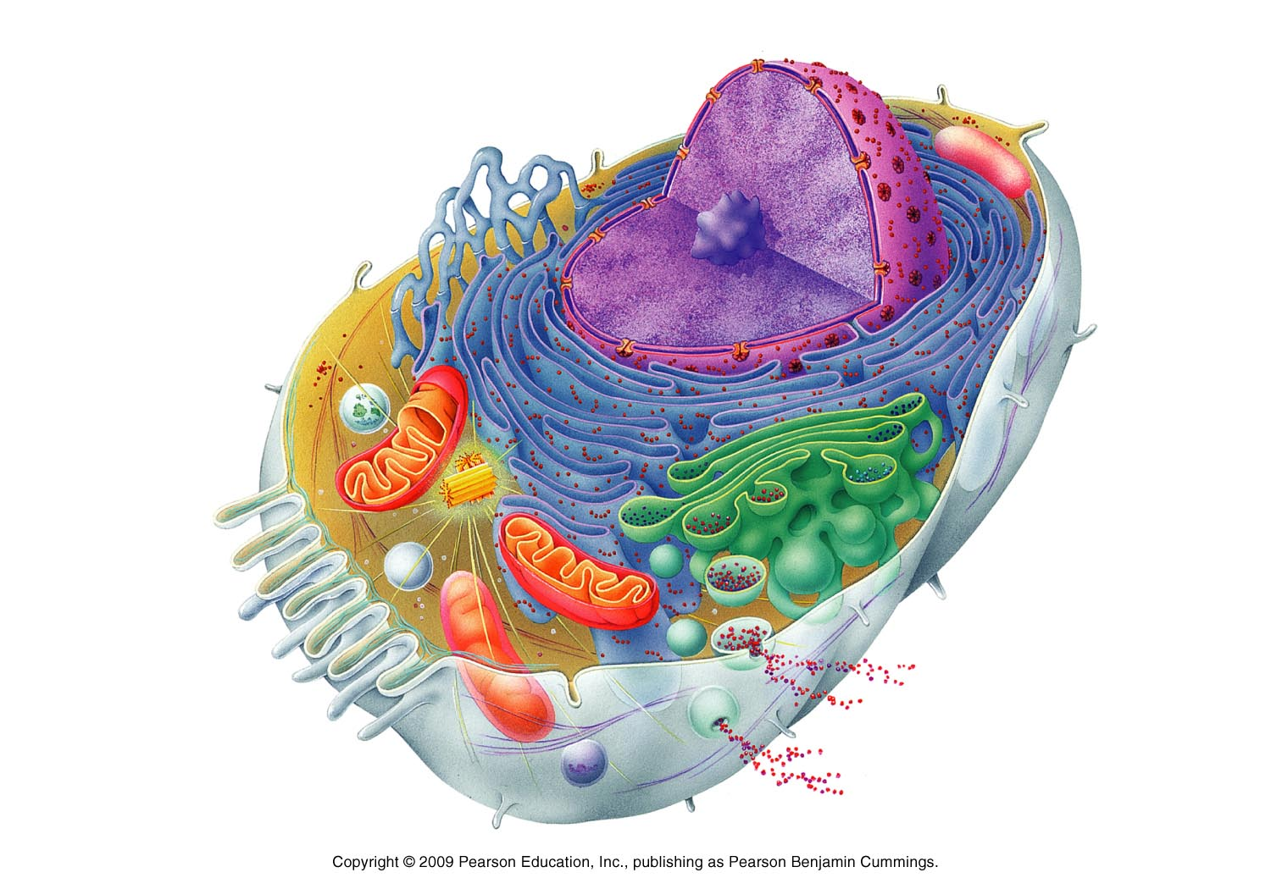

Draw a diagram of the cell membrane and account for it being described as fluid mosaic:

Compare and contrast passive and active transport. Give examples of different types of active and passive transport and indicate which substances are moved across a membrane in this way:

What are the characteristics of connective tissues? Where are they found in the body?

Name and describe the three types of muscle tissues:

Draw a diagram of the lock and key model of enzyme action:

Name and describe the factors that affect enzyme activity:

Draw a diagram of the ATP cycle and explain how this cycle works:

Compare and contrast anaerobic and aerobic respiration:

Draw a diagram to show anaerobic and aerobic respiration in the cell:

