1.4 Scientists present their data accurately

Student worksheet answers (pages 8–9)

Representing and interpreting results
1 Consider the following set of data:

a What is the average age of students?
((6+13+13+14+12+13+15+14+12+13+13+15)÷12)=12.75 = 13
b What does the average represent?
the age of the majority of students
c Which value is the outlier?
age of 6
d What is an outlier?
a value that is far away from the main group of data
e What is the median?
13
f What does the median represent?
the middle value
g What is the mode?
13
h What does the mode represent?
The most common number
2 Graph the data of the temperature rise of boiling water in a scatterplot on the graph paper provided below.
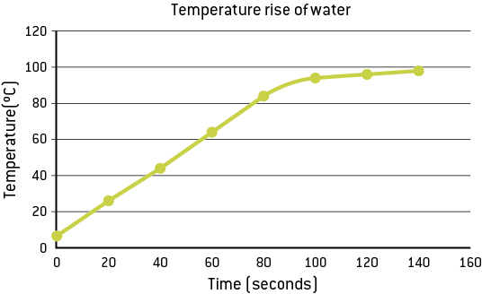
3 What is the relationship between the data in the graph you drew in question 2?
high positive correlation for 80 secs then decreases over time
4 Match the graph with the relationship within its data:
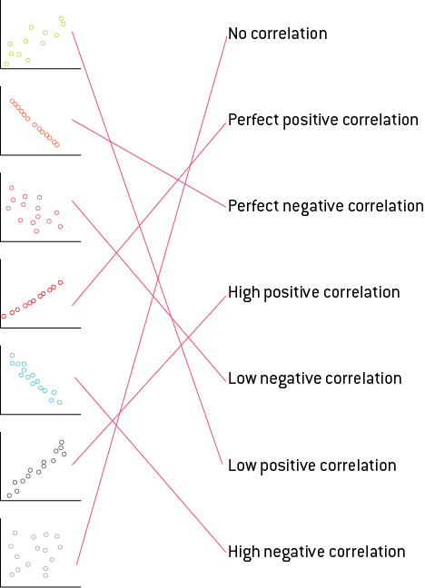

EXTEND YOUR UNDERSTANDING
5 An experiment was conducted to determine how far a wind-up toy truck would move with different weights in its flat tray. The following data were obtained: with no weights the car moved 1 m, with 50g of weight the car moved 90 cm, with 100 g of weight the car moved 80 cm, with 150 g of weight the car moved 70 cm, with 200 g of weight the car moved 60 cm, and with 250 g of weight the car moved 50 cm.
a Place the data into the results table below.
Weight (g) | Distance travelled (cm)
0 | 100
50 | 90
100 | 80
150 | 70
200 | 60
250 | 50
b Graph the data onto graph paper below.
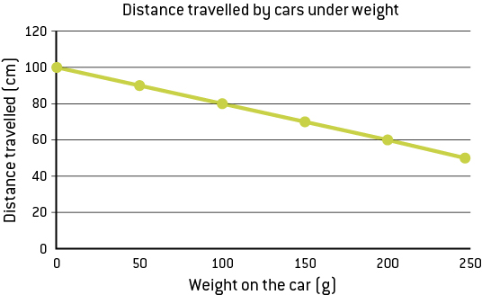
c What is the average distance that the car travelled?
((100+90+80+70+60+50)÷6) = 75cm
d What does the average represent?
the distance of the majority of the runs
e Is there an outlier? How do you know?
No, because no value is dramatically different from others.
f What is the relationship between data points on the graph?
perfect negative correlation
g Calculate the slope of the line using the formula slope = rise ÷ run.
-10 ÷ 50 = -0.2
h Using the slope of your line, calculate how far the car will travel with 400g of weight:
y = mx + c, m= -2 and c = y intercept = 100
y = mx + c = 0.2 x 400 + 100 = 20cm The car will travel 20cm

i What is the minimum weight necessary for the car to be unable to move? That is, how much weight should you add to make it immobile?
y = mx + c, therefore when y=0 the car is immobile
y = mx + c, 0 = -2 x x + 100, -100 = -0.2x, x = -100÷-0.2, 500g The car will not move under 500g weight
j What is the independent variable?
weight on top of the car
k What is the dependent variable?
the distance travelled by the car
l What is the relationship between the dependent and independent variables?
As the weight increases, the distance decreases.

