Making Science Graphs and Interpreting Data
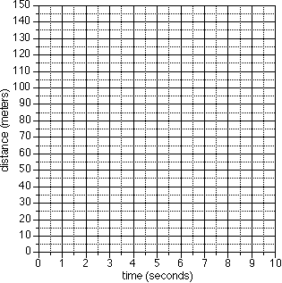
Scientific Graphs:
Most scientific graphs are made as line graphs. There may be times when other types would be appropriate, but they are rare.
The lines on scientific graphs are usually drawn either straight or curved. These "smoothed" lines do not have to touch all the data points, but they should at least get close to most of them. They are called best-fit lines.
In general, scientific graphs are not drawn in connect-the-dot fashon.

Here are two examples of best-fit graph lines.
One is drawn correctly, the other is not.
Best-Fit Line #1 | Best-Fit Line #2
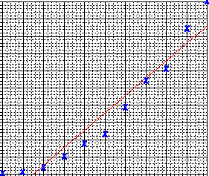 | 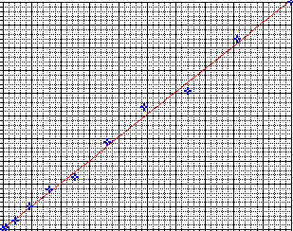
Graphs are made using:
- Paper
- Microsoft Excel

Practice Interpreting Data:
In addition to drawing graphs, it is also important that you be able to intrepret data that is represented in graph form. The following examples are provided to help you develop the ability to read information shown on a graph.

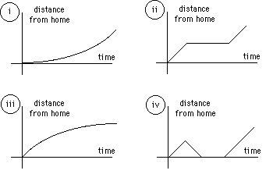
- Identify the graph that matches each of the following stories:
  - I had just left home when I realized I had forgotten my books so I went back to pick them up.
  - Things went fine until I had a flat tire.
  - I started out calmly, but sped up when I realized I was going to be late.

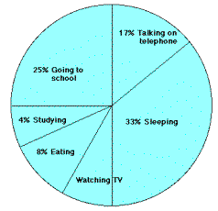
- The graph at the right represents the typical day of a teenager. Answer these questions:
  - What percent of the day is spent watching TV?
  - How many hours are spent sleeping?
  - What activity takes up the least amount of time?
  - What activity takes up a quarter of the day?
  - What two activities take up 50% of the day?
  - What two activities take up 25% of the day?

- Answer these questions about the graph at the right:
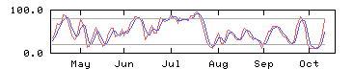
  - How many sets of data are represented?
  - On approximately what calendar date does the graph begin?
  - In what month does the graph reach its highest point?

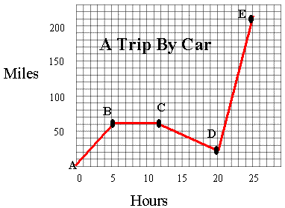
- Answer these questions about the graph on the right:
  - How many total miles did the car travel?
  - What was the average speed of the car for the trip?
  - Describe the motion of the car between hours 5 and 12?
  - What direction is represented by line CD?
  - How many miles were traveled in the first two hours of the trip?
  - Which line represents the fastest speed?
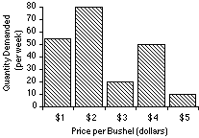
- Answer these questions about the graph at the right:
  - What is the dependent variable on this graph?
  - Does the price per bushel always increase with demand?
  - What is the demand when the price is 5$ per bushel?

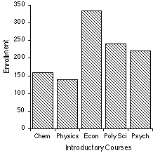
- The bar graph at right represents the declared majors of freshman enrolling at a university. Answer the following questions:
  - What is the total freshman enrollment of the college?
  - What percent of the students are majoring in physics?
  - How many students are majoring in economics?
  - How many more students major in poly sci than in psych?

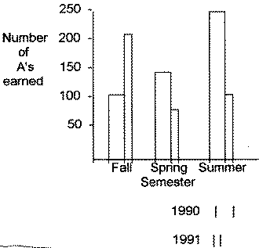
- This graph represents the number of A's earned in a particular college algebra class. Answer the following questions:
  - How many A's were earned during the fall and spring of 1990?
  - How many more A's were earned in the fall of 1991 than in the spring of 1991?
  - In which year were the most A's earned?
  - In which semester were the most A's earned?
  - In which semester and year were the fewest A's earned?

- Answer these questions about the graph at the right:
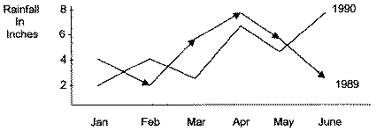
  - How much rain fell in Mar of 1989?
  - How much more rain fell in Feb of 1990 than in Feb of 1989?
  - Which year had the most rainfall?
  - What is the wettest month on the graph?

9. Answer these questions about the data table:  - What is the independent variable on this table?  - What is the dependent variable on this table?  - How many elements are represented on the table?  - Which element has the highest ionization energy?  - Describe the shape of the line graph that this data would produce? | Atomic Number Ionization Energy (volts)  2 24.46  4 9.28  6 11.22  8 13.55  10 21.47

- Answer the following using the data table:
Solar System Data Table

Name | Orbits | Distance (000 km) | Radius (km) | Mass (kg)
Sun |  |  | 697000 | 1.99 x 1030
Jupiter | Sun | 778000 | 71492 | 1.90 x 1027
Saturn | Sun | 1429000 | 60268 | 5.69 x 1026
Uranus | Sun | 2870990 | 25559 | 8.69 x 1025
Neptune | Sun | 4504300 | 24764 | 1.02 x 1026
Earth | Sun | 149600 | 6378 | 5.98 x 1024
Venus | Sun | 108200 | 6052 | 4.87 x 1024
Mars | Sun | 227940 | 3398 | 6.42 x 1023
Titan | Saturn | 1222 | 2575 | 1.35 x 1023
Mercury | Sun | 57910 | 2439 | 3.30 x 1023
Callisto | Earth | 1883 | 2400 | 1.08 x 1023
Io | Jupiter | 422 | 1815 | 8.93 x 1022
Moon | Jupiter | 384 | 1738 | 7.35 x 1022
Europa | Jupiter | 671 | 1569 | 4.80 x 1022
Triton | Neptune | 355 | 1353 | 2.14 x 1022
Pluto | Sun | 5913520 | 1160 | 1.32 x 1022

- How many planets are represented?
- How many moons are represented?
- Which moon has the largest mass?
- Which planet has a radius closest to that of Earth?
- How many moons are larger than the planet Pluto?
- Which of Jupiter's moons orbits closest to the planet?
- Which planet is closest to Earth?
Graphing Practice Problem #1
Oxygen can be generated by the reaction of Hydrogen Peroxide with Manganese Dioxide.
2H₂O₂ + MnO₂ 2H₂O + Mn + 2O₂
A chemistry class sets up nine test tubes and places different masses of MnO₂ in each test tube. An equal amount of H₂O₂ is added to each test tube and the volume of gas produced is measured each minute for five minutes. The data from the experiment is:
Tube # | MnO₂ (g) | 1 min (ml O₂) | 2 min (ml O₂) | 3 min (ml O₂) | 4 min (ml O₂) | 5 min (ml O₂)
1 | 0.1 | 1.4 | 2.6 | 3.5 | 4.2 | 5.1
2 | 0.2 | 2.8 | 4.6 | 5.8 | 7.1 | 7.6
3 | 0.3 | 4.9 | 7.2 | 8.8 | 10.2 | 11.3
4 | 0.5 | 5.9 | 8.5 | 10.4 | 11.8 | 13.3
5 | 1.0 | 8.5 | 12.4 | 14.4 | 16.1 | 17.1
6 | 1.5 | 11.0 | 14.8 | 17.5 | 19.8 | 21.8
7 | 2.0 | 12.0 | 17.0 | 20.2 | 22.7 | 24.8
8 | 2.5 | 13.6 | 19.0 | 22.1 | 24.7 | 27.3
9 | 3.0 | 16.2 | 21.8 | 25.1 | 28.2 | 30.4
- What volume of O₂ did tube #3 produce between the second and fourth minutes?
- How much O₂ is produced in tube #5 during the first two minutes?
- How much oxygen did tubes 7 and 8 produce together during the third minute?
- What volume of oxygen gas, in liters, was produced during this procedure?
- Graph the amount of oxygen produced each minute in test tubes # 2, 4, and 6.
- By comparing the slope of the graph curves, which tube was producing oxygen at the fastest rate between minutes four and five?
- Make a graph using the mass of manganese dioxide and the volume of oxygen for all tubes at five minutes.
Graphing Practice Problem #2
Age of the tree in years | Average thickness of the annual rings in cm.  Forest A | Average thickness of the annual rings in cm.  Forest B
10 | 2.0 | 2.2
20 | 2.2 | 2.5
30 | 3.5 | 3.6
35 | 3.0 | 3.8
50 | 4.5 | 4.0
60 | 4.3 | 4.5

- The thickness of the annual rings indicate what type of environmental situation was occurring at the time of its development. A thin ring, usually indicates a rough period of development. Lack of water, forest fires, or a major insect infestation. On the other hand, a thick ring indicates just the opposite.
- Make a line graph of the data.
- What is the dependent variable?
- What is the independent variable?
- What was the average thickness of the annual rings of 40 year old trees in Forest A?
- Based on this data, what can you conclude about Forest A and Forest B?
Graphing Practice Problem #3a
Time ( seconds ) | Distance ( meters )
0 | 0
1 | 2
2 | 8
3 | 18
4 | 32
5 | 50
6 | 72
7 | 98
8 | 128
9 | 162
10 | 200
- Graph the data.
- What does this graph represent?

Graphing Practice Problem #3b
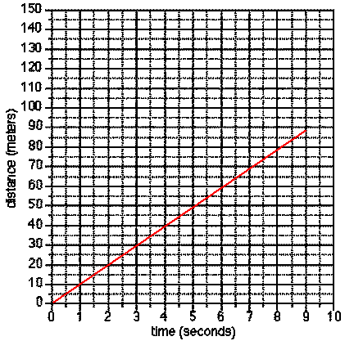
A. What type of motion does this graph represent?
B. Put the data from this graph into a table.
Graphing Practice Problem #3c
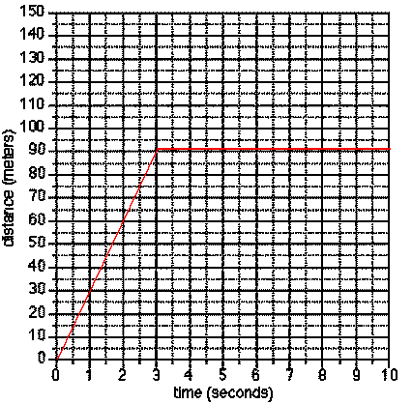
A. Describe what happens during the time represented by this graph.
B. Put the data from this graph into a table.

