Name: ____________________________ Due Date: _____________________
Comparing Respiratory Systems
In class you will learn about the function of the respiratory system. You will have a look at the structures mammals have to enable gas exchange to occur. You will also see that fish do not have lungs like mammals and instead use gills to perform gas exchange.
This task requires you to compare the respiratory structures of mammals and fish with the respiratory structures of amphibians.
The amphibian that we are going research is a frog.

You will need to do some research to answer the following questions:
- Complete the table below
(8 marks)
Group Organism | Examples: | Environment organism lives in | Respiratory organ/s needed for gas exchange
Mammal | - Humans  - ___________ | Mainly Land | Lungs
Fish | - Snapper  - ___________ | Water | Gills
Amphibians | - Frog  - ___________ | - _________  - _________ | - _________  - _________  - _________

- On the diagram of the frog below label the three (3) respiratory organs:
(3 marks)
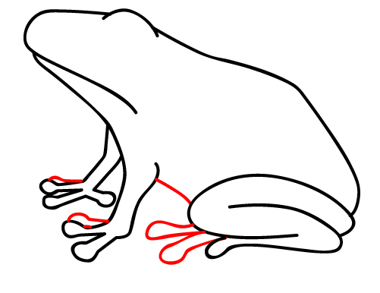

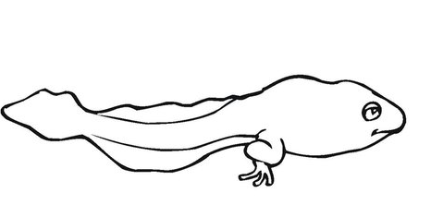

- Why must the skin of a frog remain moist?
(2 marks)

- Frogs are said to be cold – blooded. Cold blooded organisms are also called (fill in the blank): ____________________
(1 mark)

Does being cold blooded require more or less energy than being warm blooded? Why?
(1 mark)

- Humans move air in and out of their lungs using their diaphragm and intercostal muscles between the ribs. As these muscles contract and relax the volume of the lungs and the pressure of air in the lungs changes.
Frogs don’t have ribs or a diaphragm. Explain how frogs more air in and out of their lungs? You may like to use a diagram to explain your answer.
(5 marks)

You must provide at least four (4) references that assisted you to complete this task. List these in the table provided: (4 marks)
Book Title/ Website URL | Author | Date Published/Last edited | Date Accessed

Total Marks /24

