Year 11: Human Biology. Digestive System

Useful link: http://classes.midlandstech.edu/carterp/Courses/bio211/chap23/chap23.htm

1. Label the following diagram of the digestive system.

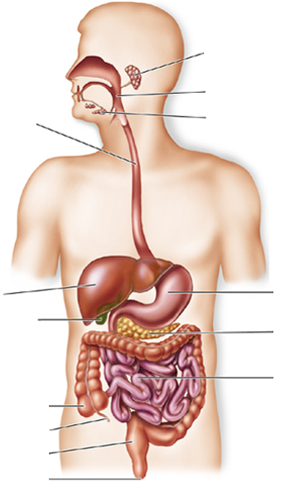

2. a) Why is it important to eat a balanced diet?

b) Most of the food we eat contain carbohydrates, proteins and lipids. Give the ‘building blocks’ for these nutrients as well as RNA and DNA.

c) What are the advantages of eating a diet that is high in both soluble and insoluble fibre?

3. a) Describe, with the assistance of a diagram, the structure of the Alimentary Canal

b) How is this structure different in the stomach?

c) In terms of alimentary canal structure: state the similarities and differences between the small and large intestines.

4. Describe the difference between Mechanical and Chemical digestion.

5. Label the name of the teeth shown in the diagram below:
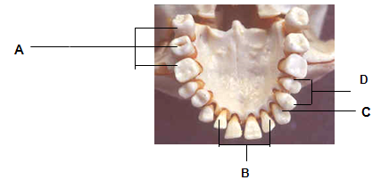

6. Some digestive organs secrete other substances. For each of the following substances, outline where it is produced and its role in the body.

a) Hydrochloric acid

b) Bile

c) Rennin

7. Mucus produced from the mucosa layer of the alimentary canal, assists in the lubrication of food contents as it is moved along the digestive tract. Outline another function of mucus in the digestive system.

8. State two other function of the liver, other than its role in producing bile.

9. Complete the table by describing any mechanical and/or chemical digestion that occurs in the organs listed.

 | Mechanical | Chemical
Mouth
Stomach
Small Intestines
Large Intestine

10. What is a sphincter and what is the function in the body?

11. Describe the following processes in terms of location/s in the body and how it assists in food propulsion:

a) Swallowing

b) Peristalsis

c) Segmentation

11 a) The structure of the small intestine is specially adapted for absorption to occur efficiently. Outline the structures/reasons below that increase the surface area and assist in the absorption at the small intestines.

b) Draw a diagram of a villus below and label the structures (blood/capillary network, lacteal, epithelial cells, microvilli

c) Why are villi so small and so numerous?

c) Outline the pathway for the following nutrients (note: assume the nutrients are present inside the lumen of the small intestines and are in their simplest units). You must outline the pathway - until it reaches the blood system.

i. fatty acids + glycerol

ii. amino acids

iii. monosaccharides

iv. vitamins and minerals

v. water

12. a) Outline the role of bacteria in the large intestines.

b) Why is defecation described as an elimination process, rather than an excretion process?

13. What effect would each of the following have on the speed with which food moves through the alimentary canal?

i. consuming alcohol

ii. consuming a very large meal

iii. consuming a meal that is very high in fat

14. Complete the table below on the common diseases of the digestive system:

Disease / Complication | Cause | Effect on the body | Treatment/s
Constipation

Diarrhoea

Bowel Cancer

Coeliac disease

Obesity

Anaemia

Gallstones

Liver disease

Anorexia

Type 2 Diabetes

Diverticulitis

