Revision for the year 9 Common Assessment Task:

Key Word | Synonyms | Definition
Context | Background information | the set of circumstances or facts that surround a particular event, situation, etc
Bias | Prejudice, preference, bigotry | a particular inclination, feeling, or opinion, especially one that is preconceived or unreasoned
Perspective | Viewpoint, attitude, angle | a mental view or prospect
Elements | Written: Metaphors, similes, analogies, etc.  Image: caricatures, colour imagery, captions, titles, etc. | The deliberate visual depictions or representations of certain people, objects, events in the image – or – the use of specific tone, wording, analogies or phrases in written sources
Justify | PROVIDING EVIDENCE, defend, explain, validate | to defend or uphold as warranted or well-grounded
Analyse | scrutinise, interpret, inspect | To examine in detail in order to discover meaning, essential features, etc.
Evaluate | calculate, weigh up, assess | to judge or determine the significance, worth, or quality
Message | directive, main point, memorandum | the point, moral, or meaning
Identify | describe, name, establish | To recognise or establish as being a particular person, motive, idea, cause, etc.
Purpose | reason, intent, direction | the reason for which something exists or is done, made

Go through the sample questions and use a highlighter to identify these key words in the sample questions.

How many words did you highlight in total? _______________

SOURCE A: “IT IS NICE IN THE SURF…” 1915

- Identify the historical context of Source A

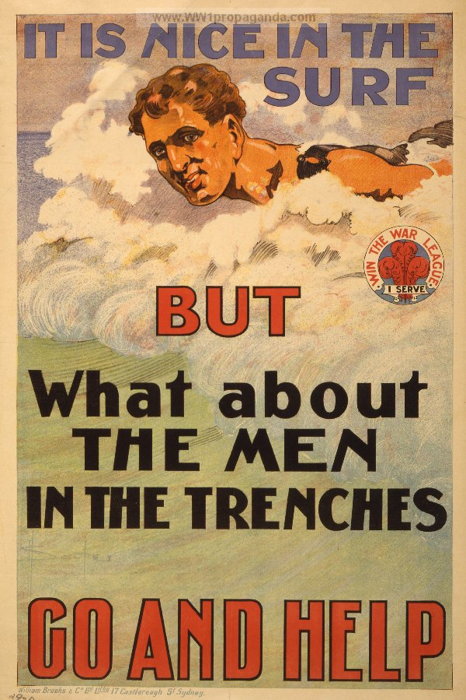
___________________________________________________________________________________________________________________________________________________________________________________________________________________________________________________________________________________________________________________________________________________________________________________________________________________________________________________________________________________________________________________________________________________________________________________________________________________________________________________________________________________________________________________________________________________________________________________________________________________________________________________________________________________________________________________________________________________________________________________________________________________________________________________________________________________________________________________________________________________________________________________________________________________________________________________________________________________________________________________________________________________________________________________________________________________________________________________________________________________________________________________________________________________________________________________________

- Identify any perspective of Source A.
___________________________________________________________________________________________________________________________________________________________________________________________________________________________________________________________________________________________________________________________________________________________________________________________________________________________________________________________________________________________________________________________________________________________________________________________________________________________________________________________________________________________________________________________________________________________________________________________________________________________________________________________________________________________________________________________________________________________________________________________________________________________________________________________________________________________________________________________________________________________________________________________________________________________________________________________________________________________________________________________________________________________________________________________________________________________________________________________________________________________________________________________________________________________________________________________

SOURCE B: "GOD BLESS DADDY" 1918 (propaganda circulated during WWI)
- Identify and explain the historical purpose of source B
___________________________________________________________________________________________________________________________________________________________________________________________________________________________________________________________________________________________________________________________________________________________________________________________________________________________________________________________________________________________________________________________________________________________________________________________________________________________________________________________________________________________________________________________________________________________________________________________________________________________________________________________________________________________________________________________________________________________________________________________________________________________________________________________________________________________________________________________________________________________________________________________________________________________________________________________________________________________________________________________________________________________________________________________________________________________________________________________________________________________________________________________________________________________________________________________
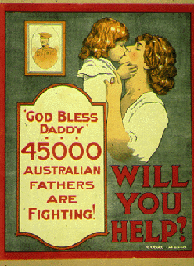

SOURCE C: "ANZAC BRAVERY"(published 2005)
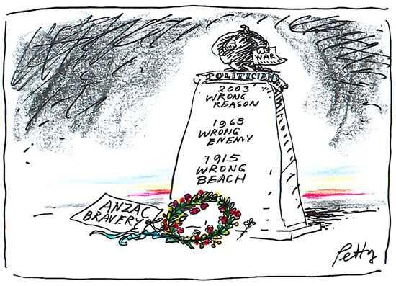

- Circle the elements of source C and give a brief explanation of their meaning on the following page.
(Some have been listed on the next page to assist you)

Element: | Meaning
Politician holding document of war on top of memorial
“2003 Wrong reason” | The allied forces went to war with Iraq over assumed weapons of mass destruction, of which there were none - the ‘wrong reason’.
“1965 wrong enemy” | Australia and America entered into the Vietnam War, which was increasing in 1965. The war was largely fought between America and the USSR, but was instead being fought in Vietnam using the North and South Vietnamese peoples - The ‘wrong enemy’.
“1915 wrong beach”

- What is the message of source C?

TOP TIPS BOX:
Start with one -to- three sentences directly answering the question:
Explain WHY/HOW you know this [JUSTIFY]: (refer to the source and reflect on how it echoes the historical context)

____________________________________________________________________________________________________________________________________________________________________________________________________________________________________________________________________________________________________________________________________________________________________________________________________________________________________________________________________________________________________________________________________________________________________________________________________________________________________________________________________________________________________________________________________________________________________________________________________________________________________________________________________________________________________________________________________________________________________________________________________________________________________________________________________________________________________________________________________________________________________________________________________________________________________________________________________________________________________________________________________________________________________________________________________________________________________________________________________________________________________________________________________________________________________________________________________________________________________________________________________________________

Source D: ‘A Voice from ANZAC’: a pencil sketch by the artist Will Dyson
Drawing for cartoon: ‘Funny thing Bill – I keep thinking I hear men marching!’

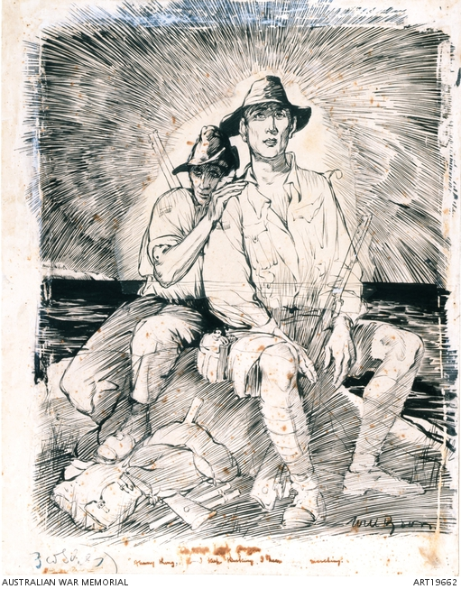
- What is the purpose of Source D? Justify you response
___________________________________________________________________________________________________________________________________________________________________________________________________________________________________________________________________________________________________________________________________________________________________________________________________________________________________________________________________________________________________________________________________________________________________________________________________________________________________________________________________________________________________________________________________________________________________________________________________________________________________________________________________________________________________________________________________________________________________________________________________________________________________________________________________________________________________________________________________________________________________________________________________________________________________________________________________________________________________________________________________________________________________________________________________________________________________________________________________________________________________________________________________________________________________________________________

SOURCE E: “SYDNEY MORNING HERALD EXTRAXT…”

- Justify how the message of Source E supports the ANZAC legend.

Australia fed 331,781 young men into the World War I mincer of France, Belgium, Gallipoli and the Middle East. Almost 60,000 never came home. Of those who did, 213,000 returned wounded, either in body or mind. Another 85,000 Australians enlisted but did not serve overseas. In a nation of just 4 million, 416,809 of its men - all volunteers - were in uniform at some time during the years 1914-18.
___________________________________________________________________________________________________________________________________________________________________________________________________________________________________________________________________________________________________________________________________________________________________________________________________________________________________________________________________________________________________________________________________________________________________________________________________________________________________________________________________________________________________________________________________________________________________________________________________________________________________________________________________________________________________________________________________________________________________________________________________________________________________________________________________________________________________________________________________________________________________________________________________________________________________________________________________________________________________________________________________________________________________________________________________________________________________________________________________________________________________________________________________________________________________________________________
Shameful history of a desecration, SMH, 16 April 2005

