Student worksheet answers

7.8 Work occurs when an object is moved or rearranged. Energy can be calculated
Pages 170–171

Work, kinetic energy, gravitational potential energy and elastic potential energy
1 Complete the table by defining the key terms.
Term | Definition
Work | Occurs whenever an object is moved by a force
Kinetic energy | The energy possessed by moving objects
Gravitational potential energy | The energy possessed by objects raised to a height in a gravitational field
Elastic potential energy | The energy possessed by stretched or compressed objects
2 Complete the flow chart below (Figure 1) that shows the energy transformations (work) for a bouncy ball falling to the ground and bouncing back up again. Where necessary, use g = 9.80 m s^{–2}. Converting units: 1000 joules (J) = 1 kilojoule (kJ).

3 How much work has to be been done on a stationary car of mass 1800 kg to get it travelling at a speed of 110 km h^{–1}?
A 0 J
B 2.8 × 10⁴ J
C 9.9 × 10⁴ J
D 8.4 × 10⁵ J
E 1.1 × 10⁷ J

$v=112 \text{km} {\text{h}}^{-1}÷3.6=31.1 \text{m} {\text{s}}^{-1}$, $m=1 800 \text{kg}$
$$\text{KE}=\frac{1}{2}mv^{2}$$
$$=\frac{1}{2}×1 800×{31.1}^{2}$$
$$=870489 \text{J}$$
$$=8.7×{10}^{5} J$$
Hence, D is the correct answer.
4 Without changing its mass, what effect will decreasing an object’s speed from 15.0 m s^{–1} to 5.0 m s^{–1} have on its kinetic energy?
A Its kinetic energy will remain unchanged.
B Its kinetic energy will be a third of what it was initially.
C Its kinetic energy will decrease by a factor of nine.
D Its kinetic energy will increase by a factor of nine.
E Its change in kinetic energy cannot be determined from the information provided.
$u=15.0 \text{m} {\text{s}}^{-1}$, $v=5.0 \text{m }{\text{s}}^{-1}$, $m=m \text{kg}$
$$\text{KE}=\frac{1}{2}mv^{2}$$
$${\text{KE}}_{\text{before}}=\frac{1}{2}×m{×15.0}^{2}$$
$$=112.5m \text{J}$$
$${\text{KE}}_{\text{after}}=\frac{1}{2}×m{×5.0}^{2}$$
$$=12.5m\text{ J}$$
$$\frac{{\text{KE}}_{\text{after}}}{{\text{KE}}_{\text{before}}}=\frac{12.5m }{112.5m}=\frac{1}{9}$$
Hence, C is the correct answer.

5 How much gravitational potential energy does a 250-g kite have if it is hovering 30 m above the ground?
A 0 J
B 73.5 J
C 735 J
D 73.5 kJ
E 73 500 kJ
$m=250 \text{g}÷1000=0.25 \text{kg}$, $h=30 \text{m}$, $g=9.80 \text{m} {\text{s}}^{-2}$
$$\text{GPE}=mgh$$
$$=0.25×9.80×30$$
$$=73.5 J$$
Hence, B is the correct answer.

Extend your understanding
6 Figure 2 shows a toy gun. Inside the gun, there is a spring that is compressed a total distance of 5.0 cm by pushing a suction-capped dart into its barrel. Figure 3 shows a graph of the spring’s force (N) against compression distance (m).
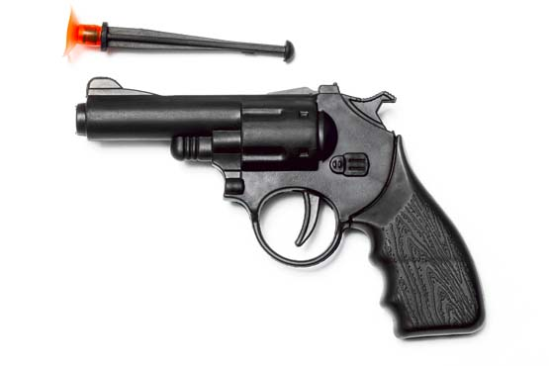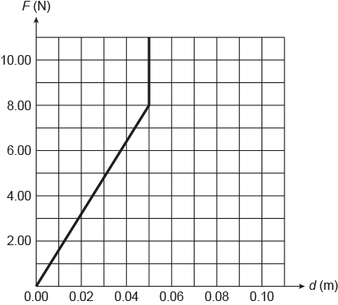
The energy stored in a spring can be determined by calculating the area underneath its force (N) against extension (m) graph.
How much energy is stored in the spring when it is compressed by 5.0 cm?
The energy stored in the spring will be equal to the area underneath its force (N) against extension (m) graph.
$$EPE=\frac{1}{2}×0.05×8.00=0.20 J$$

