7.2 The digestive system is made up of organs

Student worksheet answers (pages 118–119)

The digestive system
1 What is digestion?
When foods are broken down and absorbed into the blood to be transported to the cells
2 What are nutrients?
Substances that provide nourishment, which is essential for the maintenance of life and for growth
3 How do nutrients travel to where they are needed within the body?
The blood pushes nutrients through the body
4 What is chemical digestion? Give an example.
The breakdown of foods by enzymes and acids; for example, saliva contains enzymes that start chemical digestion
5 What is mechanical digestion? Give an example.
Organs work as machines, physically breaking food into smaller pieces; for example, mouth/teeth
6 Label the following diagram of the mouth.
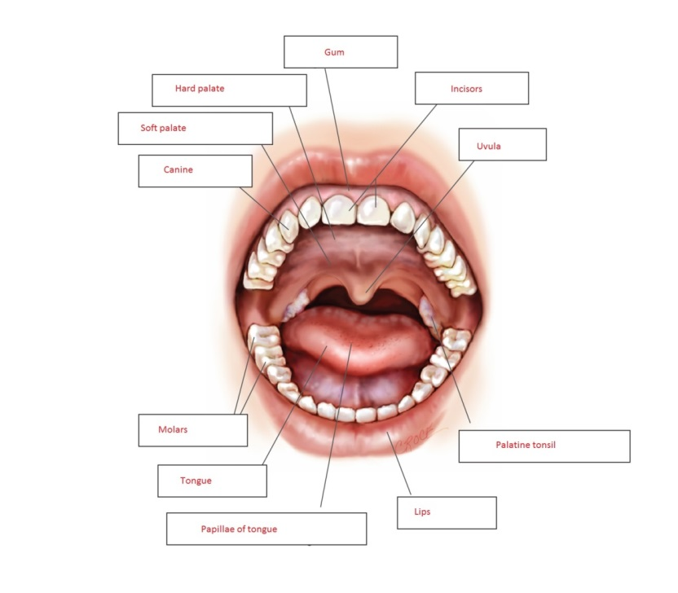
7 Label the following diagram of the digestive system.
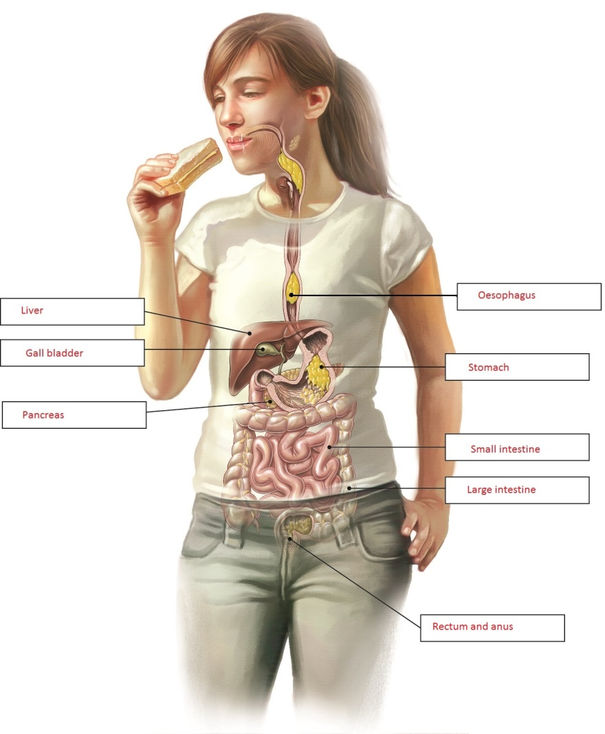
8 Match the organ with its function.
ORGAN | FUNCTION
1 Stomach | E Stores food for about three hours while it uses gastric juice to help digest it
2 Liver and gall bladder | H Makes a mixture of chemicals called bile, which is used to digest fat and neutralise (deactivate) stomach acid
3 Mouth | G Location of salivary glands that make saliva, which contains enzymes to start chemical digestion
4 Rectum and anus | D Stores faeces until it starts to become full, then pushes the faeces out of a ring of muscle
5 Large intestine | F Where water and some vitamin absorption occurs; it is the body’s last chance to absorb nutrients
6 Oesophagus | B Tubular muscle that forces food down to your stomach in a process called peristalsis
7 Pancreas | A Makes a type of juice that contains a mixture of digestive enzymes, and also neutralises stomach acid
8 Small intestine | C Absorbs nutrients that feed all cells of the body; villi help to increase the surface area of this organ for better absorption

Extend your understanding
9 The human body contains enzymes to aid in the chemical breakdown of foods. What is an enzyme?
A substance produced by living organisms that helps make chemical reactions happen
10 Research the following five enzymes: amylase, pepsin, protease, lactase, lipase
From what you have learned, complete the following sentences by matching each enzyme with its function and correct organ in the digestive system:
a Amylase is able to break down starch into sugars and is found in the mouth and small intestine
b Pepsin is able to break down proteins into amino acids and is found in the stomach
c Protease is able to break down proteins into amino acids and is found in the stomach and small intestine
d Lactase is able to break down lactose into smaller sugars (glucose and galactose) and is found in the small intestine
e Lipase is able to break down fats and oils into fatty acids and glycerol and is found in the small intestine
11 What is the function of bile?
It is secreted into the small intestine where it emulsifies (breaks down) fats and neutralises
stomach acid
12 Why is bile not considered to be an enzyme?
It is alkaline (a base), which neutralises highly acidic stomach acid. Once it has been neutralised, the remaining enzymes are able to work. Bile helps enzymes to work better.

