- Copyright for test papers and marking guides remains with West Australian Test Papers.
- The papers may only be reproduced within the purchasing school according to the advertised conditions of sale.
- Test papers must be withdrawn after use and stored securely in the school until Wednesday 1st July 2015.

YEAR 11 CHEMISTRY
UNIT 1
2015

MARKING GUIDE

Question No. | Answer
1 | C
2 | C
3 | B
4 | D
5 | D
6 | C
7 | C
8 | D
9 | C
10 | B
11 | D
12 | D
13 | A
14 | D
15 | B
16 | B
17 | D
18 | D
19 | D
20 | C
21 | C
22 | C
23 | C
24  25 | C  B

Section Two: Short answer 46% (60 marks)

This section has 12 questions. Answer all questions. Write your answers in the spaces provided.

When calculating numerical answers, show your working or reasoning clearly. Express numerical answers to the appropriate significant figures and include appropriate units where applicable.

Spare pages are included at the end of this booklet. They can be used for planning your responses and/or as additional space if required to continue an answer.
- Planning: If you use the spare pages for planning, indicate this clearly at the top of the page.
- Continuing an answer: If you need to use the space to continue an answer, indicate in the original answer space where the answer is continued, i.e. give the page number. Fill in the number of the question(s) that you are continuing to answer at the top of the page.

Suggested working time: 60 minutes.

26. Isotopes of carbon are used to determine the age of fossilised organic samples dug up by archaeologists.

- Explain what is meant by the term isotope. (2 marks)

Two or more forms of same element with same # protons and electrons (1)
and different number of neutrons (1)

- Explain why isotopes of the same element have the same chemical properties.
(2 marks)
Chemical properties describe reactivity which is due principally to electronic configuration (1)
Isotopes of same element have same number of protons and same number of electrons (1)
- Calculate the mass, in grams, of a single atom of the isotope carbon-12.
(2 marks)
n (C) in a mole = 6.022 x 10²³ atom

Therefore m (C atom) = 12.00/6.022x10²³
= 1.99 x 10⁻²³g

27. Draw electron-dot diagrams showing the arrangement of valence electrons in the following chemical species. (5 marks)
Represent all valence shell electron pairs either as : or –
Ethane C₂H₆ | Hydroxide ion OH⁻
H H  I I  H - C - C - H  I I  H H  1 for correct arrangement  1 for correct electrons  1 for no brackets or charge | 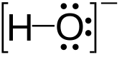  1 for correct electrons  1 for brackets and charge

28. (a)
½ mark each Total 3marks
atomic radius decreases
ionisation energy increases
electronegativity increases

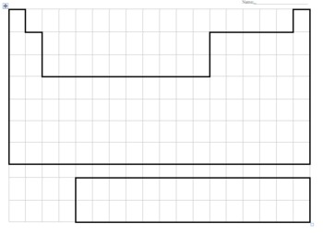
Atomic radius increases
Ionisation energy decreases
Electronegativity decreases
(b) Describe and explain the trends for atomic radius. (4 marks)
Atoms get bigger as you go down groups (1)
As we go down we are adding extra layers (shells, principal quantum levels) of electrons (1)
Atoms get smaller as you go across a period (1)
The atomic radius is being decreased because of increased nuclear charge (1)
___________________________________________________________________________________________________________________________________________________________

29. Complete the following table (4 marks)
SUBSTANCE | NAME | TYPE of BONDING
Ti | Titanium | metallic
CS2 | Carbon disulphide | Covalent
NH3 | Ammonia | Covalent
NH4Cl | Ammonium chloride | Covalent & Ionic (1/2 each)

30. Explain, with the aid of a diagram, how movement of electrons within an atom produces the emission spectra responsible for observations in flame tests. (4 marks)

Explanation must include photon absorption/ electron excitation/ photon emission.

2 for labelled diagram

When excited an electron moves to a higher energy level or orbital (1)
When the electron falls back to its ground state a photon of particular wavelength is emitted. (1) Must refer to diagram

31. A sample of gaseous vanadium is analysed by mass spectrometry. The vanadium atoms are first ionised then accelerated before being deflected. (2,1,1 marks)

(a) Describe briefly how positive ions are formed from gaseous vanadium atoms in a mass
spectrometer.

Electron beam ‘knocks’ outer electrons from atoms to create ions

(b) What is used in a mass spectrometer to accelerate the positive ions?

Ion accelerator or an electric field

(c )What is used in a mass spectrometer to deflect the positive ions?

Magnetic field or magnet.

32. Describe the differences in malleability and electrical conductivity for metals and ionic compounds. Explain these properties by referring to the bonding involved. (6 marks)

Metals are good conductors of electricity because ‘free electrons’ can carry the charge of an electric current when a potential difference is applied (1)
Metals are malleable because when planes of metal atom are bent or slide the mobile electrons can run in between the cations to maintain bond strength (1)
Bonding in metals is non-directional due to mobile electrons (1)
Ionic solid crystals do not conduct electricity because the ions are not free to move to carry a current (1) If the solid is dissolved in H₂O or melted the ions are free to carry a current (1)
Ionic solids are hard and brittle. When stressed the bonds are broken along the planes of ions (1)
OR ionic compounds are brittle because when the crystal lattice is distorted this causes like charged ions to be aligned which then repel causing crystal to shatter (1)
________________________________________________________________________________________________________________________________________________________________________________________________________________________________________________________________________________________________________________________________________________________________________________________________________________________________________________________________________________________________________________________________________________________________________________________________________________________________________________________________________________________________________________________________________________________________________________________________________________________
33. Compare the properties of hardness, melting point and electrical conductivity for a covalent molecular substance like water, and a covalent network substance like diamond. Explain the properties by referring to the bonding involved.
(6 marks)

Hardness – c.v. molecules are soft and weak due to weak intermolecular forces between molecules (1)
c.v. network are very hard due to continuous network of strongly bonded atoms (1)
Melting point – c.v. molecules have low melting points as little energy required to disrupt weak intermolecular forces (1)
c.v.network have very high mp due to all atom being strongly bonded to others (1)
electrical conductivity – c.v. molecular localised electrons so cannot conduct in any phase (1)
c.v.network (diamond) is a non-conductor due to localised electrons (1)
____________________________________________________________________________________________________________________________________________________________________________________________________________________________________________________________________________________________________________________________________________________________________________________________________________________________________________________________________________________________________________________________________________________________________________________________________________________________________________________________________________________________________________________________________________________________________________________________________________________________________________________________________________________________________________________________________________________________________________________________________________________________________________________________________________________________________________________
34. Diagram representing fractional distillation of crude oil.
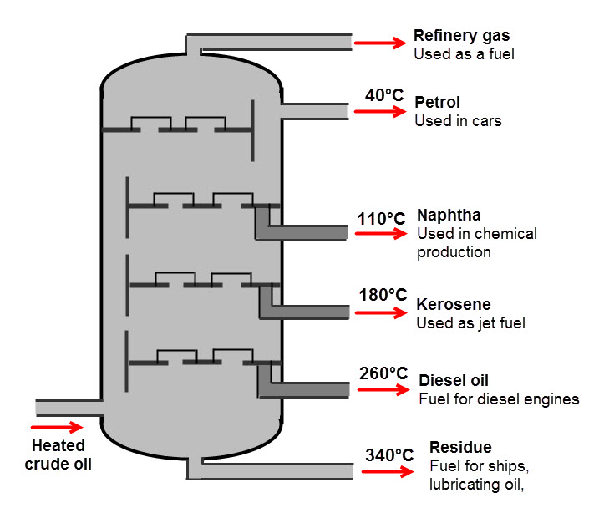
a) Give a brief description demonstrating your understanding of what is occurring in the diagram.
(3 marks)
Separation of hydrocarbons in crude oil(1) Oil is heated and enters column as a gas (1) Column is cooler towards the top and fractions condense and separate as they reach their BP. (1)

b) Name the physical property that the process depends upon (1 mark)

Boiling Point _________________________________________________________________________
c) Write an equation for the complete combustion of the alkane C₈H₁₈ (2 marks)
2C₈ H₁₈ + 25 O₂ 16CO₂ + 18H₂O (or ½ coeffiecients) _________________
35. Magnesium sulphate crystals have the formula MgSO₄.7H₂O . What loss of mass occurs when the water of crystallization is completely removed from 2.46 g of the crystals by gentle heating. (4 marks)

M(MgSO₄.7H₂O) = 246.49 gmol⁻¹ 1 mark
%(H₂O) = 126.11/ 246.49 x 100 = 51.16% 2 marks
m(H₂O) lost = 2.46 x 51.16 x 100 = 1.258 = 1.26 g 1 mark
_________________________________________________________________________

36. Write a balanced equation for the following reactions.
- Sodium carbonate solid with dilute sulphuric acid (4 marks)

Na₂CO₃ (s) + 2H⁺ (aq) 2Na⁺ (aq) + CO₂ (g) + 2H₂O (l)

ionic 2 marks

molecular 1 mark
_______________________________________________________________________________________________________________________________________________

- Barium hydroxide solution mixed with zinc nitrate solution.

Zn²⁺ (aq) + 2OH – (aq) Zn(OH)₂ (s)
ionic 2 marks

molecular 1 mark

37. Write observations for any reactions that occur in the following procedures. In each case
describe in full what you would observe: (4 marks)
- Lead nitrate solution added to potassium iodide solution.

Two clear solutions combine to give a yellow precipitate 2 marks
_________________________________________________________________________

- An iron nail is dropped into dilute nitric acid.

Silver metal nail reacts with clear solution to give colourless gas and pale green (or pale brown) solution.
________________________________________________________________________

END OF SECTION TWO
Section Three: Extended answer 35% (45 marks)

Question 38. (6 marks)

The annual contribution of Western Australia's mineral and petroleum industry to the Australian economy is well over $100 billion dollars. The industry employs approximately 100,000 people. Drug testing is an important process where Chemists are employed to ensure that the workplace remains safe. All employees are subjected to a stringent drug testing regime before they enter the workplace in addition to testing whilst they are on site.

Despite their best efforts, mining inspectors claim that synthetic drug use remains a major issue in the industry. It seems that synthetic versions of cannabis and ‘ice’ or crystal methamphetamine, in particular, are changing rapidly to avoid detection.

- A sample of suspected crystal methamphetamine confiscated from one of the mine workers was submitted for analytical testing. The following data was obtained regarding the isotopic composition of elements present in the sample.

Identify the two elements present (2 marks)

Carbon (1) Zirconium (1)
___________________________________________________________________

b) Determine the relative atomic mass of each element. You must show your working to attain full marks. (4 marks)

A_{r}(C) = (12 x 98.9/100) + 13 x 1.1/100) = 12.011 2 marks
A_{r}(Zr) = (90 x 51.45/100) + (94 x 17.38/100) + (92 x 17.15/100) + (91 x 11.22/100) + 96 x 2.8/100) = 91.32 2 marks

___________________________________________________________________
Question 39 (10 marks)
Saponification (the making of soap) is the hydrolysis of plant oil or an animal fat by treating it with a strong base. Below is a chemical reaction depicting the conversion of a fat molecule (triglyceride) into glycerol and the salt of a fatty acid (soap).
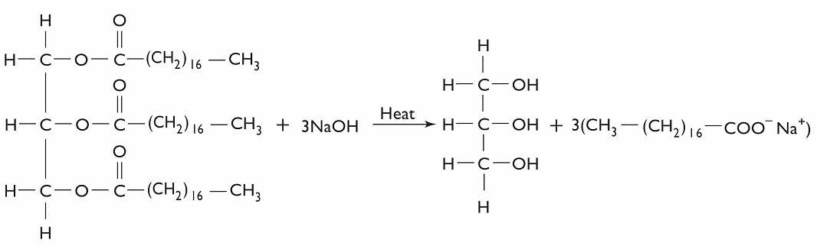

Triglyceride (fat) glycerol + salt of fatty acid (soap)

- Determine the mass of one mole of the triglyceride molecule. (2 marks)

M = (C x 57) + (0 x 6) + (H x 110)
= (12.01 x 57) + 16 x 6) + (1.008 x 110) 1 mark
= 891g 1 mark

_________________________________________________________________________

- If 0.140 moles of triglyceride reacts, how many moles of the salt of a fatty acid are produced?
(3 mark)

n(Soap) = 3/1 x n(TGC) 1 mark
= 3/1 x 0.140 1 mark
= 0.420 mol 1 mark
_________________________________________________________________________

- What is the mass of salt of fatty acid resulting from the breakdown of 0.140 moles triglyceride? (2 marks)

M (Soap) = n x M
= 0.420 x 306.45 1 mark
= 129g 1 mark _________________________________________________________________________

- Determine the percentage composition of each element in a triglyceride molecule.
(3 marks)

M (891.45g)
% C = 12.01 x 57/891.45 = 76.8% 1 mark
% H = 1.008 x 110/891.45 = 12.4% 1 mark
% O = 16 x 6/891.45 = 10.8% 1 mark

_________________________________________________________________________

Question 40 (10 marks)
The study and assembly of materials at the subatomic level is otherwise known as Nanotechnology. This emerging area of Science is aiming to provide solutions to some of the problems that humanity faces.

(a) Describe two examples of nanotechnology potentially solving present day problems
(4 marks)

Medicine – customised nanoparticles the size of molecules delivering drugs directly to diseased cells. No damage to healthy calls like in chemotherapy (2)

Cleaner water – nanoparticles devised to decontaminate waste/chemicals (2)
Others – air quality, food

_________________________________________________________________________

(b) Describe one potential risk arising from the use of nanotechnology. (2 marks)

Very small particle size (1) may be inhaled / pass through body’s defences (1)
any reasonable inference _________________________________________________________________________

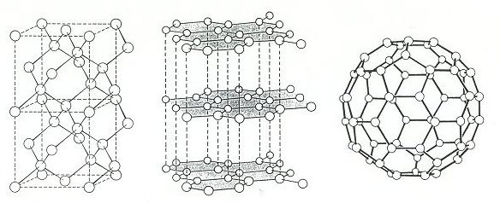

(c) Three allotropes of carbon (diamond, graphite and a fullerene) are shown above.

- What do you understand by the term ‘allotrope’ (1 mark)

Two or more different physical forms of an element
___________________________________________________________________

- Account for one physical property of each allotrope with reference to the bonding type present. Your answer must include a different property for each. (3 marks)

Diamond – from hard, brittle, insulator, insoluble, very high M.P
Graphite – soft and slippery, brittle, conductor, insoluble, very high M.P
Fullerene – soft and slippery, brittle, insulator, insoluble, low M.P solids
MUST EXPLAIN: can only use once

Hard – many strong covalent bonds
Soft and slippery – strong c.v. in two dimension, free moving electrons between sheets
Brittle – directional bonds, stress across a layer will break them
Insulator – all valence electrons held in bonds
Conductor – some freedom of valence electrons
Insoluble – weak IMF between carbon atoms and water molecules
Melting point – many strong bonds holding the structures together.
_________________________________________________________________________

Question 41 (10 marks)

A typical diesel molecule has the molecular formula C₁₆H₃₄. It is produced by the fractional distillation of crude oil. Biodiesel, however, is derived from renewable sources such as vegetable oil or animal fat and has a typical molecular formula, C₁₇H₃₄O₂.

The equations for the complete combustion for these 2 fuels are:

(i) 2 C₁₆H₃₄ (l) + 49 O₂ (g) 32 CO₂ (g) + 34 H₂O (l)

(ii) 2 C₁₇H₃₄O₂ (l) + 49 O₂ (g) 34 CO₂ (g) + 34 H₂O (l)

- In order to determine the mass of carbon dioxide released from the combustion of 1.000 tonne of C₁₆H₃₄ and 1.000 tonne of C₁₇H₃₄O₂, first determine the number of moles of each reactant in 1.000 tonne. (4 marks)

- n (C₁₆ H₃₄) = 1 x 10⁶/ 226.432 1 mark
= 4.42 x10³ moles 1 mark
- n (C₁₇ H₃₄ O₂) = 1 x 10⁶/ 270.442 1 mark
= 3.70 x10³ moles 1 mark

- Determine the number of moles of carbon dioxide released from the combustion of 1.000 tonne of each diesel molecule. (2 marks)

(i) n(CO₂) = 32/2 x n (C₁₆ H₃₄)
= 32/2 x 4.42 x10³ ½ mark
= 70,661 = 7.066 x 10⁴ mol ½ mark
______________________________________________________________

(ii) n(CO₂) = 34/2 x n (C₁₇ H₃₄ O₂)
= 34/2 x 3.70 x10³ ½ mark
= 62,860 = 6.286 x 10⁴ mol ½ mark
______________________________________________________________

- Assuming 3.50 tonnes of oxygen gas is available for each reaction determine whether there is sufficient oxygen for complete combustion. You must show all working for maximum marks.
(4 marks)
- n(O₂) = 3.50 x 10⁶/32 = 109,375 mol 1 mark
n(O₂) required = 49/2 x n(C₁₆ H₃₄) = 49/2 x 4.42 x10³
= 108,200 mol 1 mark
Therefore enough available ( ½ ) ______________________________________________________________
(ii) n(O₂) required = 49/2 x n(C₁₇H₃₄O₂) = 49/2 x 3.70 x10³
= 90,592 mol 1 mark
Therefore enough available ( ½ ) ______________________________________________________________

Question 42 (9 marks)

Our current conception of the atomic model is due to a series of findings from key experiments in the past. Some involved newly developed devices of that time. Below are depictions of some of the devices or data obtained from the experiment. Outline how the principal findings of each contributed to our current understanding of atomic structure.

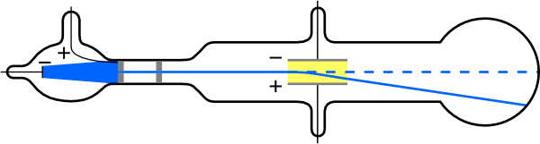
Cathode Ray Tube

Applying an electric field across the cathode ray caused the ray to be deflected towards the positive pole proving that 1 mark
cathode rays were composed of negatively charged particles. 1 mark
particles had a high charge to mass ratio. 1 mark ______________________________________________________________
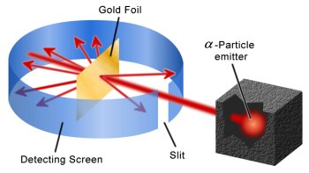
Rutherford’s Gold Foil Experiment
based on alpha particle scattering after striking a thin foil 1 mark
most of atom empty space or space occupied by electrons 1 mark
nucleus source of mass, atom contains a nucleus. 1 mark
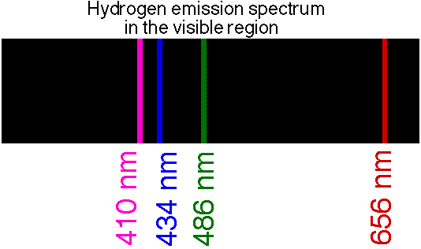
observed spectral lines for hydrogen atom 1 mark
lines due to electron making transitions between energy levels 1 mark
certain orbits/energy levels for electrons are available 1 mark

END OF EXAMINATION

