Debt Scenarios
- Read the scenarios, decide whether you think the debt in each case is ‘good debt’ or ‘bad debt’ and provide reasons why. Offer some strategies to help each person manage their debt.

Scenario 1
Alex is an apprentice plumber. He loves his work and eventually wants to have his own plumbing business. In order to do this, he needs his own vehicle. He’s looked at some cars and the only way he can afford to buy one is to take out a loan.
Good Debt Bad Debt

Reasons

How could Alex make sure he manages his car loan well?

Scenario 2
Erin works in TV production. In her job, it’s pretty important to keep on top of what’s going on with all the different networks and TV shows. This means she ends up watching a lot of TV at work and sometimes at home too. The TVs in the office are very fancy, but her TV at home is pretty old and dinky. She’s considering buying a big new one and just putting it on her credit card. It will cost a lot and she hasn’t quite figured out how much she’ll be able to pay off every month. She tells herself that it’s for work and that she really should buy it.
Good Debt Bad Debt

Reasons

What are some strategies that might help Erin manage her credit card expenses?

Scenario 3
Sam has just bought a new bike. He’s on a pretty strict payment plan with the bike company – if he doesn’t pay a certain amount every week for the next eight weeks, he starts getting charged 15% interest! He’s not too worried at the moment; he’s wanted this bike for ages so has saved up enough to pay the first four weeks without any problems. However, once week five hits, he’ll be paying the bike company 75% of his weekly income. That doesn’t leave much money left over! He’s still living at home and doesn’t have to pay rent or for food, which is a big help. But he’s still concerned: Sam really doesn’t want to have to start paying interest on this bike.
Good Debt Bad Debt

Reasons

What strategies could you suggest to Sam to help him make sure this bike doesn’t end up being more expensive than it should be?

How much can you afford (the 20-10 rule)?

After paying rent, Laura and Jamie have a combined monthly net income of $1,200. What is the most they can afford to pay for instalment and credit card debt?

Isaac has a monthly net income of $800. He shares an apartment with friends and pays $150 each month for rent. Isaac wants to buy a car. Currently, he has only one credit card payment each month for $80. Given his current income and current fixed expenses, what does Isaac have left in his budget for a car payment?

After paying rent, Isabella has a monthly net income of $450. She wants to buy a new bike and pay for it using a credit card. What is the largest monthly payment she can commit to making?

Loans and Debt Important Review Points
- Loans are a very common way to borrow money.
- With a loan, you receive all the money the lender has approved for you in one lump sum - the principal.
- To pay the lender back, you make equal monthly payments called instalments, for a fixed period of time, until it is paid off.
- The lender will charge you extra money over the amount you borrow. This is called interest. Some lenders may charge you a fee for the loan.
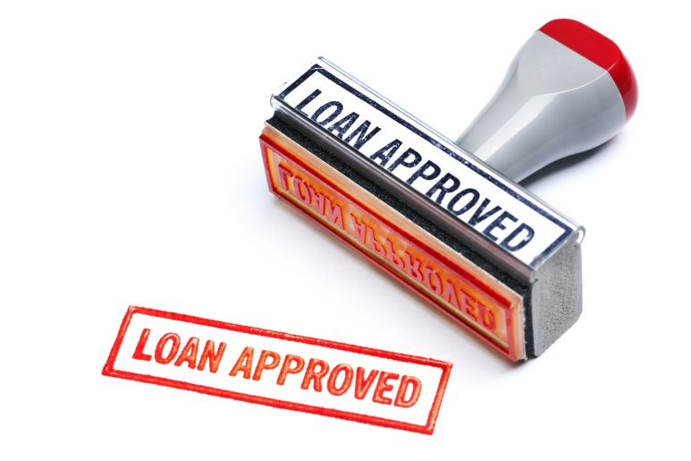
- How much interest you’ll pay for your loan depends on three things - how much you’re borrowing (principal), the interest rate, and the term of the loan (how long it will take you to pay it back).
- Borrowing money gives you financial flexibility but if you’re not careful you may buy more things and spend more than you would otherwise.
- Owing people more than you can repay is painful. And it can negatively affect your money situation for years.
- The best defence is to avoid too much debt to begin with.

