~ THE MUSCULAR SYSTEM ~ Chapter 11
Functions:
- Enable us to move / movement of the body and body organs (voluntary vs. involuntary movements)

Properties:
- Contractibility, Extensibility, Elasticity

~ MUSCLE TISSUE TYPES ~

Function | Allows for body/limb movement (voluntary contraction) | Allows for heart to pump blood (involuntary contraction) | Allows for internal organs to contract (various functions depending on the organ. e.g. digestive organs for mechanical digestion)
Appearance | Elongated cylindrical cells with many nuclei.  Striated appearance | Elongated cylindrical cells with many nuclei and mitochondria.  Striated appearance, Intercalated discs present | Elongated cells.  Non-striated.  Single nucleus
Location/s | Attached to bones | Heart | Many locations.  e.g. Digestive organs (stomach, intestines etc.), bladder, tunica media layer of vessels
Muscle  Type | Skeletal | Cardiac | Smooth
~ SKELETAL MUSCLE STRUCTURE ~

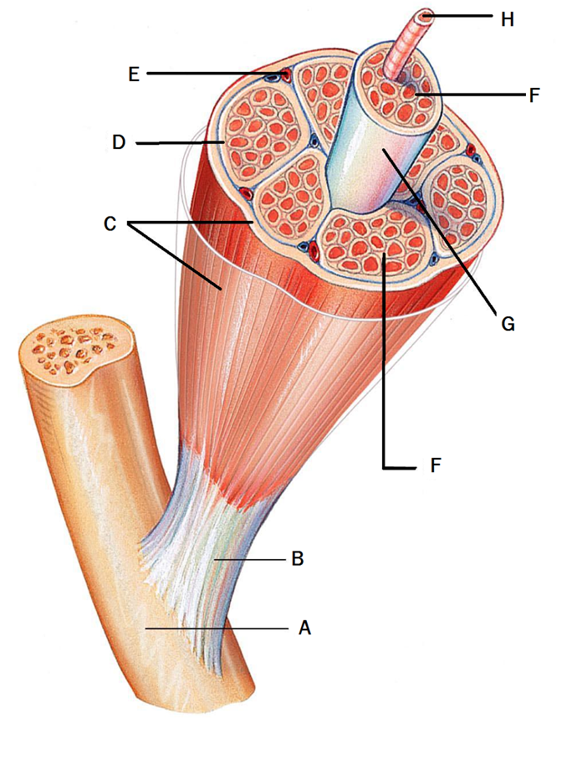

https://www.studyblue.com/notes/note/n/chapter-7/deck/12388264
Letter | Name of structure | Description / Function
A | Bone | Anchor/attachment point for muscle/tendon = together allow movement
B | Tendon | Connective tissue that attaches muscle to bone
C | Epimysium | A sheath of connective tissue that surrounds many fascicles/bundles
D | Perimysium | A sheath of connective tissue that surrounds a fascicle (a bundle of muscle fibres)
E | Blood Vessels  (arteries/veins) | Vessels which supply muscles with oxygen and nutrients and remove wastes
F | Endomysium | A sheath of connective tissue that surrounds individual muscle fibres
G | Fascicle | Term used to describe a bundle of muscle fibres
H | Muscle fibre | Muscle cell (made up of smaller contractile units)

MUSCLE FIBER (MICROSCOPIC) STRUCTURE

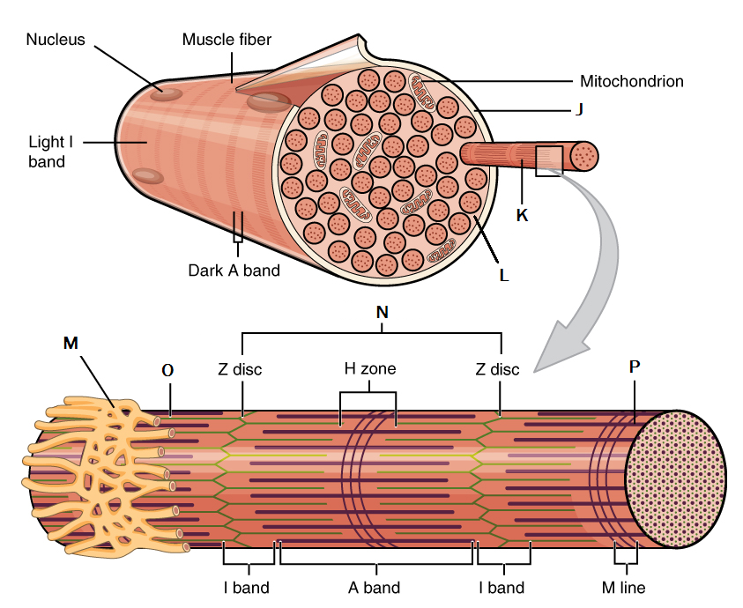

https://opentextbc.ca/anatomyandphysiology/chapter/10-2-skeletal-muscle/
Letter | Name of structure | Description / Function
J | Sarcolemma | The cell membrane of a muscle cell = provides barrier and carries out cell transport (entry/exit of substances)
K | Myofibril | The elongated contractile threads found inside muscle cells/fibres. (a rod-like unit of a muscle cell). Made up of actin and myosin myofilaments
L | Sarcoplasm | The cytoplasm of a muscle cell = suspends other organelles
M | Sarcoplasmic Reticulum | The endoplasmic reticulum of the muscle cell = allowing storage and transport of substances throughout the cell
N | Sarcomere | The structural and contractile units of striated muscle cells. The sarcomeres create the striated appearance of skeletal muscles due to the variations in actin and myosin filaments (create dark and light bands).
O | Actin myofilament | A thin protein unit involved in the contraction of a muscle
P | Myosin myofilament | A thick protein unit involved in the contraction of a muscle

SARCOMERE STRUCTURE

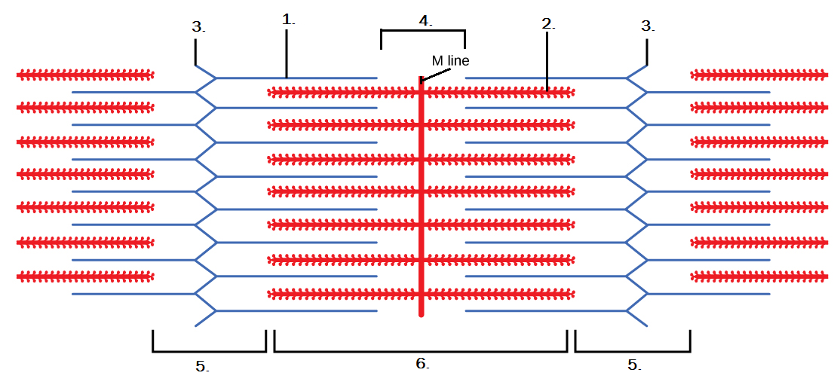

1. Actin (thin) filament 2. Myosin (thick) filament 3. Z-Line 4. H-Zone 5. I-Band 6. A-Band

RELAXED:

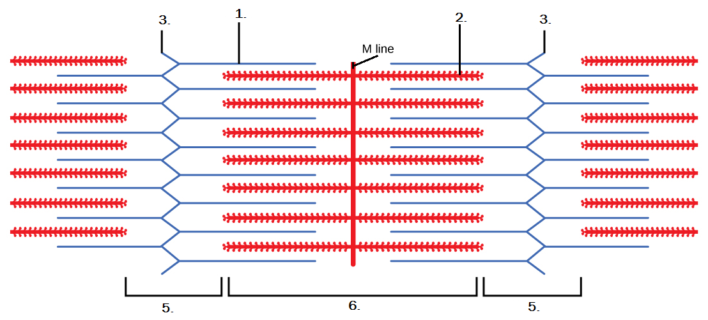

CONTRACTED:

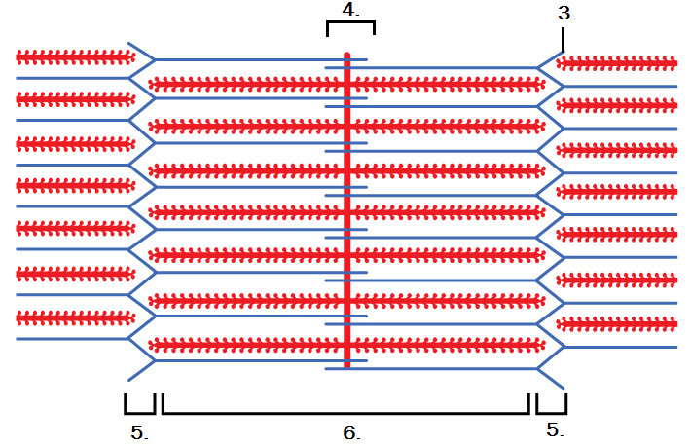

SLIDING FILAMENT MODEL

1. For muscle contraction to take place, contraction requires nerve stimulation, calcium (Ca²⁺⁾ ions, glucose and ATP. (Ca²⁺ released from sarcoplasmic reticulum and uncovers the binding site on actin)

2. Myosin heads attach to actin (binding sites) = forming cross-bridges

3. Myosin heads rotate towards the centre of sarcomere (pulling actin closer) = actin ‘slides’ over myosin

4. Myofilaments overlap = shortening the sarcomere.
= Z lines become closer (the H-Zone + I Bands decrease)

5. As sarcomeres shorten = muscle fibre shortens. All muscle fibres shortening = whole muscle shortening (contracting)

NOTE: Myofilaments (actin and myosin) never change in length.

~ WORKING MUSCLES ~
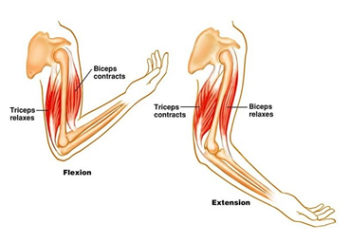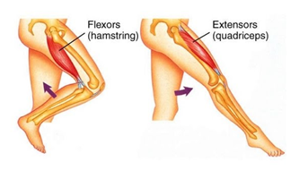
Describe how muscles work in pairs.
Antagonistic muscles (e.g. biceps and triceps) are muscles that produce opposing movements (one muscle provides movement in one direction and the other produces movement in the opposite direction). For example, when the biceps contracts (agonist) the elbow flexes (bends the arm). Whilst this is occurring, the triceps (the antagonist) is ‘relaxed’. The opposite occurs when the arm is straightened (extended) = triceps contracts whilst the biceps relax.

Define the following terms:
Antagonist | Muscle that opposes the action. e.g. when biceps contracts, the triceps extends (the antagonist)
Agonist / Prime Mover | Muscle that causes the desired action. e.g. elbow flexion is brought about by the biceps contracting (agonist)
Origin | The end of the muscle fixed to the stationary bone. (where the muscle ‘originates’
Insertion | The attachment of the muscle to the moveable bone. (where the muscle ends or ‘inserts’)
Tendon | Connective tissue that attaches muscle to bone
Synergist | Muscles that help the prime mover (they may produce the same movement of the prime mover or steady a joint during movement)
Fixator | A synergist muscles that immobilise a joint = it stabilise one part of the body during movement (thus prevent unwanted movement)
Muscle Tone | The partial contraction of skeletal muscles (some muscles are contacted, whilst others are relaxed). The fibres relieve one another so smoothly that the contraction can be maintained for longer periods of time. Muscle tone helps maintain posture/position of body parts.

