NATURAL SELECTION AND ADAPTATIONS WORK PACKAGE!
SPECIES
In the space below write the definition of a species:

Charles Darwin proposed that new species could occur as a result of natural selection.
Define natural selection in the space below:

Within each species there must be variation. Variation is……
Genetic variations allow natural selection to occur. Genetic variation describes the differences in alleles within a population.
For example: different coat colours, eye colours and blood groups.
Variation within a species gene pool is bought about by:
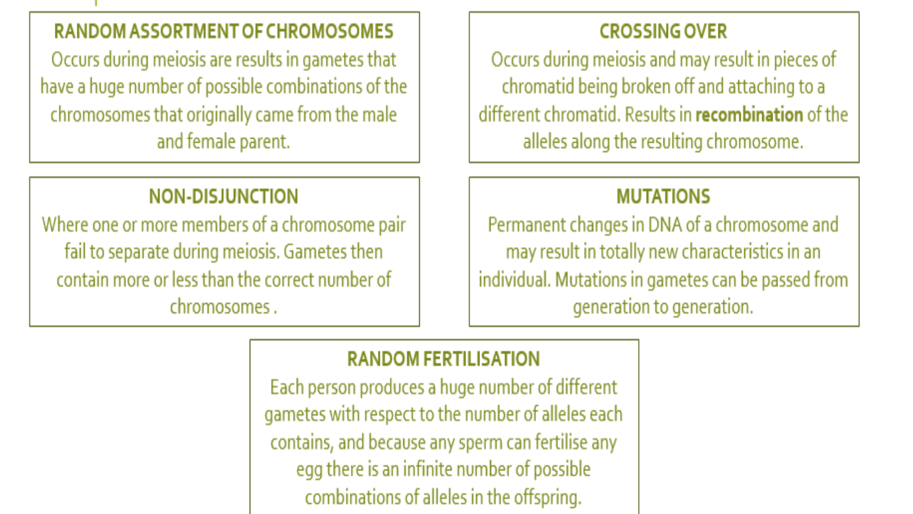
ADAPTATIONS
Animals and plants need to have special features to help them survive and reproduce in their environment. These special features are called ADAPTATIONS.
There are 3 main groups of adaptations:
STRUCTURAL | BEHAVIOURAL | PHYSIOLOGICAL
Features of an organism’s construction that helps it to survive. | Actions of an organism that help it to survive. | Ways in which an organism’s body works that help it to survive.
Examples: | Examples: | Examples:

The environmental facts that acts on the population is called the ‘selective pressure’.
Selective pressures select adaptations that help an organism survive in its environment
The selective pressure may be biotic (living) such as predation, bacterial infection or competition. Or it may be abiotic (physical) such as temperature, water, fire or soil nutrients.
Those species which are not affected by this pressure breed and pass on their favourable genes to the future generations.
Using the key words: Selective pressure, adaptations and species describe the peppered moth example of natural selection (you may like to draw a diagram to help you):

SPECIATION
Speciation is the process where one species separates into two or more separate species. Speciation is responsible for the high biodiversity around the earth.
In the space below name and describe the three steps involved in speciation (use a diagram to assist you):

EVOLUTION
All of the factors mentioned above contribute to the process of evolution.
Evolution is described as the gradual change in a species characteristics over time.
