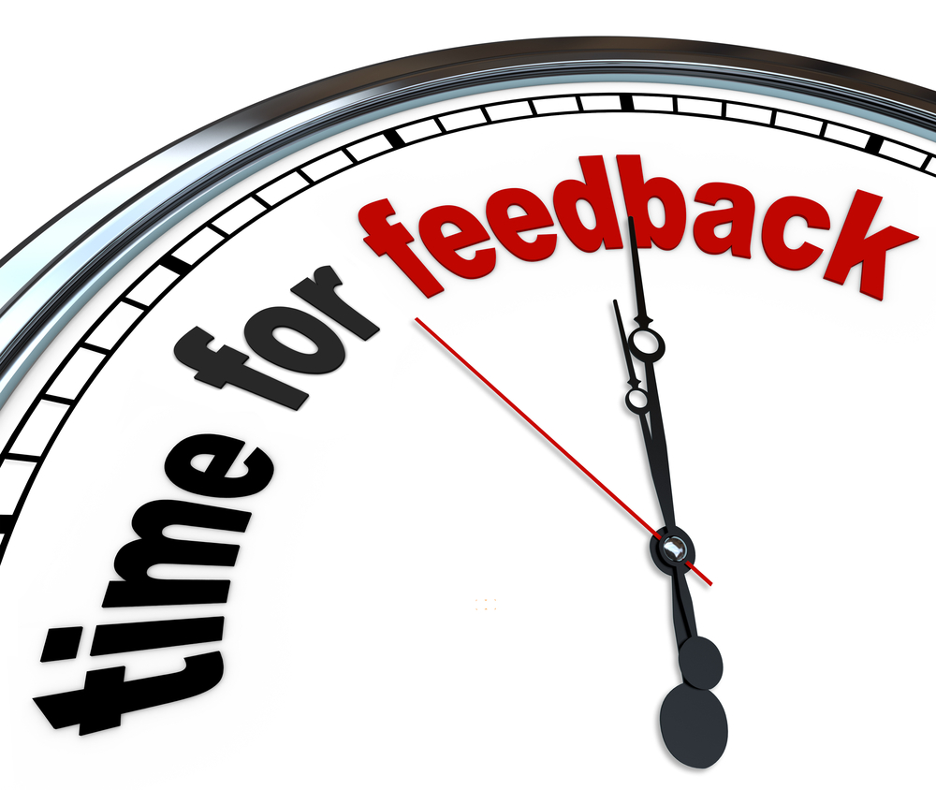
360 degree feedback of group leader

Criteria
- instructions to group
- encouragement of the group
- feedback to the group
- level of group cohesion
- level of safety within the group
- task completion

Task | Comments on achievement & areas of improvement
Conveying of instructions: communicating effectively, considering the needs of the team, clarity of instructions & encouragement of questions | Achievement:  Area for improvement:
Group leader taking control of group: direction of the group in a fair manner, considering the needs of the group with the completion of the task in mind | Achievement:  Area for improvement:
Were there regular/any feedback given to the group on performance of the task? team encouragement throughout reinforcing behaviour such as praise, giving members feedback & offering alternative solutions to problems | Achievement:  Area for improvement:
Level of safety within the group – being heard, encouraged etc: did not force tasks beyond individual’s capabilities, considered different ability & designated production tasks according to individual differences | Achievement:  Area for improvement:
Task completed in a timely fashion: oversees & encourages team during task process, shares ideas to improve production | Achievement:  Area for improvement:
Collaboration within the group: considers team ideas, listens effectively, encourages flow of ideas within the group | Achievement:  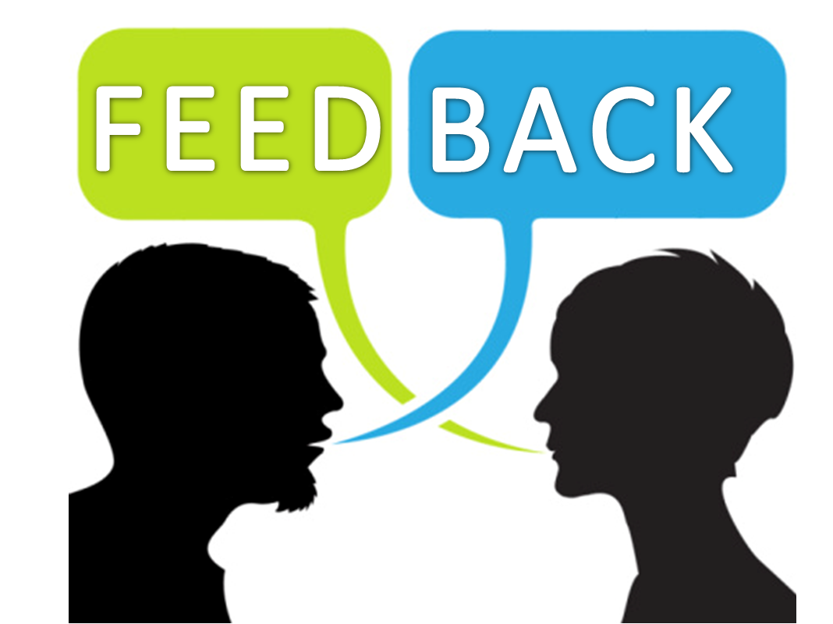  Area for improvement:

Reflection: Growth & Development of the Team Leader
Strengths

Growth/development opportunities

What will I do to improve?

Areas I would like to address in the next 6 months

Performance Management of Team Member…
Competency Area | Comments on achievement & area of improvement
Taking responsibility: completion of task accurately & competently, exhibits concern for goals & needs of others | Achievement:  Area for improvement:
Problem solving: identifies & analyses problems, formulates alternative solutions, recommends appropriate actions | Achievement:  Area for improvement:
Collaboration/teamwork: uses diplomacy & tact to maintain effective & harmonious work relations, shares resources with others to promote positive & collaborating working relations, respects group diversity | Achievement:  Area for improvement:
Communication skills: effectively communicates ideas, responds to others’ ideas & concerns without judgement, communicates & influences others to meet company goals | Achievement:  Area for improvement:

Reflection: Growth & Development of Employee…
Strengths

Growth/development opportunities

What will I do to improve?

What can the manager do to support this?

